SUBCOURSE EDITION
OD1503 A

MAINTENANCE OF THE M2 MACHINEGUN



US ARMY TANK TURRET REPAIRER

MOS/SKILL LEVEL: 45K30

MAINTENANCE OF THE M2 MACHINEGUN

SUBCOURSE NO. OD1503

US Army Correspondence
Course Program

7 Credit Hours

GENERAL

The purpose of this subcourse is to provide knowledge of the components, operation, inspection and maintenance procedures for the M2 machinegun.

The scope of this subcourse broadly covers the components, operation, inspection and maintenance procedures for the M2 machinegun.

Seven credit hours are awarded for successful completion of this subcourse. It consists of one lesson with two tasks.

Lesson 1: THE COMPONENTS, OPERATION, INSPECTION, AND MAINTENANCE PROCEDURES FOR THE M2 MACHINEGUN

TASK 1: Describe the components and operation of the M2 machinegun.

TASK 2: Describe the inspection and maintenance procedures for the M2 machinegun.

i

M2 MACHINEGUN MAINTENANCE

TABLE OF CONTENTS

Section Page

TITLE i

TABLE OF CONTENTS ii

Lesson 1: THE COMPONENTS, OPERATION,
INSPECTION, AND MAINTENANCE
PROCEDURES FOR THE M2
MACHINEGUN 1

Task 1: Describe the components and
operation of the M2 machinegun 1

Task 2: Describe the inspection and
maintenance procedures of the M2
machinegun 42

Practical Exercise 1 69

Answers to Practical Exercise 1 71

REFERENCES 73

* * * IMPORTANT NOTICE * * *

THE PASSING SCORE FOR ALL ACCP MATERIAL IS NOW 70%.

PLEASE DISREGARD ALL REFERENCES TO THE 75% REQUIREMENT.

ii
M2 MACHINEGUN MAINTENANCE

When used in this publication “he,” “him,” “his,” and “men” represent both the masculine and feminine genders, unless otherwise stated.

iii

M2 MACHINEGUN MAINTENANCE

STUDENT NOTES

iv

M2 MACHINEGUN MAINTENANCE - OD1503 - LESSON 1/TASK 1

LESSON 1

THE COMPONENTS, OPERATION, INSPECTION, AND
MAINTENANCE PROCEDURES FOR THE M2 MACHINEGUN

TASK 1. Describe the components and operation of the M2 machinegun.

CONDITIONS

Within a self-study environment and given the subcourse text, without assistance.

STANDARDS

Within three hours

REFERENCES

No supplementary references are needed for this task.

1. Introduction

The M2 caliber .50 machinegun supports the infantryman in both the attack and defense. It provides the rifleman with the heavy volume of close, accurate, and continuous fire necessary to accomplish his mission in the attack. The long range, close defensive, and final protective fires delivered by this weapon form an integral part of the unit's defensive fires.

The M2 caliber .50 machinegun is also used to provide protection for motor movements, vehicle parks, and train bivouacs. It is also used to defend against low-flying hostile aircraft and to destroy lightly armored vehicles. In addition, it is used for reconnaissance by fire on suspected enemy positions.

From these brief statements it is easy to see that the M2 is a vital and valuable piece of equipment, not only to the infantryman, but also to almost everyone in the Army who may find themselves in a combat situation. For this weapon to accomplish

1

M2 MACHINEGUN MAINTENANCE - OD1503 - LESSON 1/TASK 1

its mission, it needs first rate care. That is the purpose of this subcourse, to describe the procedures used to inspect and maintain the M2 machinegun. However, before the weapon can be inspected and maintained, repair personnel must be familiar with the components and operation of the weapon. This task will introduce the student to the components and operation of the M2.

2. Description

a. Principles of Operation. The Browning machinegun, caliber .50 heavy barrel (HB), M2, is a belt-fed, recoil-operated, air-cooled, crew-operated machinegun. The gun is capable of single shot, as well as automatic fire.

(1) Belt Feed. By repositioning some of the component parts, the gun is capable of alternate feed (ammunition can be fed into the weapon from the left side or the right side of the receiver); however, the infantry uses only left side feed. A disintegrating metal link belt is used for feeding.

(2) Recoil Operation. The force for recoil operation is furnished by expanding powder gases which are controlled by various springs, cams, and levers.

(3) Air Cooling. Maximum surface of the barrel and receiver are exposed to permit air cooling. Perforations in the barrel support allow air to circulate around the breech end of the barrel and help in cooling the parts. The heavy barrel is used to retard early overheating.

(4) General Data. The receiver alone weighs 60 pounds, while the barrel weighs 24 pounds. The weapon can be mounted on the M3 tripod with traversing and elevating mechanism. The tripod weighs 44 pounds. When the machinegun is assembled and placed on the M3 tripod, the total weight of the weapon is approximately 128 pounds.

When firing M2 ball ammunition, the weapon has an approximate maximum range of 6,800 meters, while the maximum effective range of the weapon is 1,830 meters. The weapon can maintain a sustained rate of fire of 40 rounds or less per minute and a rapid rate of fire of 40 rounds or more per minute. The cyclic rate of fire for the weapon is between 450 and 550 rounds per minute. The velocity of M2 ball

2

M2 MACHINEGUN MAINTENANCE - OD1503 - LESSON 1/TASK 1

ammunition as it leaves the muzzle is 3,050 feet per second or 2,080 mph. The overall length of the gun is approximately 65 inches with the length of the barrel being 45 inches.

3. Function and Operation

a. Functioning. The cycle of operation is broken down into eight basic steps. More than one step may occur at the same time. The steps are listed below and each step is explained before moving on to the next step.

(1) Feeding. Feeding is the action of placing a cartridge in the receiver, approximately in back of the barrel, ready for chambering.

When the bolt is fully forward, the belt feed slide is in the cover; the ammunition belt is held in the feedway by the belt holding pawl. As the bolt moves to the rear, the cam grooves guide the belt feed lever, pivoting the lever and moving the slide out of the side of the cover. The belt is held stationary by the belt holding pawl, while the belt feed pawl pivots, compressing its spring, and rides up over the link holding the first round.

When the bolt is all the way to the rear, the belt feed slide moves out far enough to allow the belt feed pawl spring to force the pawl down behind the first round. As the bolt moves forward, the belt feed lever moves the slide back into the receiver. The belt is pulled in by the belt feed pawl. The next round rides over the belt holding pawl compressing its spring and forcing the pawl down until the round has passed over the pawl.

When the bolt is fully forward, the slide is back in the cover; the first round is engaged by the extractor. If for any reason a round is not extracted from the belt, the belt feed pawl arm will ride up over the round, holding up the belt feed pawl to prevent double feeding.

When withdrawing a round from the belt, the extractor grips the first round in the feedway and, as the recoiling parts move to the rear, withdraws it from the ammunition belt. Initially, the grip of the extractor is held secure by the downward pressure of the cover extractor spring. As the bolt continues its movement to the rear, the cover extractor cam forces the extractor down, causing

3

M2 MACHINEGUN MAINTENANCE - OD1503 - LESSON 1/TASK 1

the cartridge to enter the T-slot in the bolt. As the bolt moves to the rear and the extractor is forced down, the extractor lug, riding along the top of the extractor switch, forces the rear end of the extractor switch downward. Near the end of the rearward movement, the extractor lug overrides the end of the switch and the switch snaps back up into position.

(2) Chambering. As the bolt moves forward, the round is held by the T-slot and the extractor assembly. The extractor stop pin (on the left side of the bolt) permits the extractor assembly to go down only far enough to align the round with the chamber. As the bolt continues forward, the round is chambered. As this action takes place, the extractor lug rides up over the extractor cam, compressing the cover extractor spring, and through the pressure of the spring, snaps into the groove in the next cartridge base.

(3) Locking. Initially, the bolt is forced forward in counterrecoil by the energy stored in the driving spring assembly and the compressed buffer disks. At the start of counterrecoil, the barrel buffer body tube keeps the accelerator tips from bouncing up too soon and catching in the breech lock recess in the bolt. After the bolt travels forward about five inches, the lower rear projection of the bolt strikes the tips of the accelerator, turning the accelerator forward. This unlocks the barrel extension from the barrel buffer body group and releases the barrel buffer spring. The barrel buffer spring expands, forcing the piston rod forward.

Since the cross groove in the piston rod engages the notch on the barrel extension shank, the barrel extension and barrel are also forced forward by the action of the barrel buffer spring. Some of the forward motion of the bolt is transmitted to the barrel extension through the accelerator. As the accelerator speeds up the barrel extension, the accelerator tips slow down the bolt.

Locking begins 1 1/8 inches before the recoiling groups (bolt, barrel extension, and barrel) are fully forward. The breech lock in the barrel extension rides up the breech lock cam in the bottom of the receiver into the breech lock recess in the bottom of the receiver and into the breech lock recess in the bottom of the bolt. This locks

4

M2 MACHINEGUN MAINTENANCE - OD1503 - LESSON 1/TASK 1

the recoiling groups together. The recoiling groups are completely locked together three-fourths of an inch before the groups are fully forward.

(4) Firing. As the trigger is pressed down, it pivots on the trigger pin, so that the trigger cam on the inside of the backplate engages and raises the rear end of the trigger lever which, in turn, pivots on the trigger lever pin assembly. This causes the front of the trigger lever to press down on the top of the sear stud. The sear is forced down until the hooked notch of the firing pin extension is disengaged from the sear notch. The firing pin and firing pin extension are driven forward by the firing pin spring; the striker of the firing pin hits the primer of the cartridge, firing the round.

For automatic firing, the trigger is pressed and held down. The bolt latch release must be locked, or held depressed, so that the bolt latch will not engage the notches in the top of the bolt. This would hold the bolt to the rear, as in single-shot firing. Each time the bolt travels forward in counterrecoil, the trigger lever depresses the sear releasing the firing pin extension assembly and the firing pin, automatically firing the next round when the forward movement of the recoiling groups is nearly completed. The gun should fire about one-sixteenth of an inch before the recoiling groups are fully forward. At the instant of firing, the parts are in battery, i.e., the proper position for firing. Only the first round should be fired with the parts fully forward. The gun fires automatically as long as the trigger and bolt latch are held down, and ammunition is fed into the gun.

(5) Unlocking. At the instant of firing, the bolt is locked to the barrel extension and against the rear end of the barrel by the breech lock, which is on top of the breech lock cam and in the breech lock recess in the bottom of the bolt.

When the cartridge explodes, the bullet travels out of the barrel; the force of the recoil drives the recoiling groups rearward. During the first three-fourths of an inch, the recoiling groups are locked together. As this movement takes place, the breech lock is moved off the breech lock cam stop, allowing the breech lock depressors (acting on the breech lock pin) to force the breech lock down, out of its recess from the bottom of the bolt. At the

5

M2 MACHINEGUN MAINTENANCE - OD1503 - LESSON 1/TASK 1

end of the first three-fourths of an inch of recoil, the bolt is unlocked, allowing it to move to the rear, making it independent of the barrel and barrel extension.

As the recoiling groups move to the rear, the barrel extension causes the tips of the accelerator to rotate rearward. The accelerator tips strike the lower rear projection of the bolt, accelerating the movement of the bolt to the rear.

The barrel and barrel extension continue to travel to the rear an additional three-eighths of an inch, or an approximate total distance of 1 1/2 inches, until they are stopped by the barrel buffer assembly. During the recoil of the 1 1/8 inches, the barrel buffer spring is compressed by the barrel extension shank, since the notch on the shank is engaged in the cross groove in the piston rod head. The spring is locked in the compressed position by the claws of the accelerator, which engage the shoulders of the accelerator, and also engage the shoulders of the barrel extension shank.

After its initial travel of three-fourths of an inch, the bolt travels an additional 6 3/8 inches to the rear. This is after it is unlocked from the barrel and barrel extension, for a total of 7 1/8 inches. During this movement, the driving springs are compressed. The rearward movement of the bolt is stopped as the bolt strikes the buffer plate. Part of the recoil energy of the bolt is stored by the driving spring rod assembly, and part is absorbed by the buffer disks in the backplate.

(6) Extracting. The empty case, held by the T-slot, has been expanded by the force of the explosion; therefore, it fits snugly in the chamber. If the case is withdrawn from the chamber too rapidly, it may be torn. To prevent this, and to ensure slow initial extraction of the case, the top forward edge of the lock recess in the bolt is beveled. As the breech lock is unlocked, the initial movement of the bolt away from the barrel and barrel extension is gradual.

The slope of the locking faces facilitates locking and unlocking and prevents sticking. The leverage of the accelerator tips on the bolt speeds extraction, after it is started, by kicking the bolt to the rear to extract the empty case from the chamber.

6

M2 MACHINEGUN MAINTENANCE - OD1503 - LESSON 1/TASK 1

(7) Ejecting. As the bolt starts its forward movement (counterrecoil) the extractor lug rides below the extractor switch, forcing the extractor assembly further down, until the round is in the center of the T-slot. The round, still gripped by the extractor, ejects the empty case from the T-slot. The last empty case of an ammunition belt is pushed out of the ejector.

(8) Cocking. When the recoiling groups are fully forward, the top of the cocking lever rests on the rear half of the V-slot in the top plate bracket. As the bolt moves to the rear, the top of the cocking lever is forced forward. The lower end pivots to the rear on the cocking lever, which fits through the slot in the firing pin extension, forcing the extension to the rear, and compressing the firing pin spring against the sear stop pin (accelerator stop).

As the firing pin extension is pressed to the rear, the hooked notch of the extension rides over the sear notch, forcing the sear back up after the hooked notch of the firing pin extension has entered the sear notch. The pressure of the sear and firing pin springs holds the two notches locked together. There is a slight overtravel of the firing pin extension in its movement to the rear, to ensure proper engagement with the sear. As the bolt starts forward, overtravel is taken up and completed when the cocking lever enters the V-slot of the top plate bracket, and is cammed towards the rear; pressure on the cocking lever is relieved as the bolt starts forward.

b. Operation. Operation includes loading or unloading the gun, clearing the gun, or allowing the bolt to go forward.

(1) Half-loading and Loading the Gun. Half-loading of an automatic weapon occurs when the belt or magazine is inserted and is charged, but without the first cartridge actually being inserted into the chamber. To half-load the M2, the gunner ensures that the bolt is forward and the cover is closed. The assistant gunner inserts the double loop end of the ammunition belt in the feedway until the first round is engaged by the belt holding pawl. The gunner grasps the retracting slide handle with the right hand, palm up, and vigorously jerks the bolt to the rear and releases

7

M2 MACHINEGUN MAINTENANCE - OD1503 - LESSON 1/TASK 1

the retracting slide handle. If the bolt latch release lock is engaging the bolt latch release, the bolt and retracting slide handle will move forward under pressure of the driving spring group, half-loading the gun. However, if the bolt latch is up and free of the bolt latch release lock, the bolt latch will hold the bolt and retracting slide handle to the rear. The retracting slide handle must be returned to its most forward position prior to releasing the bolt. To complete half-loading, press the bolt latch release, allowing the bolt to go forward.

To fully load the gun, the procedure is the same as in half-loading, except it requires the gunner to pull and release the bolt twice.

(2) Unloading and Clearing the Gun. To unload the gun, the gunner unlocks the bolt latch release (if applicable) and raises the cover. The assistant gunner lifts the ammunition belt from the feedway. The gunner pulls the bolt to the rear and examines the chamber and T-slot to ensure they hold no rounds. In darkness, the gunner must feel the chamber and T-slot.

To clear the gun, additional precautions must be taken. After the steps above have been accomplished, a wooden block, extending above and below the receiver approximately one inch, is inserted in the receiver between the bolt and the rear of the barrel. A cleaning rod is then inserted in the muzzle end of the barrel, pushed through the bore until it can be seen in the receiver, and immediately removed.

During any temporary stoppage of fire, where it is not necessary to unload or clear the gun, the bolt should be latched to the rear to prevent accidental firing.

(3) Precautions During Operation. Ensure that the cover (once raised) remains in the raised position. Ensure the barrel remains in the gun before allowing the bolt to go forward. If the cover is lowered when the bolt is to the rear, the belt feed lever lug will not fit into the proper groove in the bolt. Thus, parts may be damaged as the bolt goes forward. In the cover assembly, the belt feed lever lug is held to the left by the action of the shoulder headless pin and spring just above the pivot.

8

M2 MACHINEGUN MAINTENANCE - OD1503 - LESSON 1/TASK 1

If the bolt is allowed to go forward with the barrel out of the gun, parts may be damaged when the bolt slams forward. The added weight and cushioning effect of the barrel acts as a buffer and protects the parts from damage. To allow the bolt to go forward with the barrel out of the gun, pull the retracting slide handle all the way to the rear, engaging the bolt stud in the notch in the rear of the retracting slide. Maintain a steady pressure to the rear on the retracting slide handle; press the bolt latch release and allow the bolt to ride slowly forward.

(4) Single Shot Operation. To fire the gun single shot, the bolt latch release must be in the up position. The latch engages the notches on top of the bolt when the bolt is to the rear after each round is fired. When the bolt latch release is depressed the latch assembly is raised, allowing the bolt to be driven forward into battery. The gun may then be fired by pressing the trigger. When the bolt latch release is locked down by the bolt latch release lock on the buffer tube sleeve, the gun functions as an automatic weapon.

4. Components

The best way to learn the components that comprise a piece of equipment is to disassemble that piece of equipment and to study each part as it is removed. Therefore, in the following paragraphs, the disassembly procedures for the M2 machinegun will be covered.

It should be noted here that when the operator/unit armorer, or when intermediate direct support (IDS) maintenance disassembles the weapon, they would clean, inspect and/or repair any discrepancies at the time they are found. In this subcourse, however, we will not use this procedure. We will cover the disassembly, then the inspection and repair procedures, followed by the reassembly procedures.

a. Disassembly. Disassembly of the M2 machinegun is divided into two categories. The first is general disassembly or field stripping; the second is detailed disassembly. Field stripping is the removing of major groups and assemblies of the gun. This type of disassembly is authorized for the operator/unit armorer. Detailed disassembly is the disassembly of the major groups and assemblies into

9

M2 MACHINEGUN MAINTENANCE - OD1503 - LESSON 1/TASK 1

the component parts that make up the major group and assembly. Detailed disassembly is authorized only at the IDS maintenance level. Before beginning any work on this or any other weapon system, first clear the weapon. The procedures for clearing the weapon were covered in paragraph 3b(2) on page 8 of this task.

(1) General Disassembly. After the weapon has been cleared, begin the disassembly by following the procedures outlined in the following paragraphs:

(a) Barrel Group. Turn the cover latch and raise the cover group (figure 1).
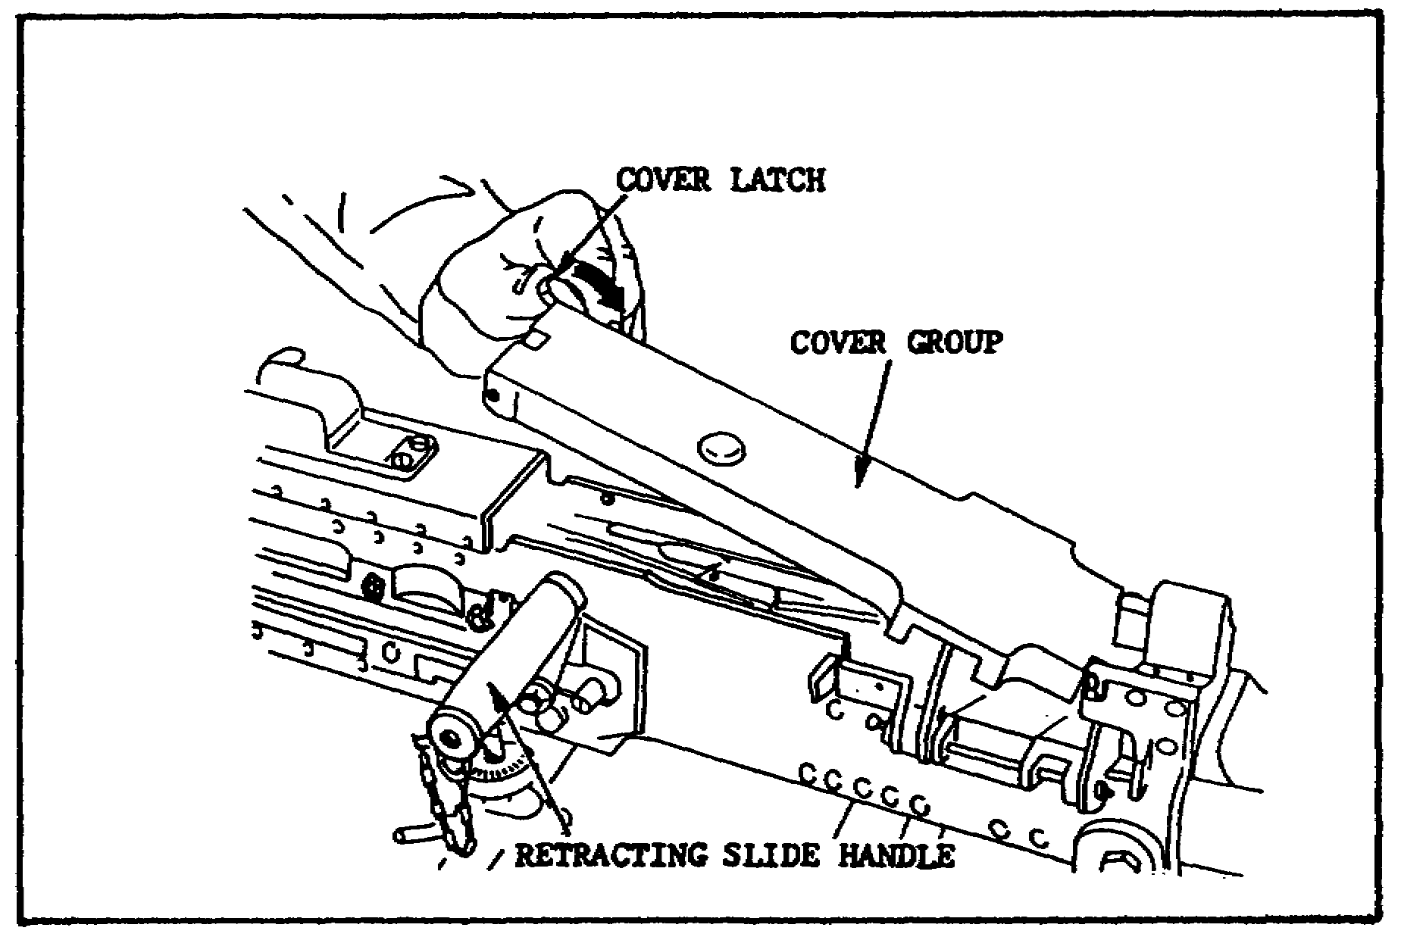

FIGURE 1. RAISING THE COVER.

Grasp the retracting slide handle with the right hand, palm up, and pull the recoiling parts to the rear until the lug on the barrel locking spring aligns with the 3/8 inch hole in the right sideplate of the receiver (just below the feedway exit). The barrel can be turned only when the lug is aligned with the 3/8 inch hole. Place the smallest loop of a caliber .50 link, or suitable spacer, between the trunnion block and the barrel extension (figures 2 and 3 on the following pages).
10
M2 MACHINEGUN MAINTENANCE - OD1503 - LESSON 1/TASK 1

This holds the barrel locking spring lug aligned with the 3/8 inch hole in the right sideplate.
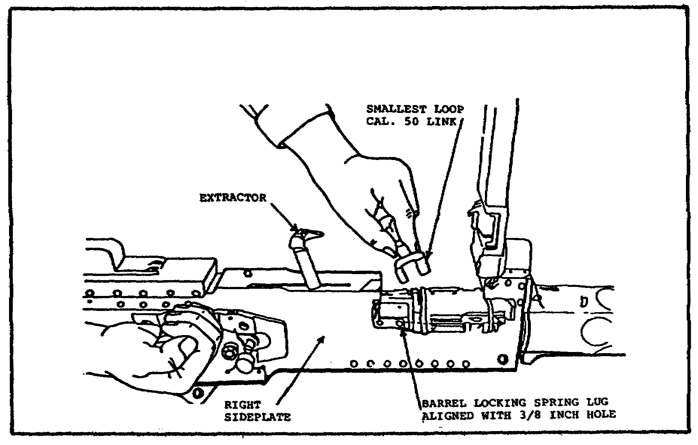

FIGURE 2. ALIGNING THE BARREL LOCKING
SPRING LUG WITH THE 3/8
INCH HOLE.

Unscrew the barrel from the receiver (figure 4 on the following page). Be careful not to damage the threads or barrel locking notches when setting the barrel down. Pull back slightly on the retracting slide handle and remove the link or spacer from the receiver.

(b) Backplate Group. Ensure that the bolt latch release is in the up position, free of the bolt latch release lock. If it is not, push down on the bolt latch release and turn the buffer tube sleeve down to the right to free it (figure 5 on page 13). The bolt must be forward before the backplate is removed. If the bolt is to the rear, push down on the bolt latch release and allow the bolt to go forward slowly.

CAUTION

Care must be taken to prevent the bolt from slamming forward with the barrel removed.

11

M2 MACHINEGUN MAINTENANCE - OD1503 - LESSON 1/TASK 1

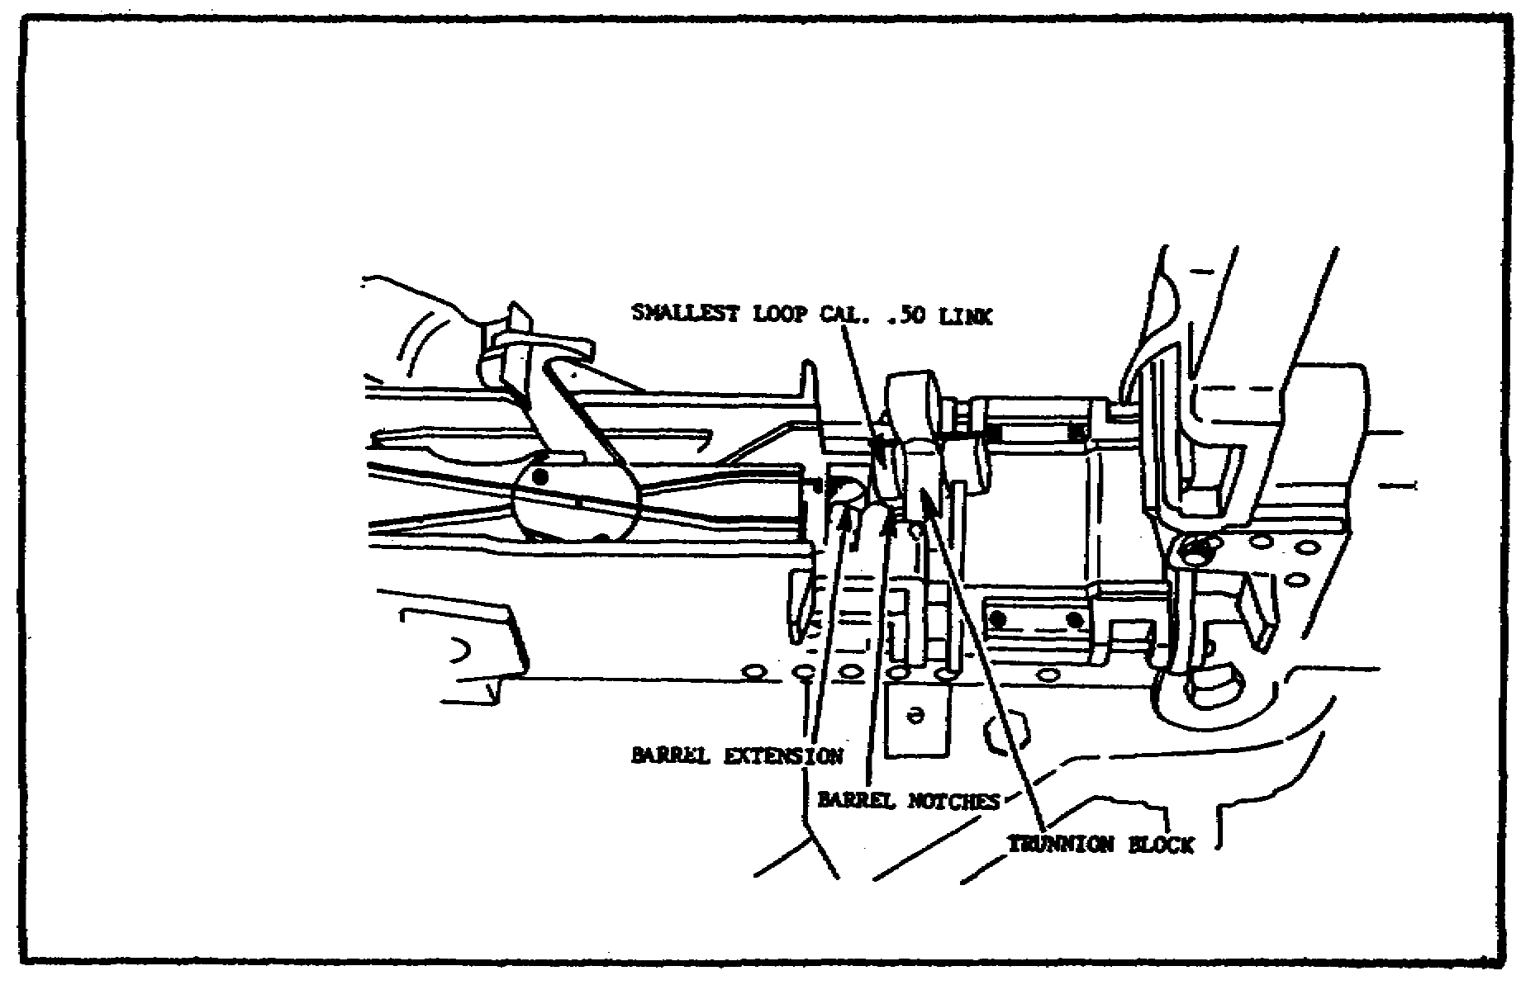

FIGURE 3. ALIGNING THE BARREL LOCKING
SPRING LUG USING THE SMALLEST
LOOP OF THE CALIBER .50 LINK.

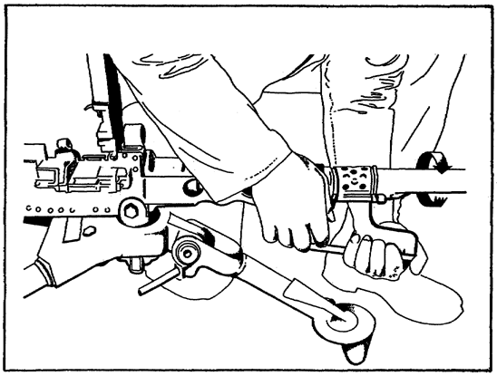
FIGURE 4. REMOVING THE BARREL.

12

M2 MACHINEGUN MAINTENANCE - OD1503 - LESSON 1/TASK 1

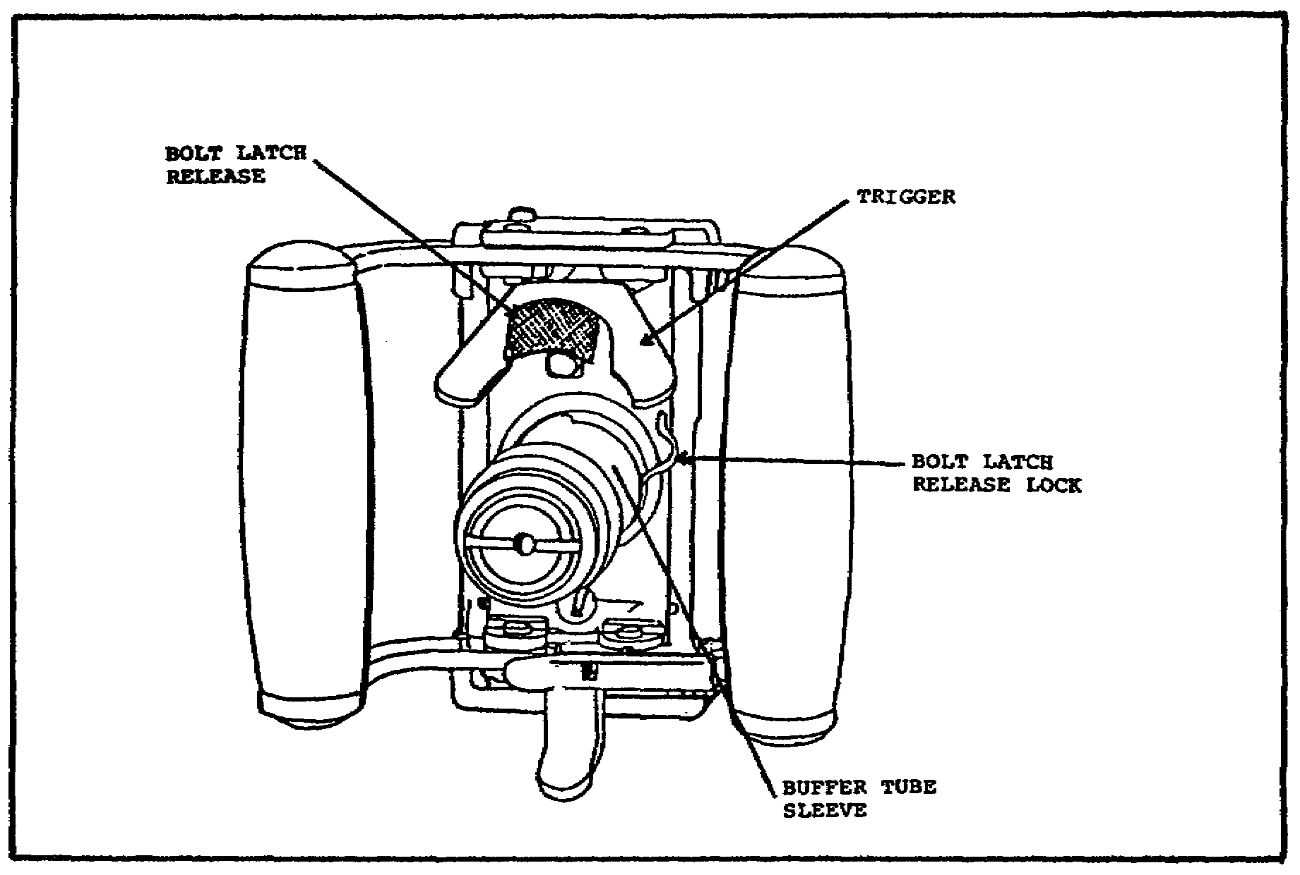

FIGURE 5. BOLT LATCH RELEASE FREE OF THE
BOLT LATCH RELEASE LOCK.

Use the retracting slide handle to ease the bolt forward after the bolt latch is released. The backplate latch lock and latch are below the buffer tube. Pull out on the lock and up on the latch to remove the backplate by lifting it straight up (figure 6 on the following page).

(c) Driving Spring Rod Assembly. The inner and outer driving springs and driving spring rod are located inside the receiver next to the right sideplate (figure 7 on the following page). Push in on the head of the driving spring rod and push to the left to remove the driving spring rod retaining pin from its seat in the right sideplate. Pull the driving assembly to the rear and out of the receiver.

Never attempt to cock the gun while the backplate is off and the driving spring assembly is in place. If the backplate is off and the driving spring assembly is compressed, the retaining pin on the driving spring rod can slip from its seat and cause serious injury to anyone behind the gun.

13

M2 MACHINEGUN MAINTENANCE - OD1503 - LESSON 1/TASK 1

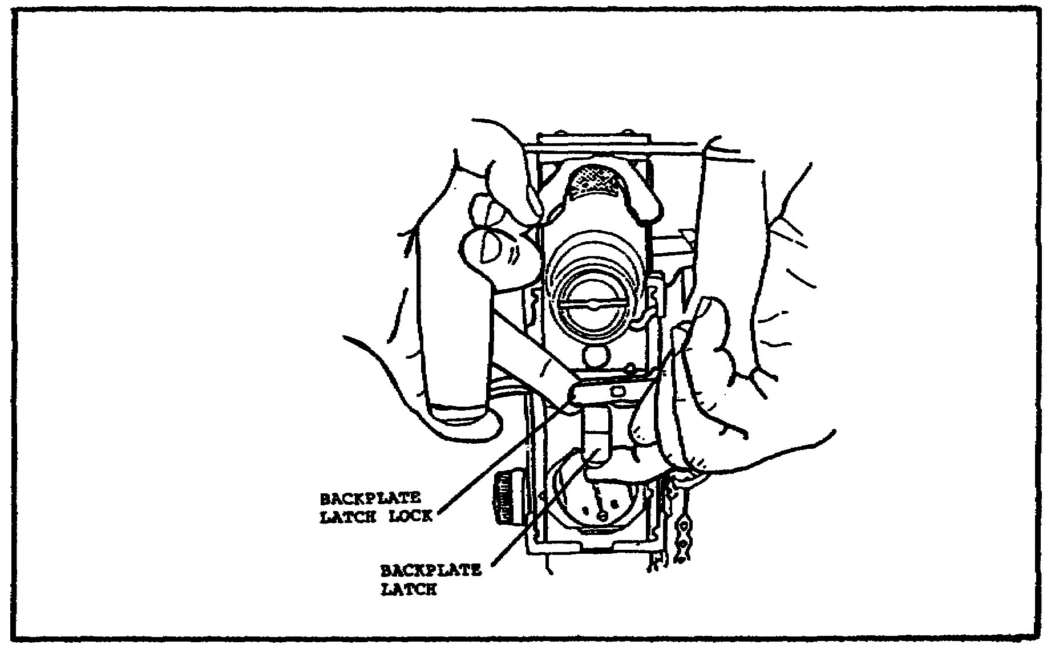

FIGURE 6. REMOVING THE BACKPLATE.

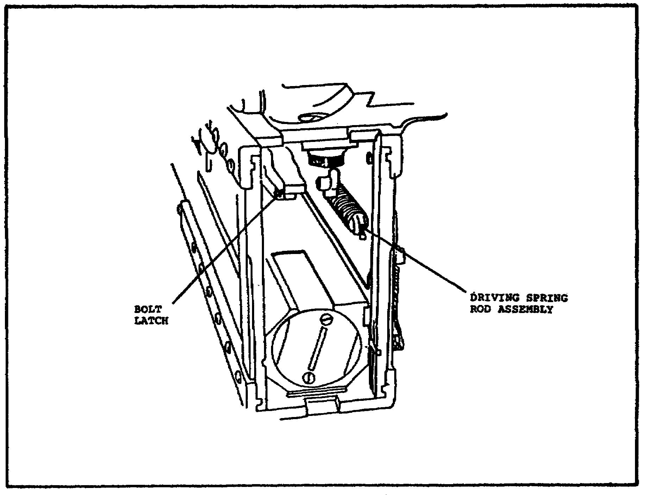
FIGURE 7. DRIVING SPRING ROD ASSEMBLY.

14
M2 MACHINEGUN MAINTENANCE - OD1503 - LESSON 1/TASK 1

(d) Bolt Stud. Grasp the retracting slide handle and give it a quick jerk, freeing the bolt from the barrel extension. Align the shoulder on the bolt stud with the clearance hole in the bolt slot on the right sideplate and remove the bolt stud (figure 8).

NOTE

If the bolt latch is accidentally moved all the way to the rear, the bolt latch will engage in the bolt latch notches in the top of the bolt. If this occurs, raise the bolt latch (left of the trigger lever) and push the bolt forward to align the bolt stud with the clearance hole (figure 9 on the following page).
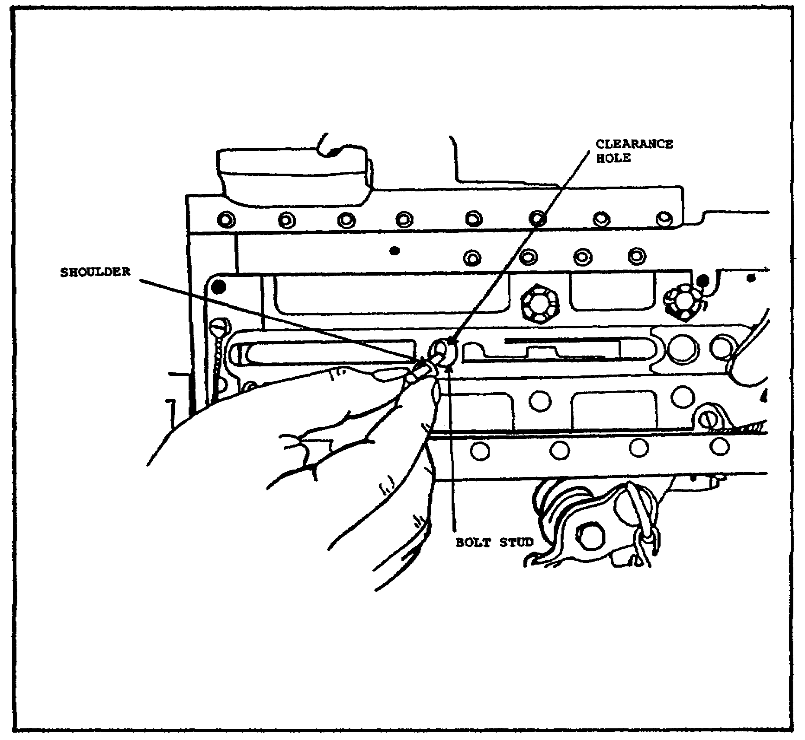

FIGURE 8. REMOVING THE BOLT STUD.

15

M2 MACHINEGUN MAINTENANCE - OD1503 - LESSON 1/TASK 1

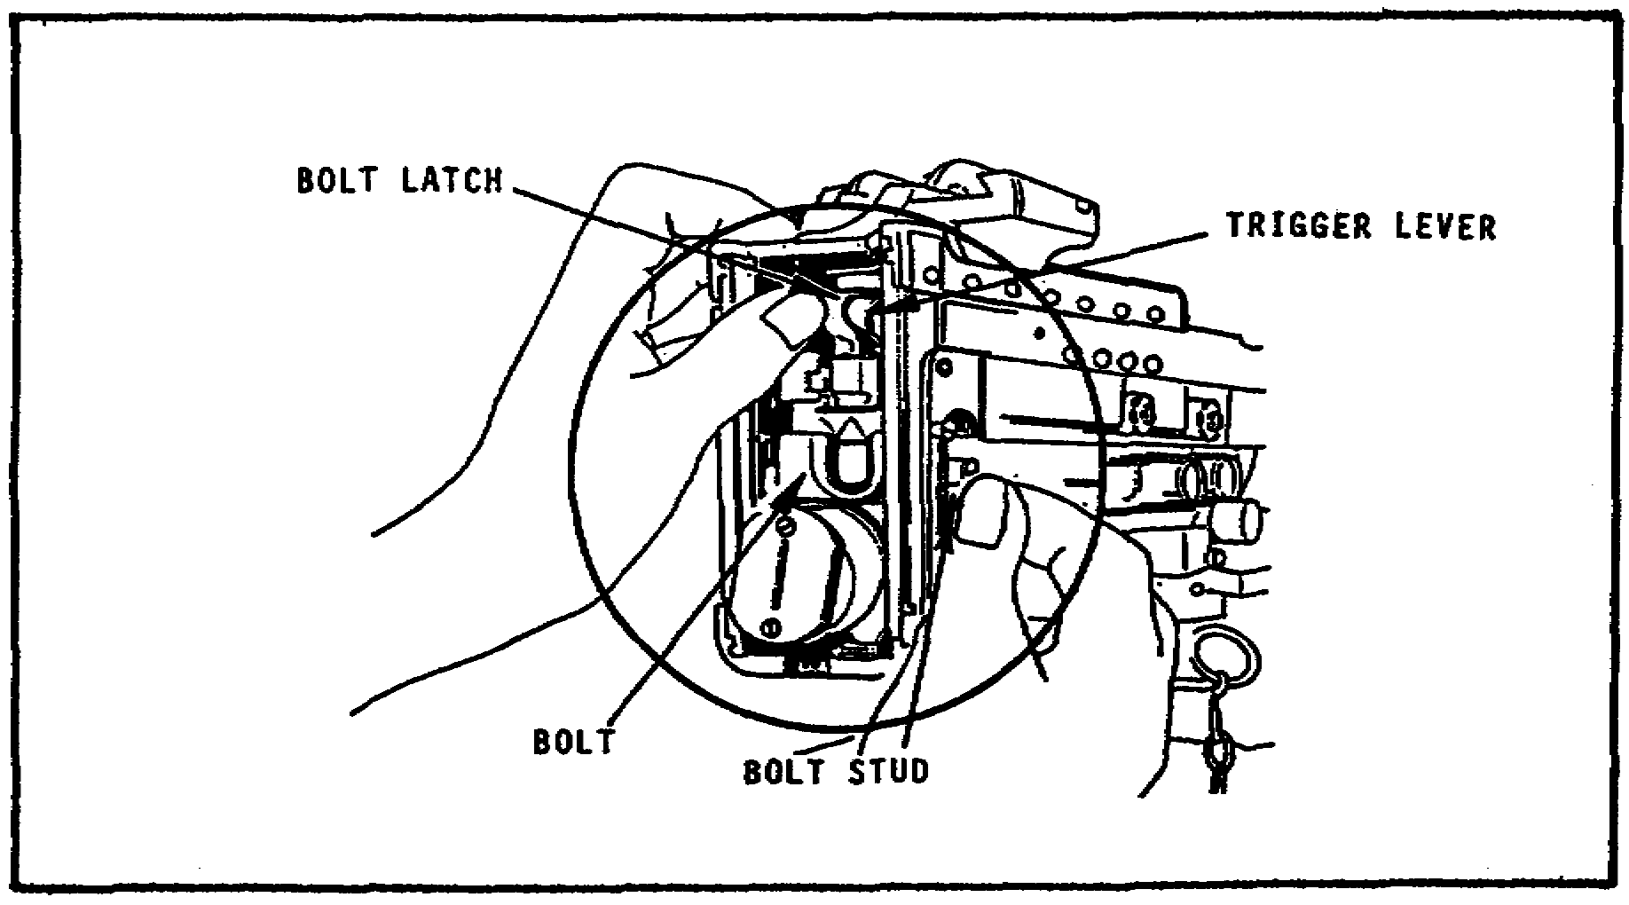

FIGURE 9. FREEING THE BOLT.

(e) Bolt Group. After freeing the bolt, slide it to the rear, remove it, and place it on its right side (figure 10).
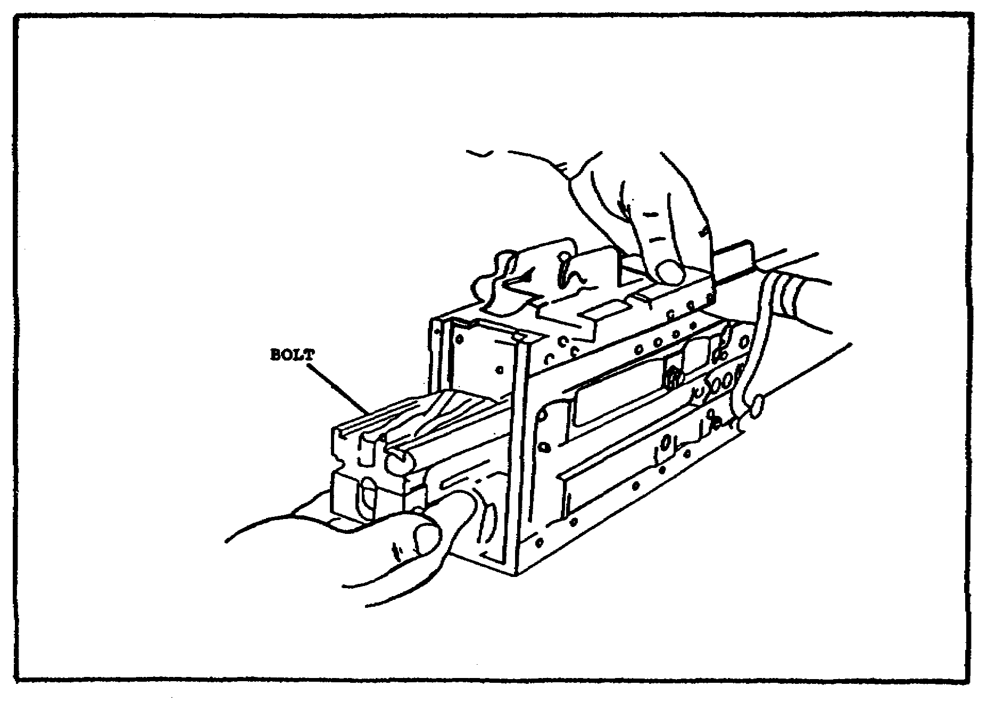

FIGURE 10. RECEIVING THE BOLT FROM
THE RECEIVER.

16

M2 MACHINEGUN MAINTENANCE - OD1503 - LESSON 1/TASK 1

(f) Barrel Buffer and Barrel Extension Groups. Insert a pointed instrument through the hole in the lower rear corner of the right sideplate and push in on the barrel buffer body lock. With one hand in the receiver, push the barrel extension group and barrel buffer group to the rear (figure 11) and remove.
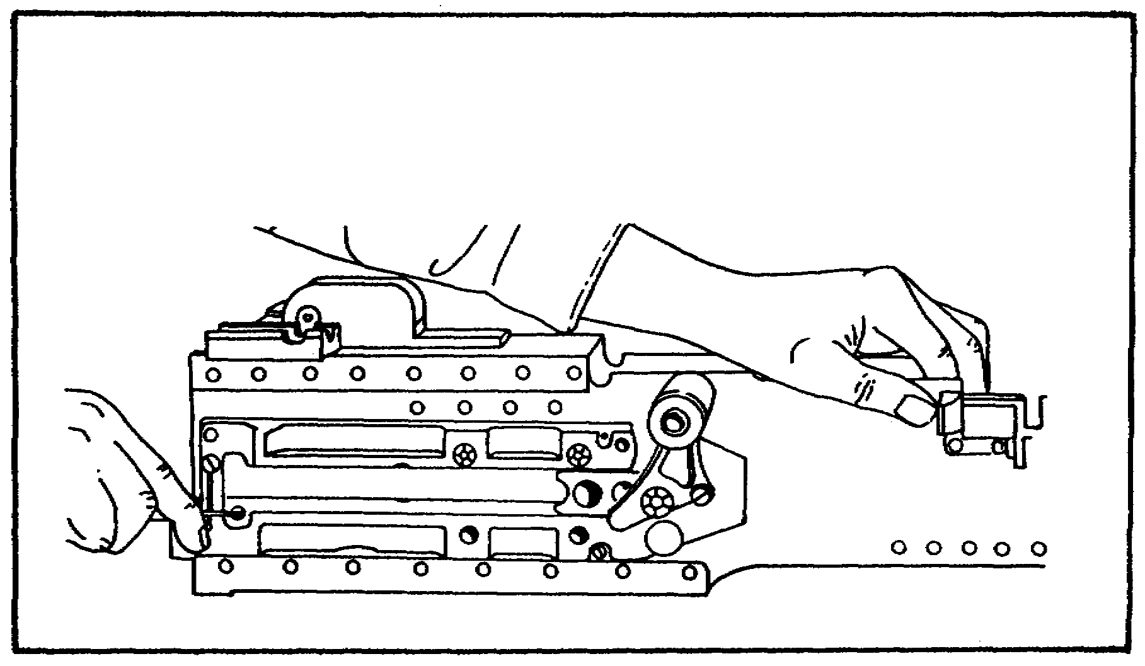

FIGURE 11. REMOVING THE BARREL BUFFER
GROUP AND BARREL EXTENSION
GROUP.

Push the tips of the accelerator forward to separate them (figure 12).
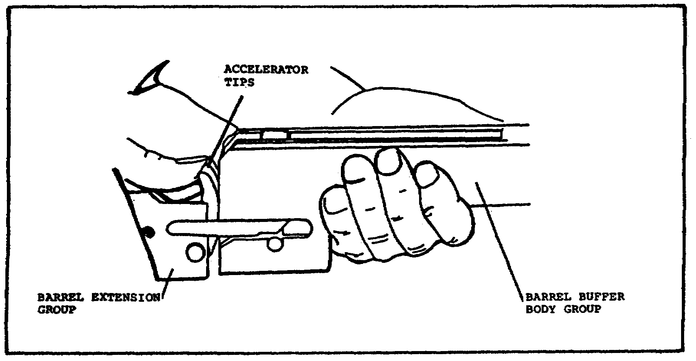

FIGURE 12. SEPARATING THE GROUPS.

17

M2 MACHINEGUN MAINTENANCE - OD1503 - LESSON 1/TASK 1

(g) Barrel Buffer Assembly. Pull the barrel buffer assembly from the rear of the barrel buffer body group (figure 13). The barrel buffer assembly will not be disassembled any further.
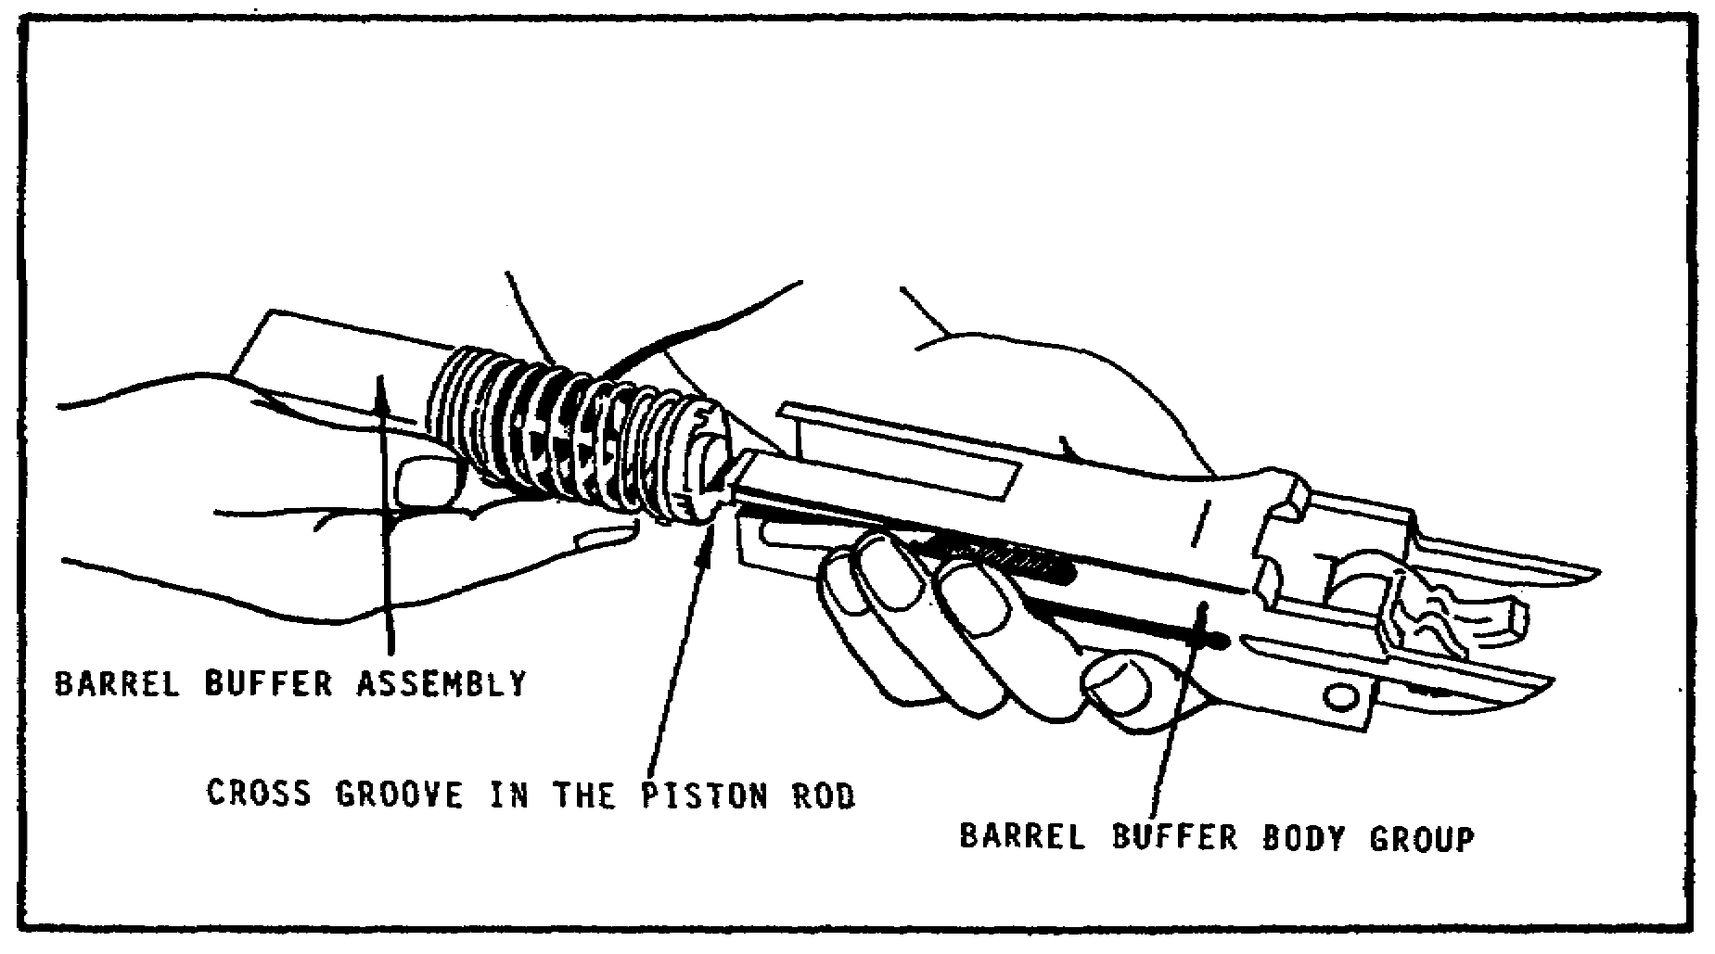

FIGURE 13. SEPARATING THE BARREL BUFFER
ASSEMBLY FROM THE BARREL
BUFFER BODY GROUP.

(2) Detailed Disassembly. Once the weapon has been field stripped, using the procedures contained in paragraphs 4a(1)(a) through 4a(1)(g), on pages 10-18, begin the detailed disassembly of the major components and assemblies. These procedures are contained in the following paragraphs:

(a) Bolt Group. First, rotate the extractor upward, (figure 14 on the following page) and remove it from the bolt, freeing the bolt switch. The ejector and ejector spring are not disassembled from the extractor.

Now, lift out the bolt switch and pull out the bolt switch stud (figure 15 on the following page). On some models the bolt stud may be staked. If staked, do not remove.

Next, rotate the top of the cocking lever toward the rear of the bolt and remove the cocking lever pin; then, lift out the cocking lever. The rounded nose of the cocking lever is down and to the rear of the bolt (figure 16 on page 20).

18

M2 MACHINEGUN MAINTENANCE - OD1503 - LESSON 1/TASK 1

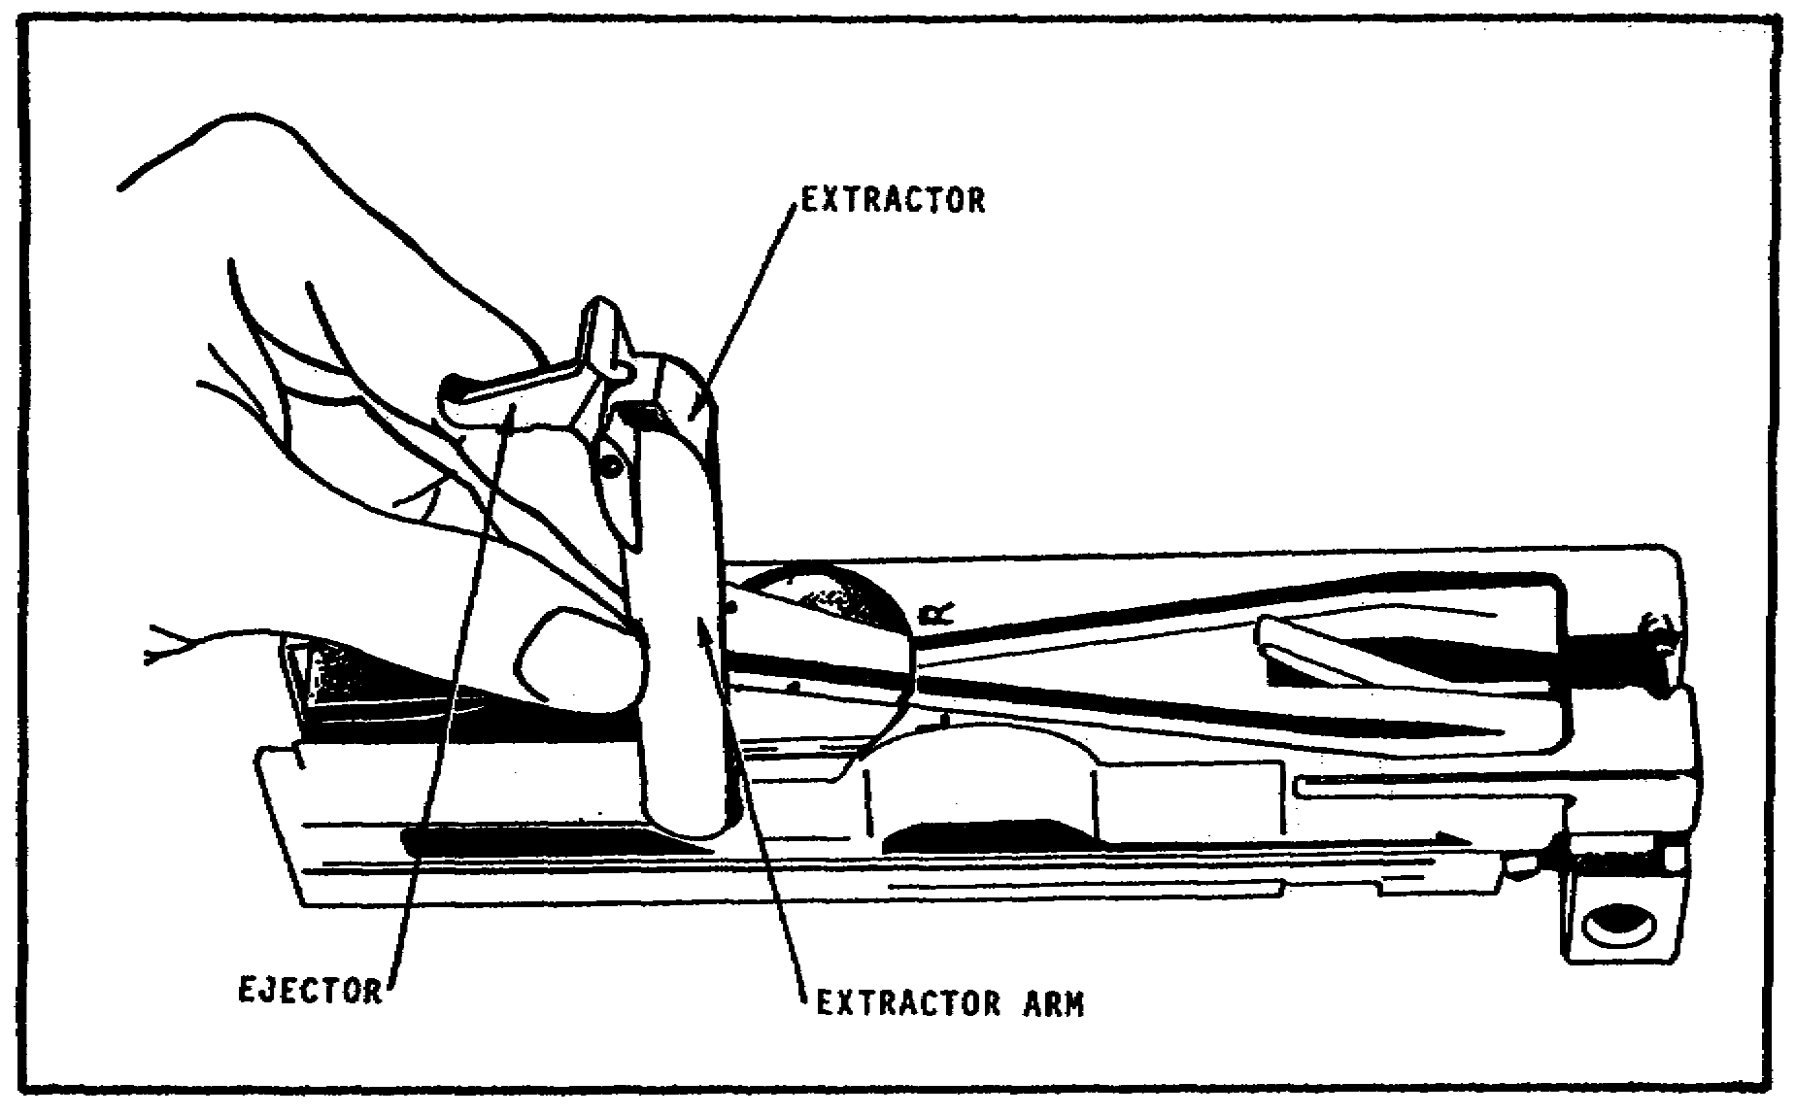

FIGURE 14. REMOVING THE EXTRACTOR.

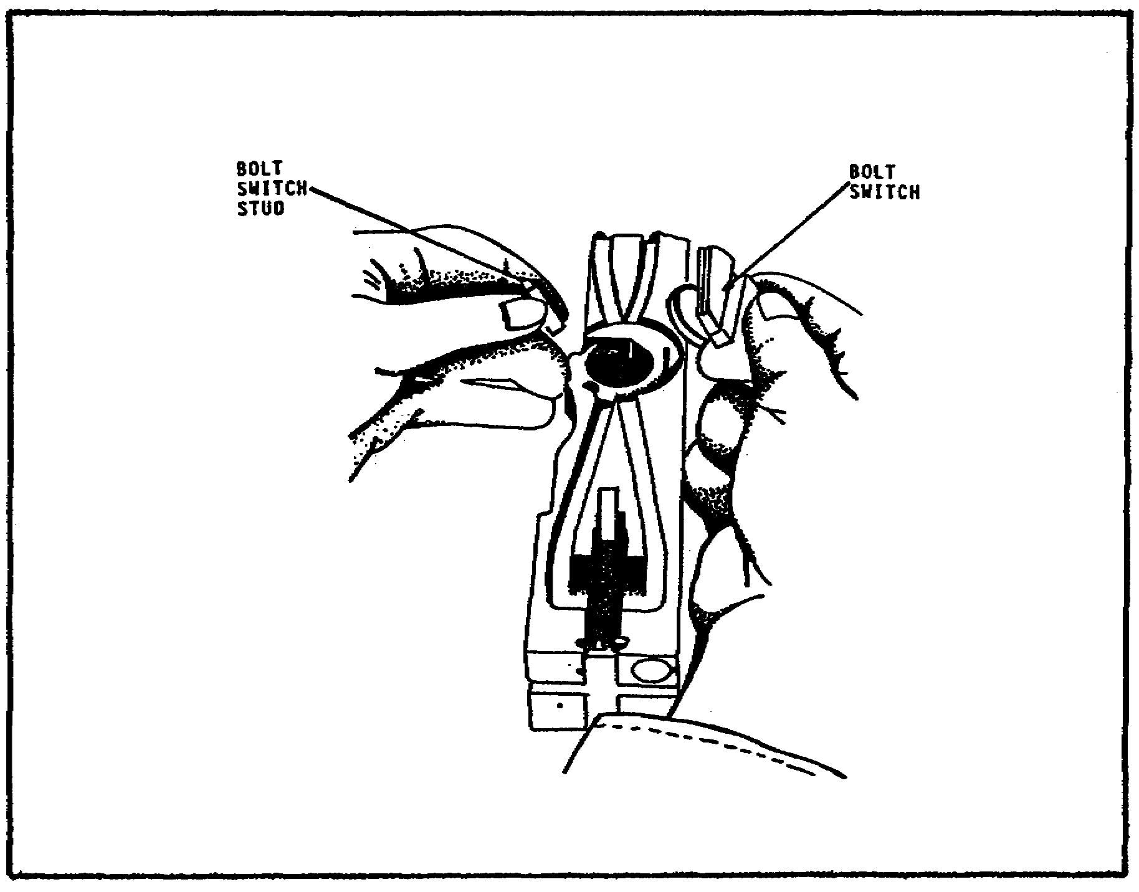
FIGURE 15. REMOVING THE BOLT SWITCH
AND BOLT SWITCH STUD.

19

M2 MACHINEGUN MAINTENANCE - OD1503 - LESSON 1/TASK 1

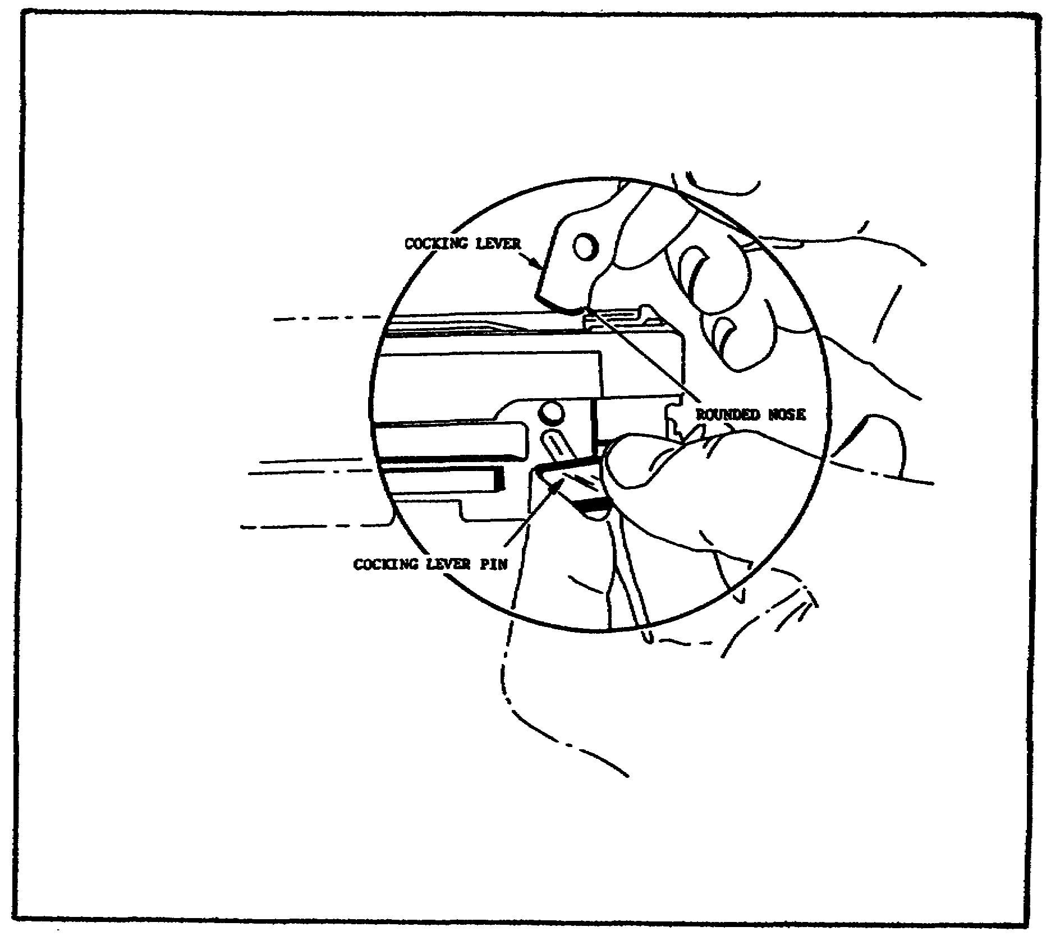
FIGURE 16. REMOVING THE COCKING LEVER
AND COCKING LEVER PIN.

Use the thin end of the cocking lever to pry the sear stop, called the accelerator stop lock, out of its groove in the bolt, and into the center recess (figure 17 on the following page). Turn the bolt over and drift the sear stop pin free from engagement with the firing pin spring and then shake out the accelerator stop lock (figure 18 on the following page). Now, turn the bolt over and lift the sear stop and pin from the bolt, then drift out the accelerator stop (figure 19 on page 22). If the pin does not come out freely, place the thin end of the cocking lever under the sear stop, against the pin, and pry it out of the bolt.

20

M2 MACHINEGUN MAINTENANCE - OD1503 - LESSON 1/TASK 1

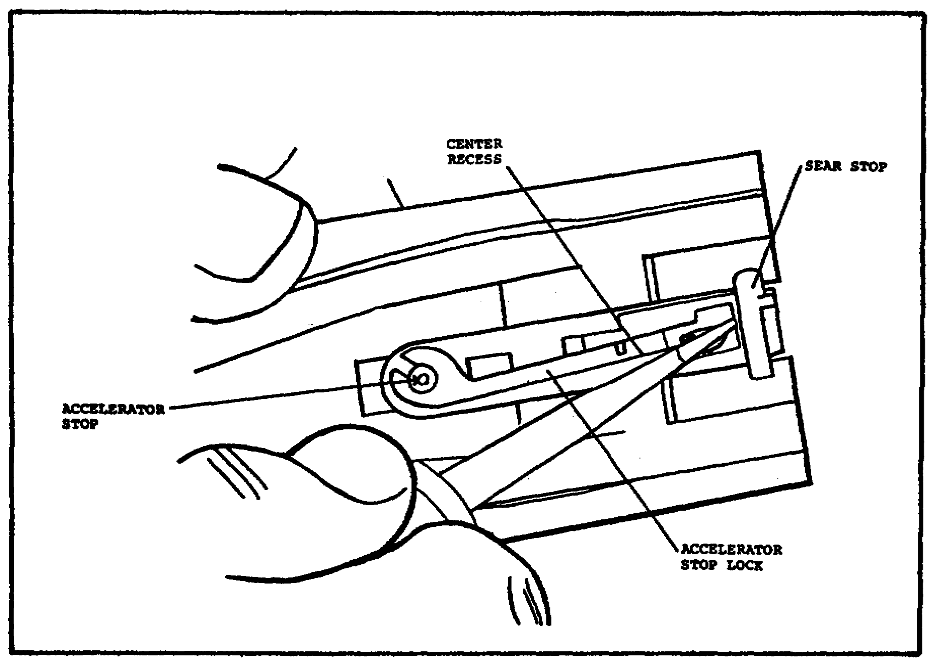

FIGURE 17. PRYING THE ACCELERATOR STOP
LOCK INTO THE CENTER RECESS.

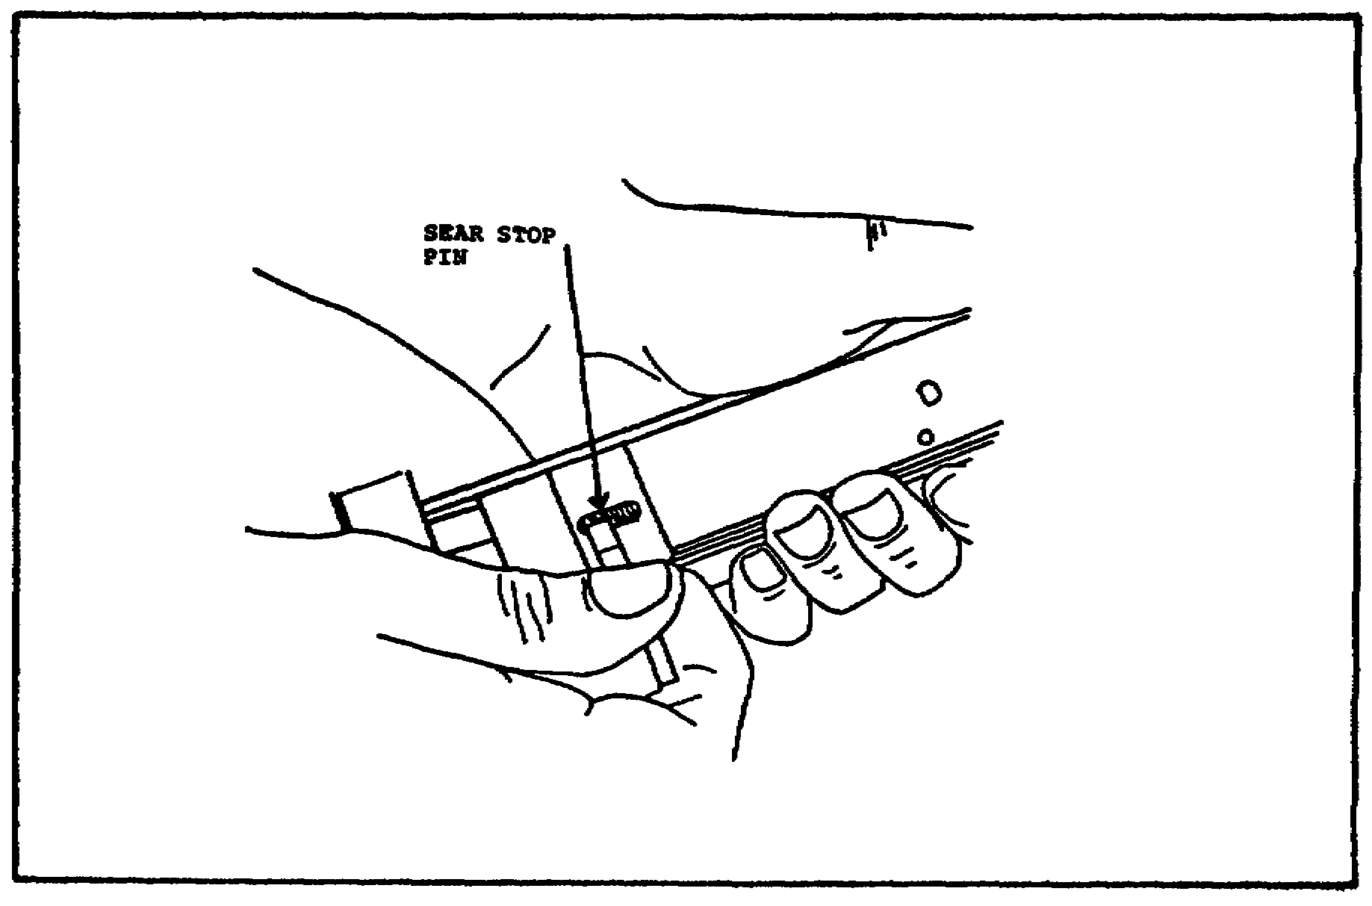

FIGURE 18. DRIFTING THE SEAR STOP PIN.

21

M2 MACHINEGUN MAINTENANCE - OD1503 - LESSON 1/TASK 1

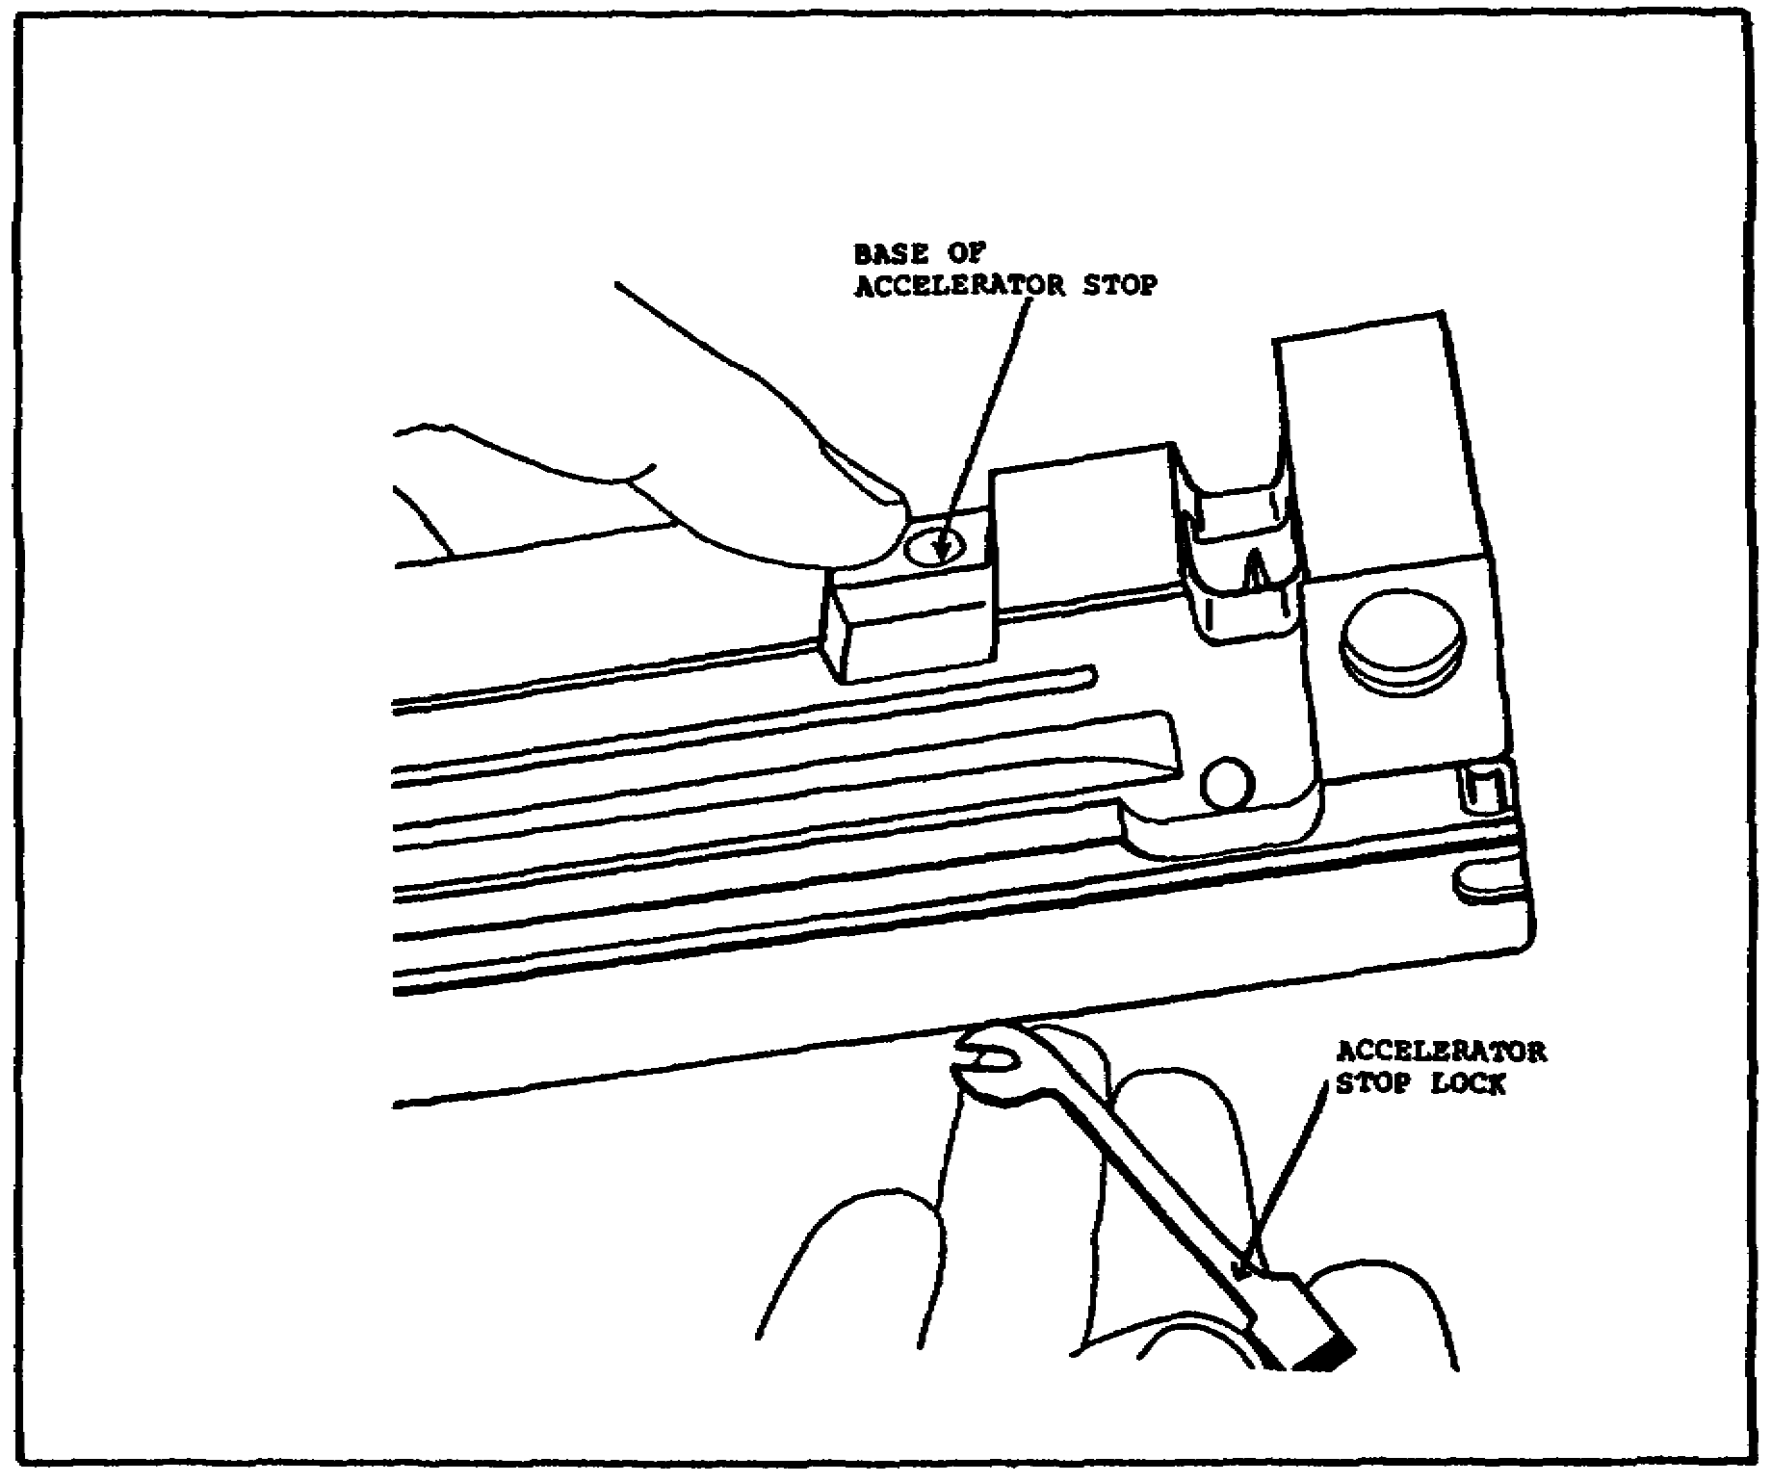

FIGURE 19. REMOVING THE ACCELERATOR
STOP LOCK.

After the accelerator stop lock has been removed, press down on the sear and withdraw the sear slide, withdrawing the square end first (figure 20 on the following page). To prevent loss of the sear spring, insert the thin end of the cocking lever between the coils of the sear spring. Lift out the sear and remove the sear spring. Leave the spring on the cocking lever (figure 21 on the following page).

Now, raise the front end of the bolt and allow the firing pin extension assembly and the firing pin to fall into your hand (figure 22 on page 24) and separate the firing pin from its extension.

This completes the detailed disassembly procedures for the bolt assembly. Figure 23, on page 24, shows the bolt group disassembled.

22

M2 MACHINEGUN MAINTENANCE - OD1503 - LESSON 1/TASK 1

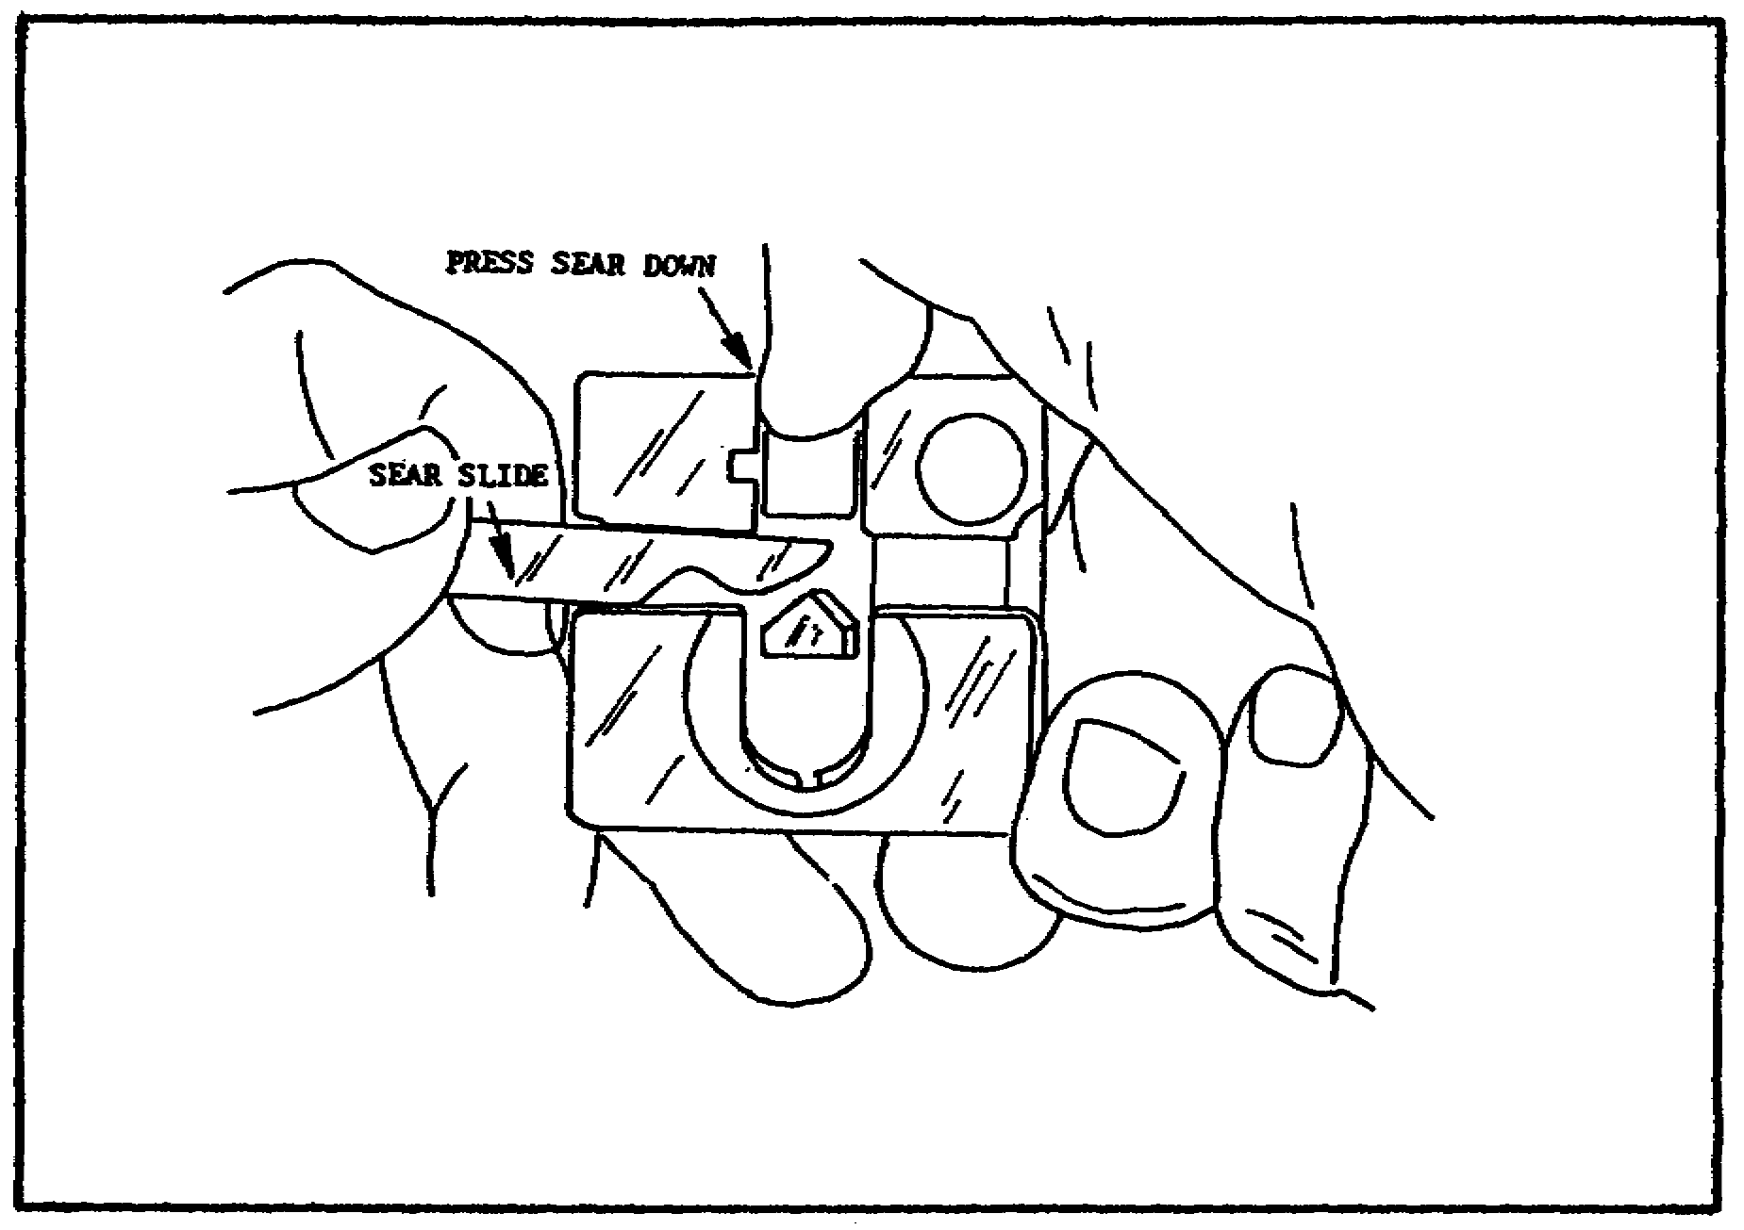

FIGURE 20. REMOVING AND REPLACING
THE SEAR SLIDE.

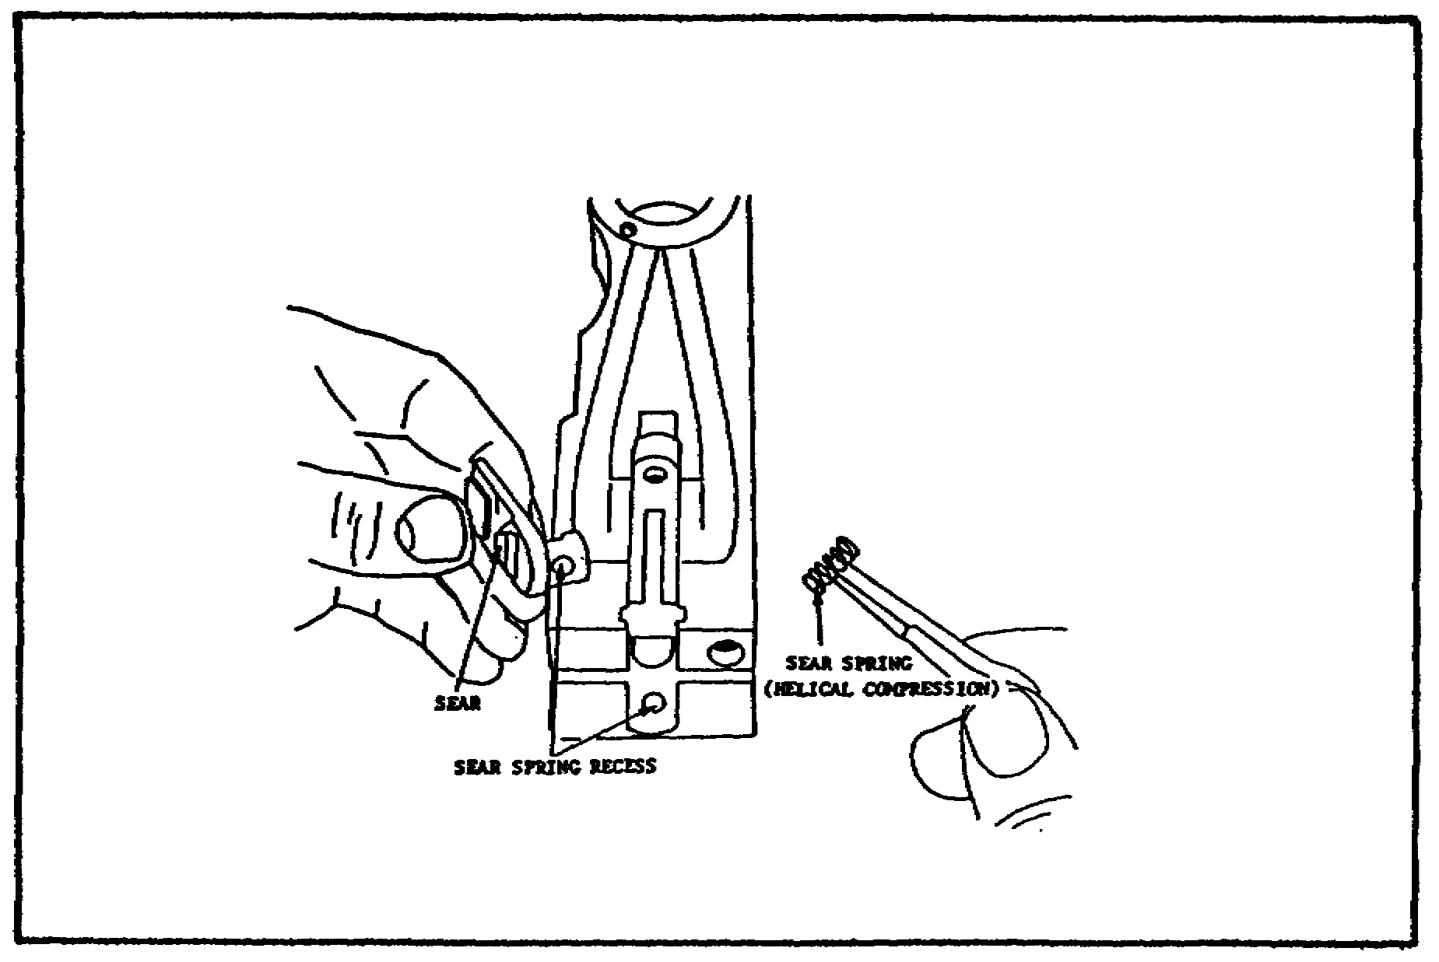

FIGURE 21. REMOVING AND REPLACING THE
SEAR AND SEAR SPRING.

23

M2 MACHINEGUN MAINTENANCE - OD1503 - LESSON 1/TASK 1

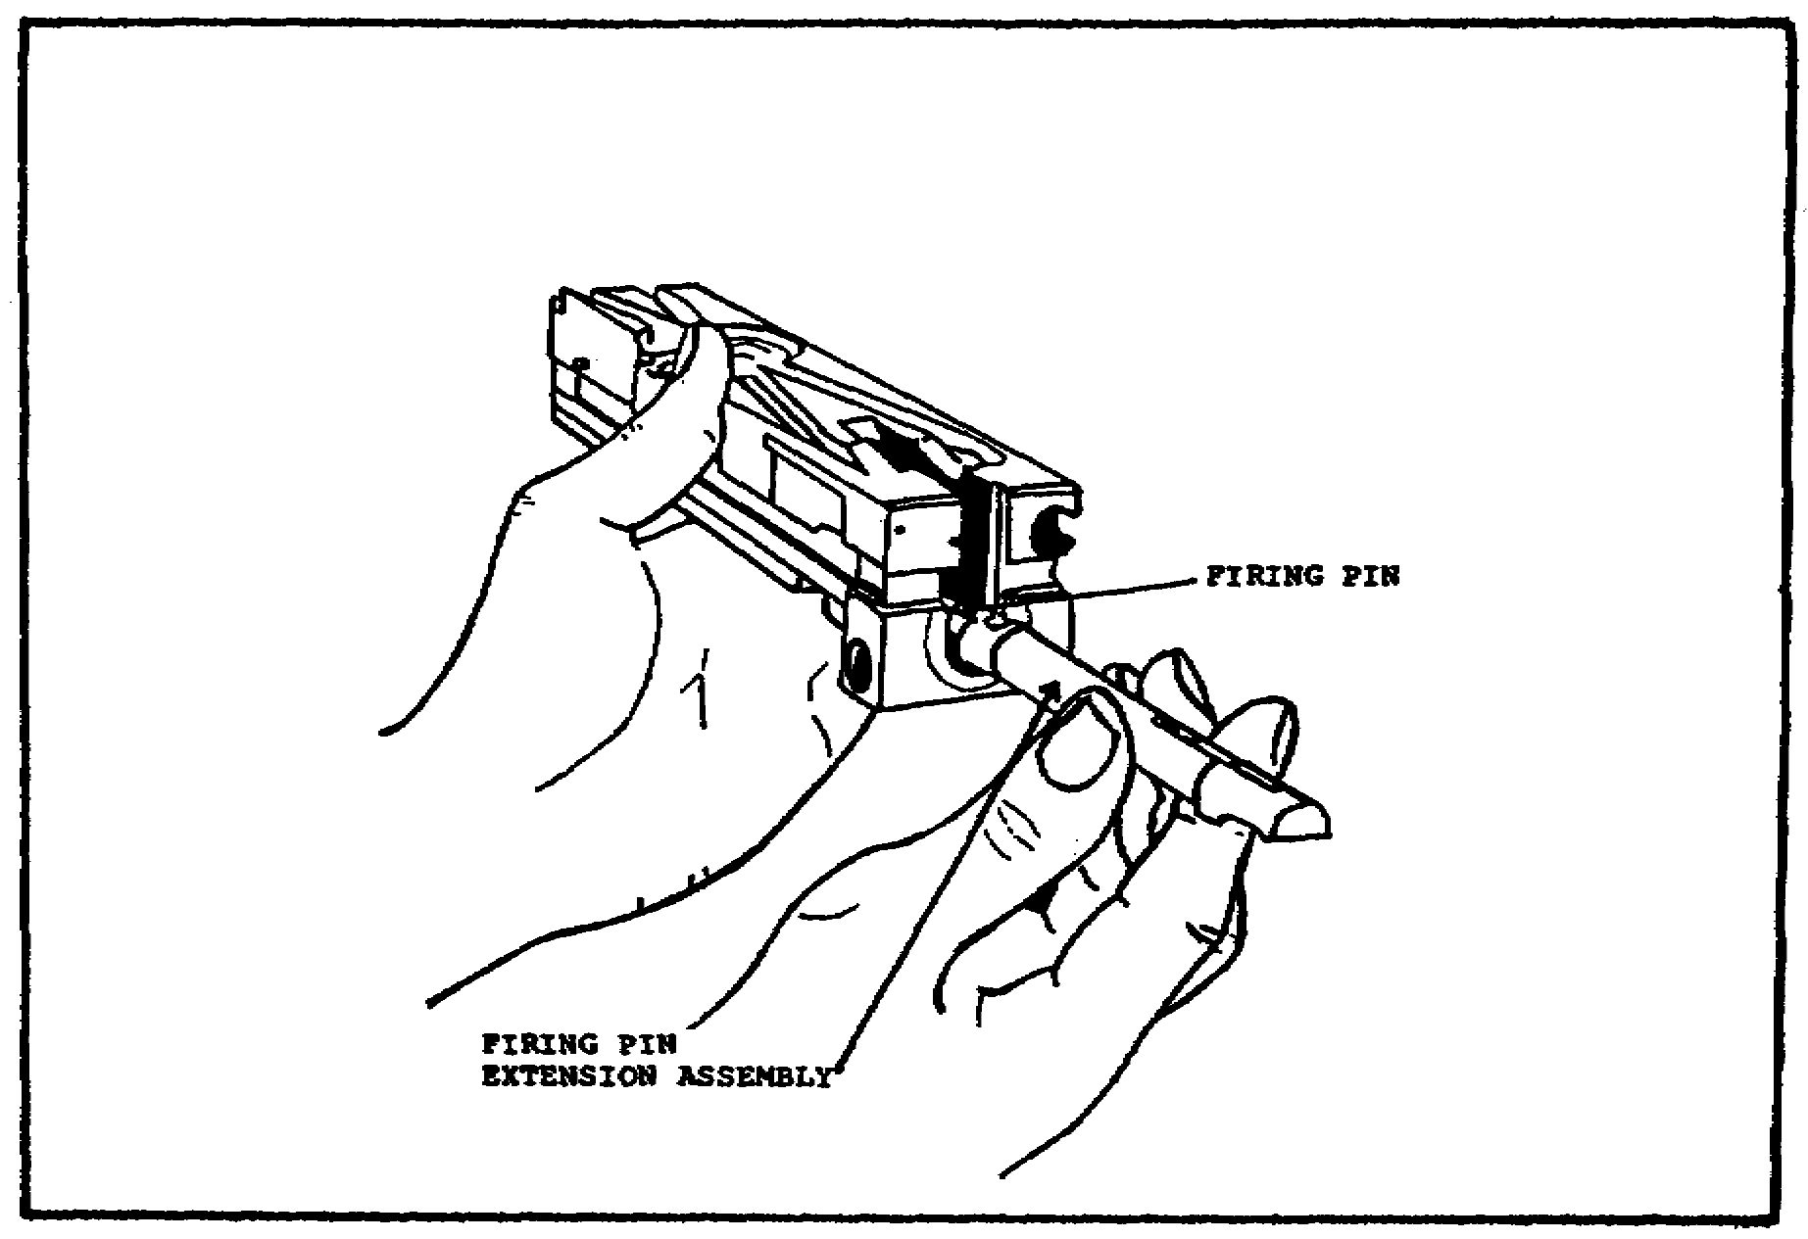

FIGURE 22. REMOVING THE FIRING PIN
EXTENSION ASSEMBLY AND
THE FIRING PIN.

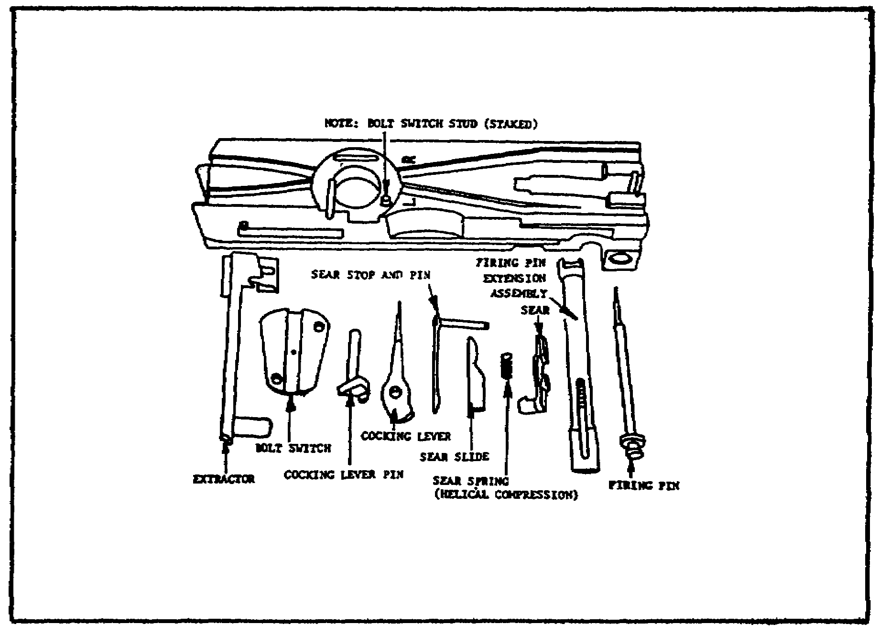
FIGURE 23. BOLT DISASSEMBLED.

24
M2 MACHINEGUN MAINTENANCE - OD1503 - LESSON 1/TASK 1

(b) Barrel Buffer Body Group. Disassemble the barrel buffer group by turning the barrel buffer body group upside down. Pry up on the barrel buffer tube lock latch to disengage the latch before moving the lock body to the rear. Pry up on the latch end of the assembly so that the lug will clear the barrel buffer body. At the same time, press down on the front of the lock body to keep it from springing out (figure 24).
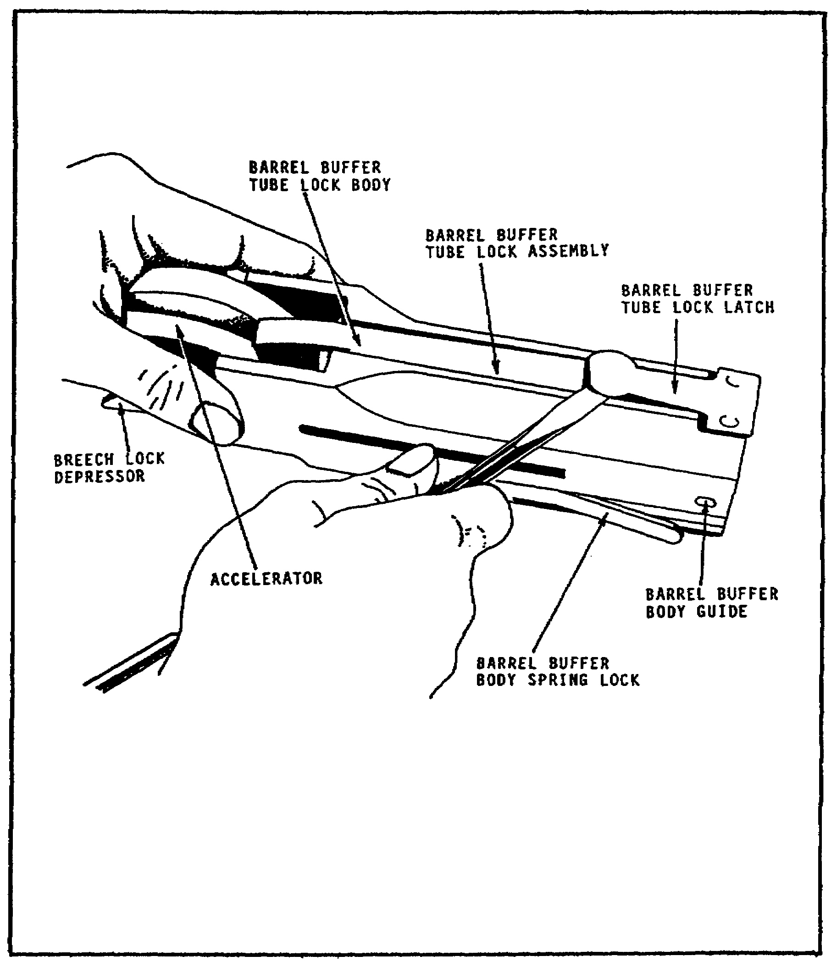

FIGURE 24. DISENGAGING THE LATCH.

25

M2 MACHINEGUN MAINTENANCE - OD1503 - LESSON 1/TASK 1

Turn the accelerator back to push the barrel buffer tube lock assembly out of its slot (figure 25).

In most cases, the barrel buffer body spring lock is staked and will not be removed.

Drift the accelerator pin out and remove the accelerator.
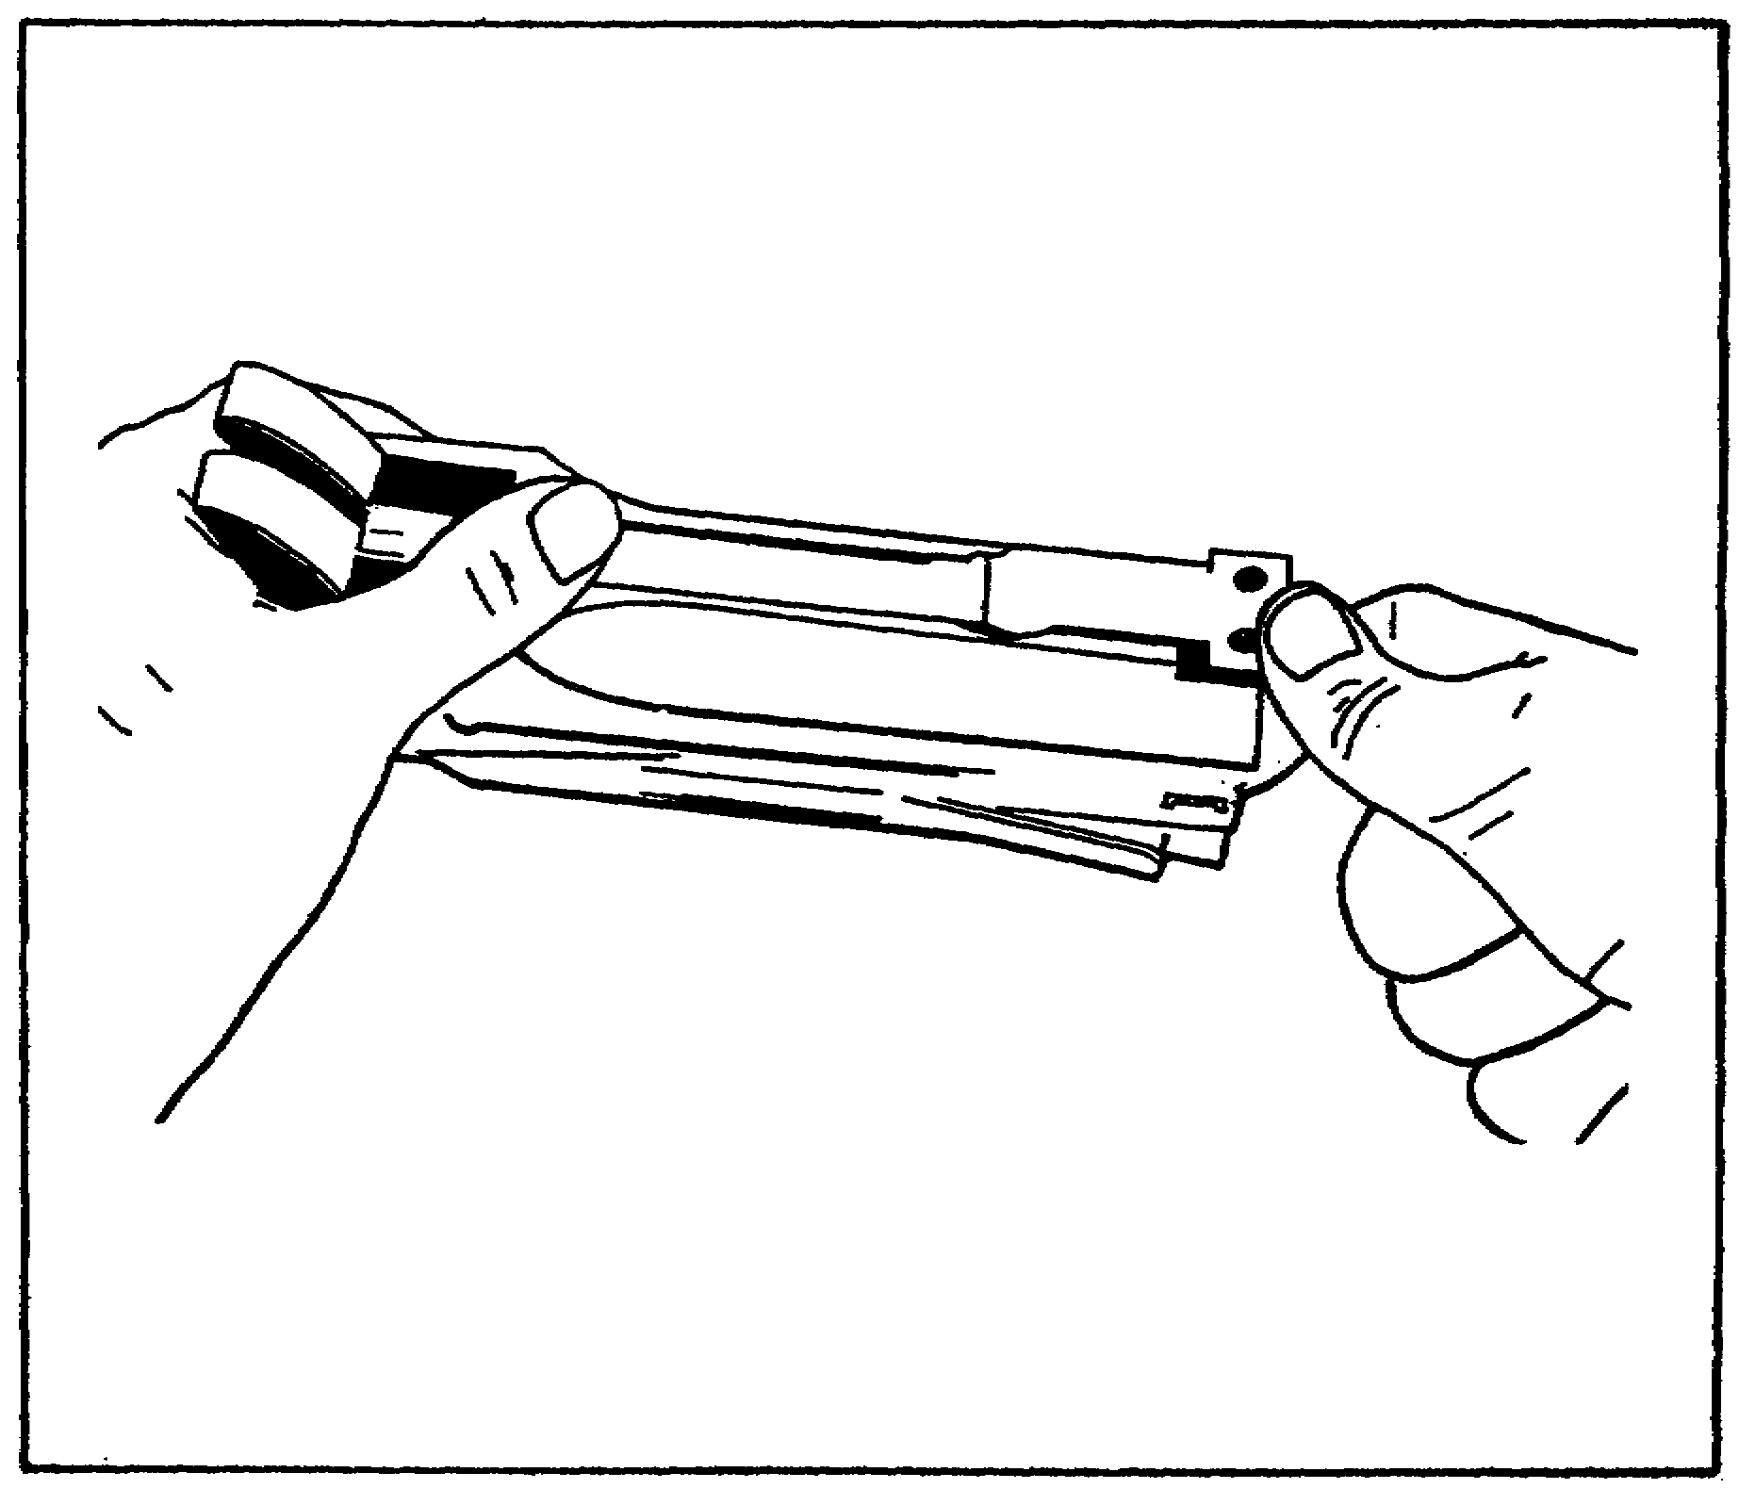

FIGURE 25. REMOVING THE BARREL BUFFER
TUBE LOCK ASSEMBLY.

(c) Barrel Extension Group. First, drift the lockpin out and remove the breech lock from the bottom of the barrel extension group. The top of the breech lock may have a wide, single-beveled edge, or a double-beveled edge. In earlier models, the top may be flat (figure 26 on the next page); newer models may have a large slot (figure 27 on the following page). Guns currently manufactured have the breech lock with the slot on top, for use
26

M2 MACHINEGUN MAINTENANCE - OD1503 - LESSON 1/TASK 1

with the accelerator stop and lock. When the accelerator stop and lock replaces the sear stop and pin, the breech lock with the slot will be used.
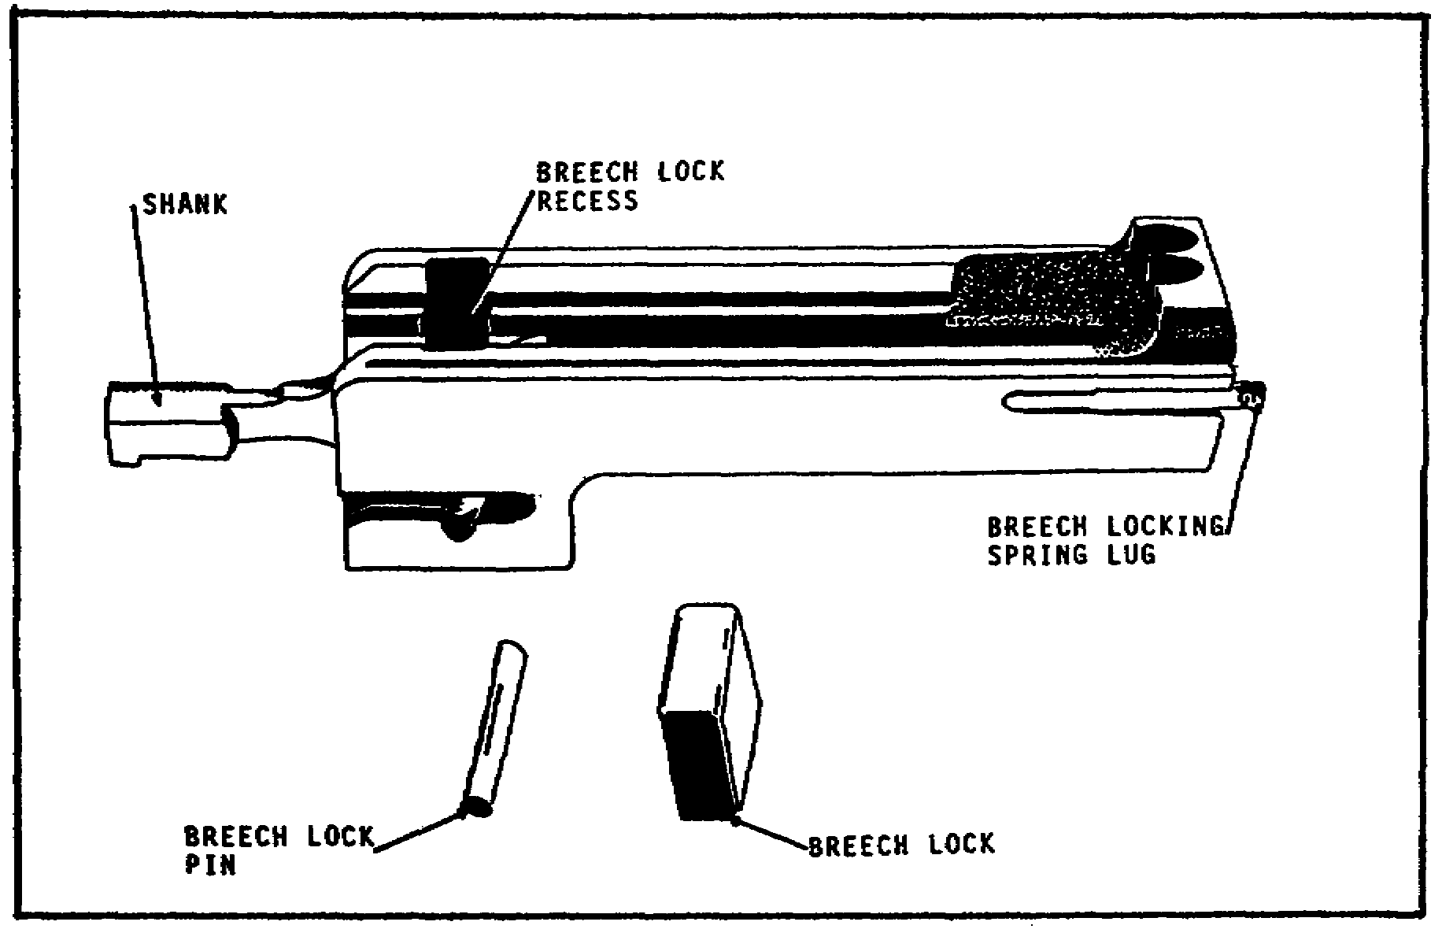

FIGURE 26. OLD TYPE BREECH LOCK.

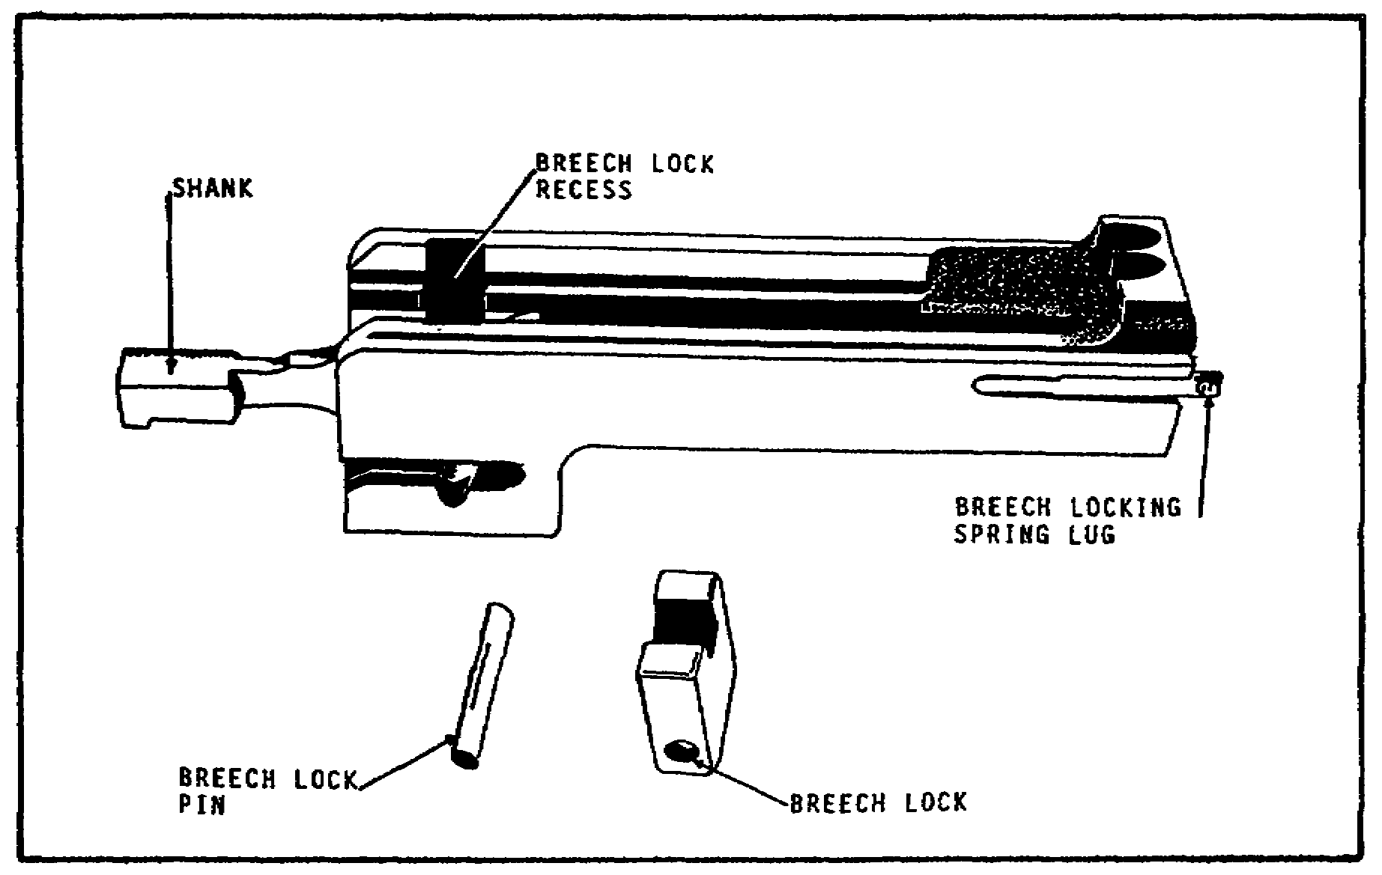

FIGURE 27. NEW TYPE BREECH LOCK.

27
M2 MACHINEGUN MAINTENANCE - OD1503 - LESSON 1/TASK 1

(d) Cover Group. With the cover closed, remove the cotter pin and drift the cover pin out of the receiver. Unlatch the cover and rotate it up and forward to remove the cover from the trunnion block (figure 28). Place the cover group top down on a flat, sturdy surface, with the latch end to the right and the hinged end toward you.
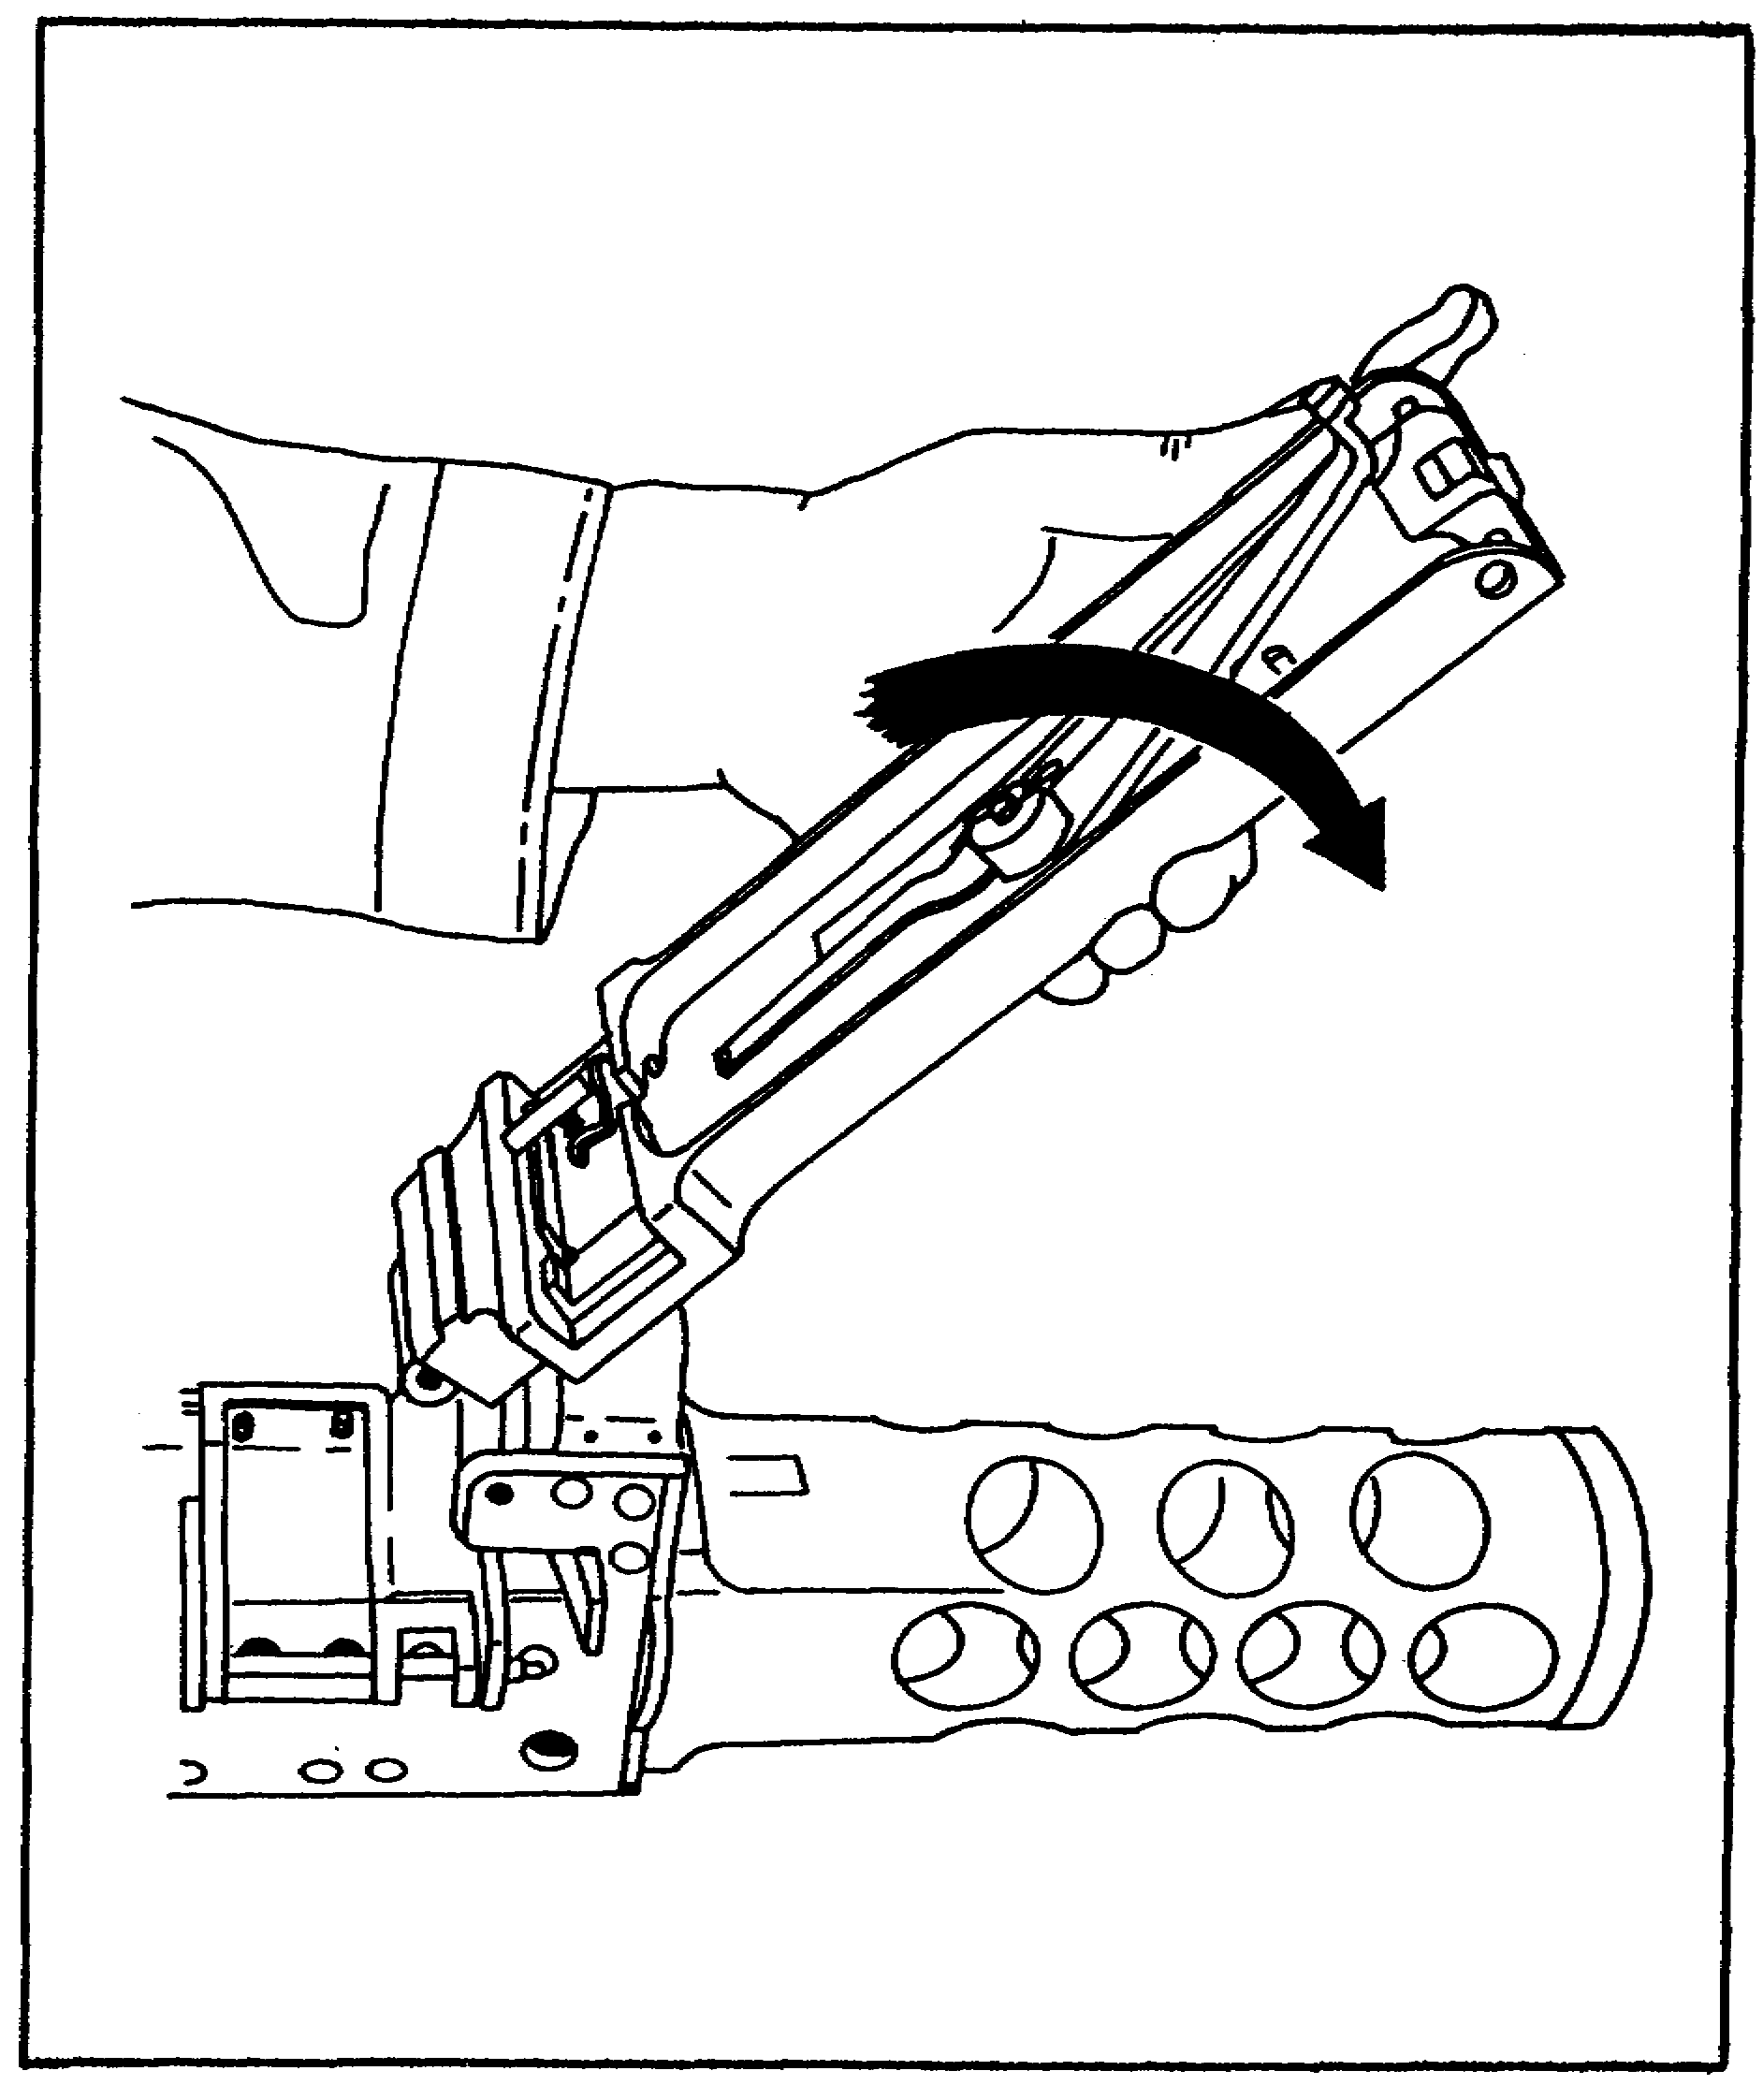

FIGURE 28. REMOVING THE COVER GROUP.

28
M2 MACHINEGUN MAINTENANCE - OD1503 - LESSON 1/TASK 1

Remove the belt feed pin, which is a cotter pin. Push the belt feed lever to the right, until the toe end of the belt feed lever, which engages the slide, is in line with the slot in the cover (figure 29). Lift the belt feed lever off its pivot slot. Ensure the shoulder headless pin and spring do not fly out.
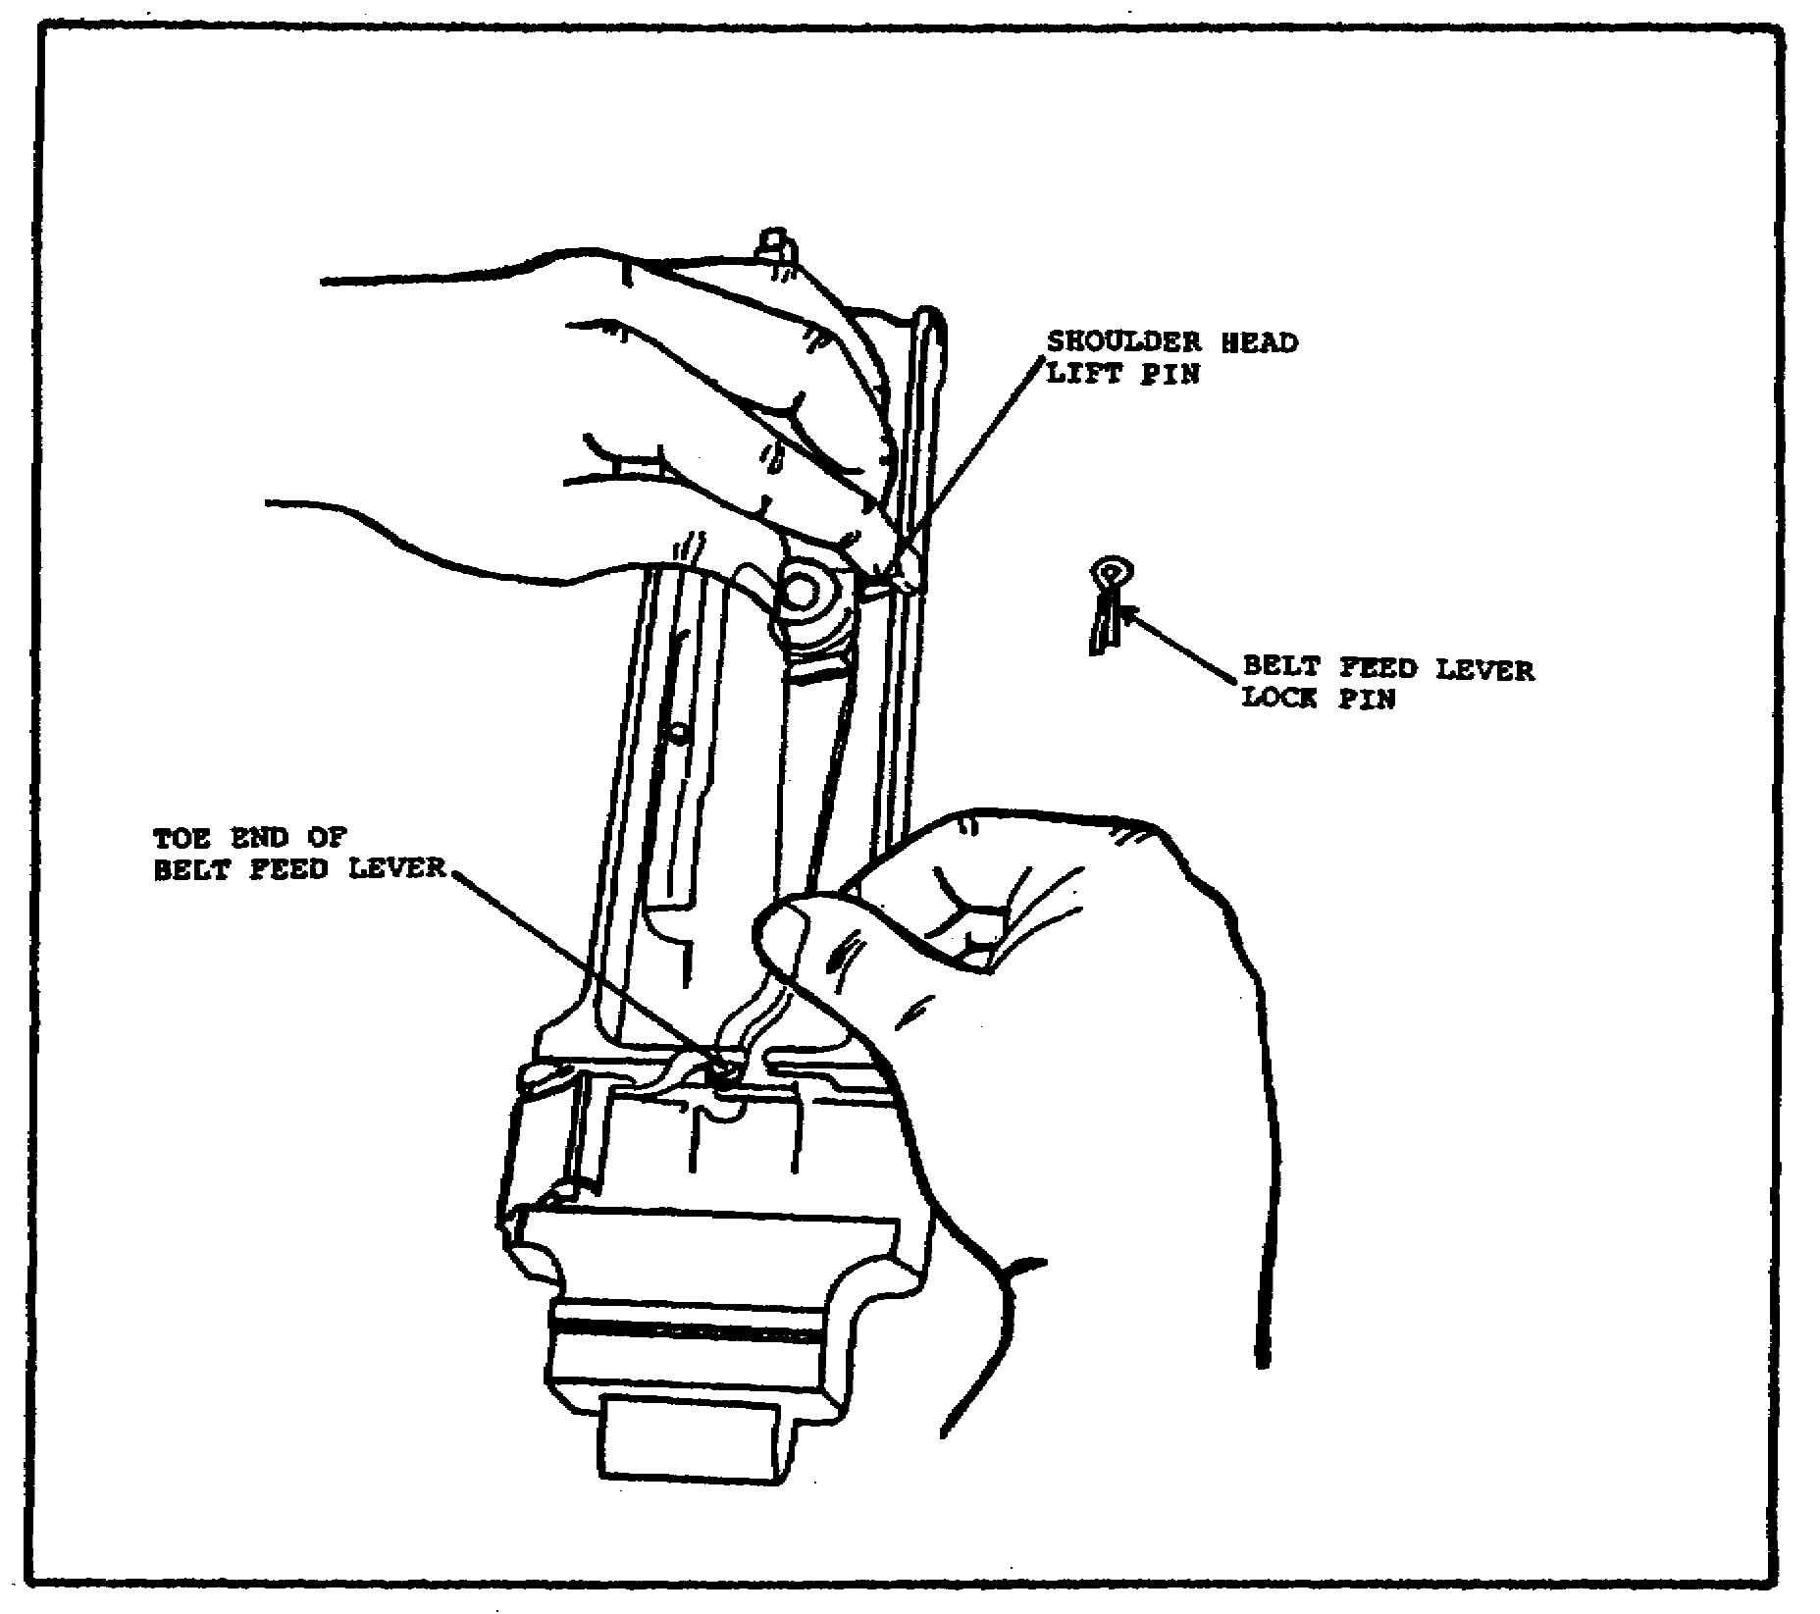

FIGURE 29. REMOVING THE BELT FEED LEVER.

Now, remove the shoulder headless pin and spring from their seat in the side of the belt feed lever (figure 30 on the following page).

Then remove the belt feed slide from either side of the cover group. Drift the belt feed pawl pin out, maintaining pressure on the belt feed pawl to prevent the spring from flying out (figure 31 on the following page).

29

M2 MACHINEGUN MAINTENANCE - OD1503 - LESSON 1/TASK 1

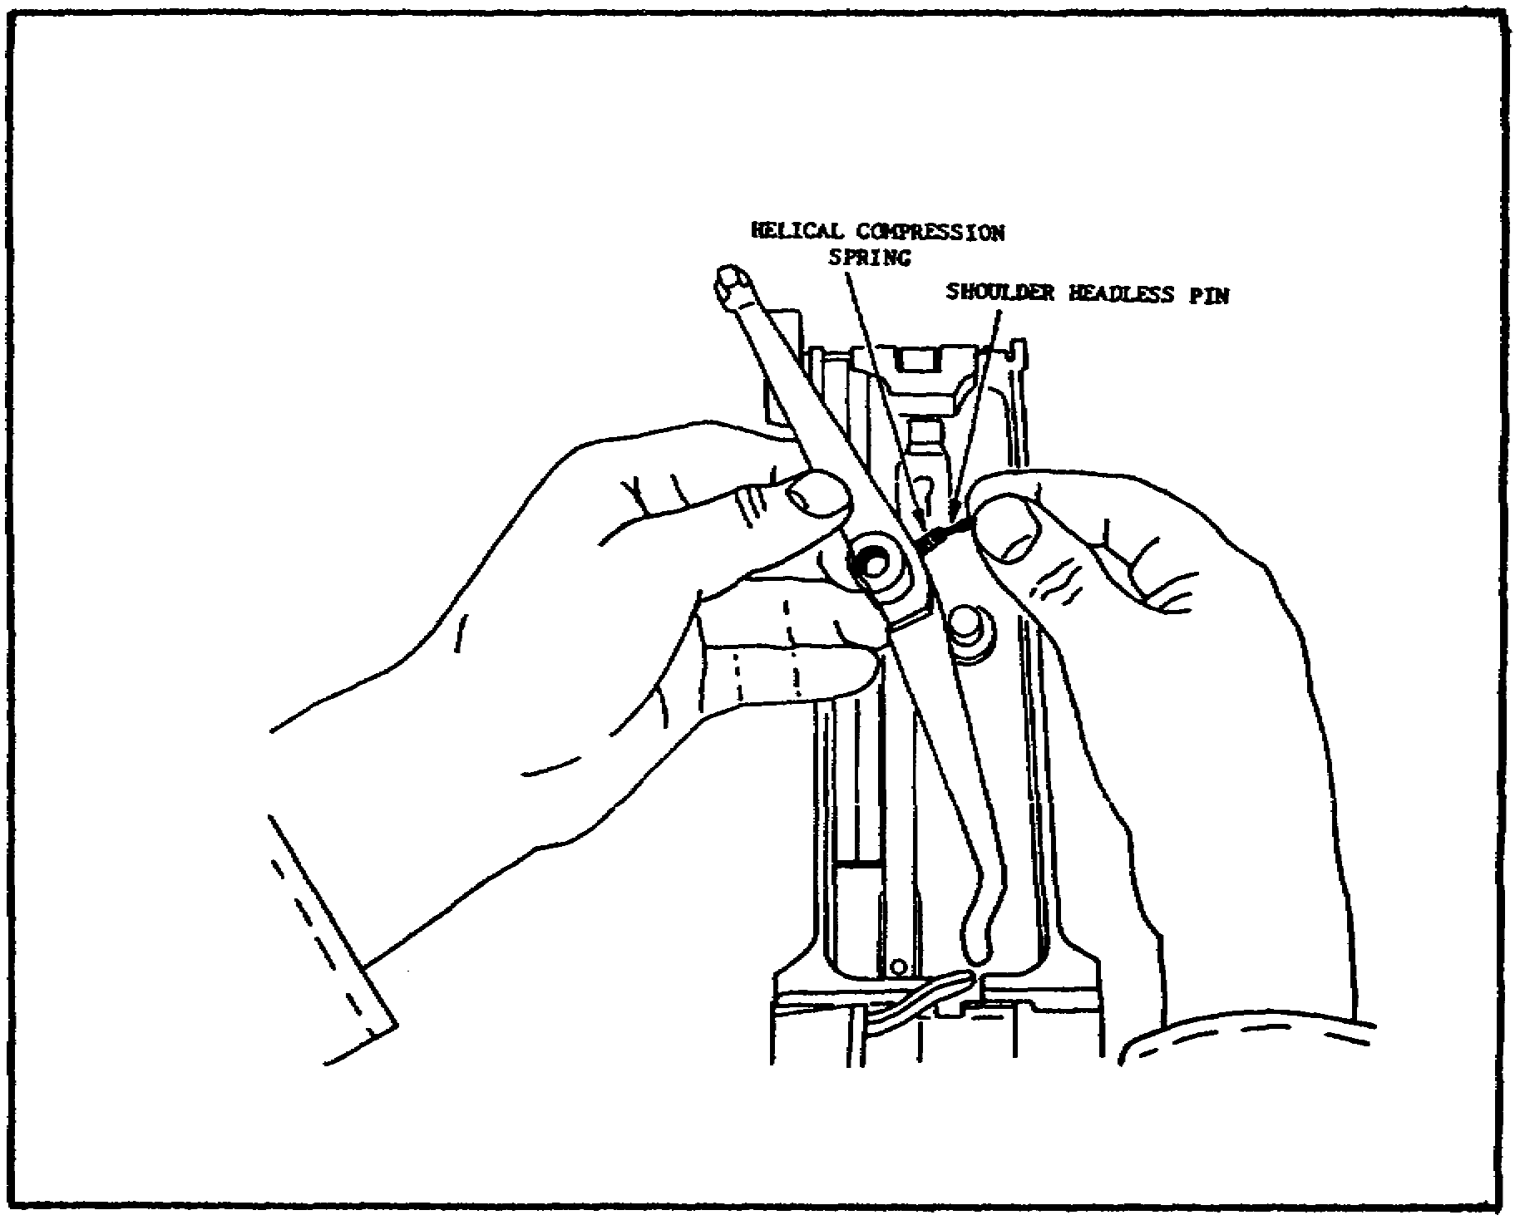

FIGURE 30. REMOVING THE SHOULDER HEADLESS
PIN AND SPRING.

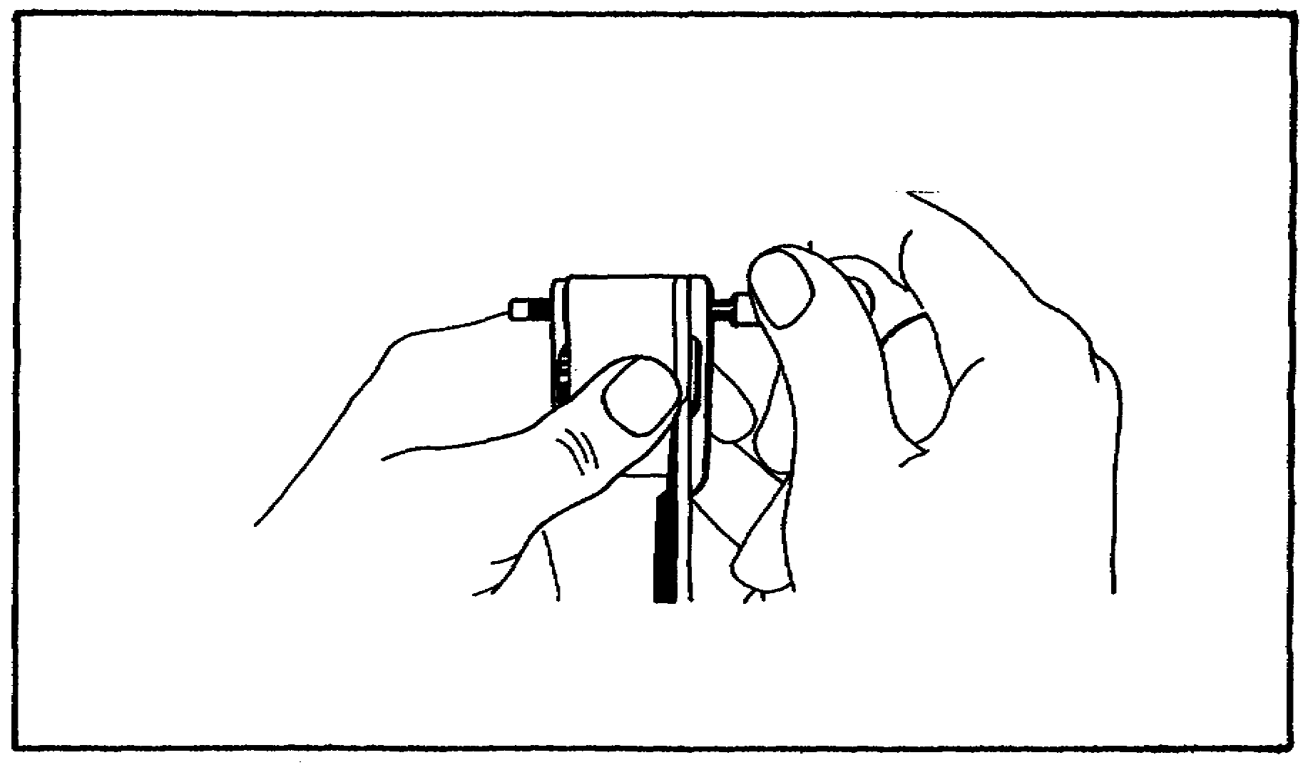

FIGURE 31. REMOVING THE BELT FEED
PAWL PIN.

30

M2 MACHINEGUN MAINTENANCE - OD1503 - LESSON 1/TASK 1

Slowly release the pressure, and remove the belt feed pawl and arm (figure 32).

Disengage the belt feed pawl arm (figure 33).
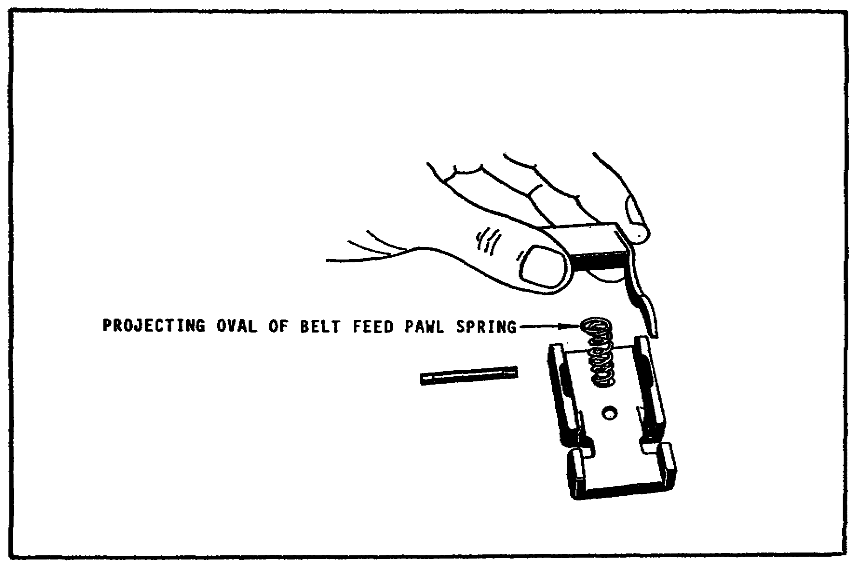

FIGURE 32. REMOVING THE BELT FEED
PAWL AND ARM.

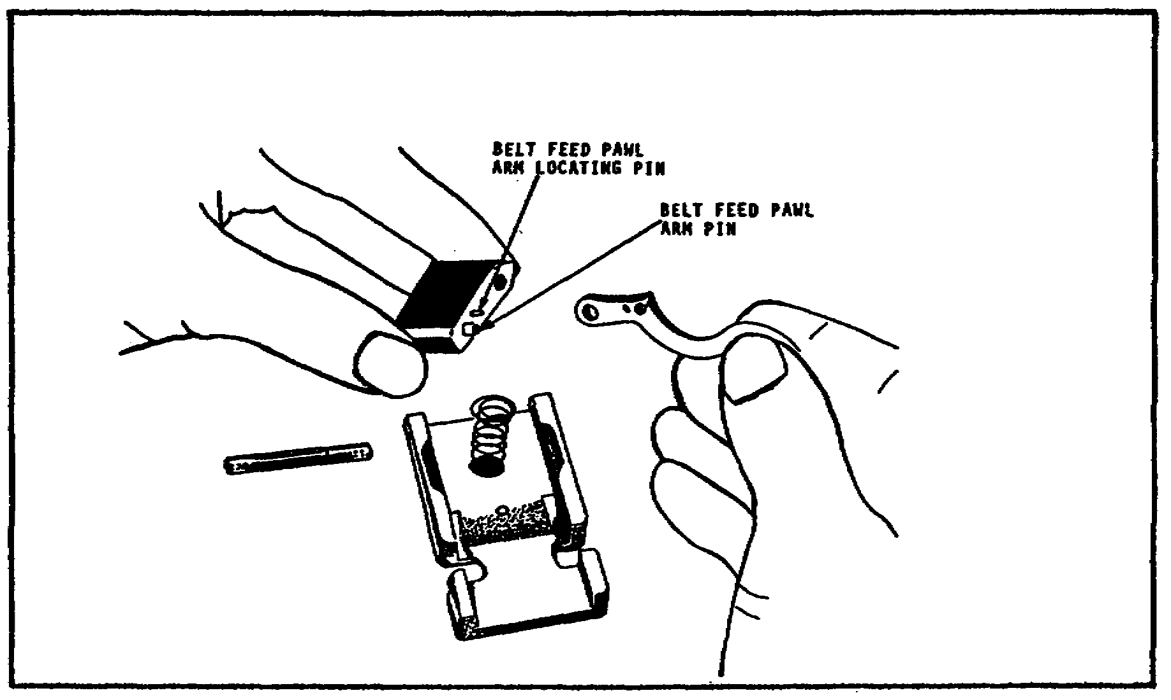

FIGURE 33. DISENGAGING THE BELT
FEED PAWL ARM.

31
M2 MACHINEGUN MAINTENANCE - OD1503 - LESSON 1/TASK 1

Now, remove the belt feed pawl spring. Then, pry the hooked end of the spring out of its groove in the cover, and shift it to the left until it rests on the cover extractor spring. Press down on the cover latch spring, and slide it away from the cover latch. Make sure that it rides on top of the cover extractor spring. When the enlarged hole in the spring meshes with the cover latch spring stud, remove the spring from its stud (figure 34).
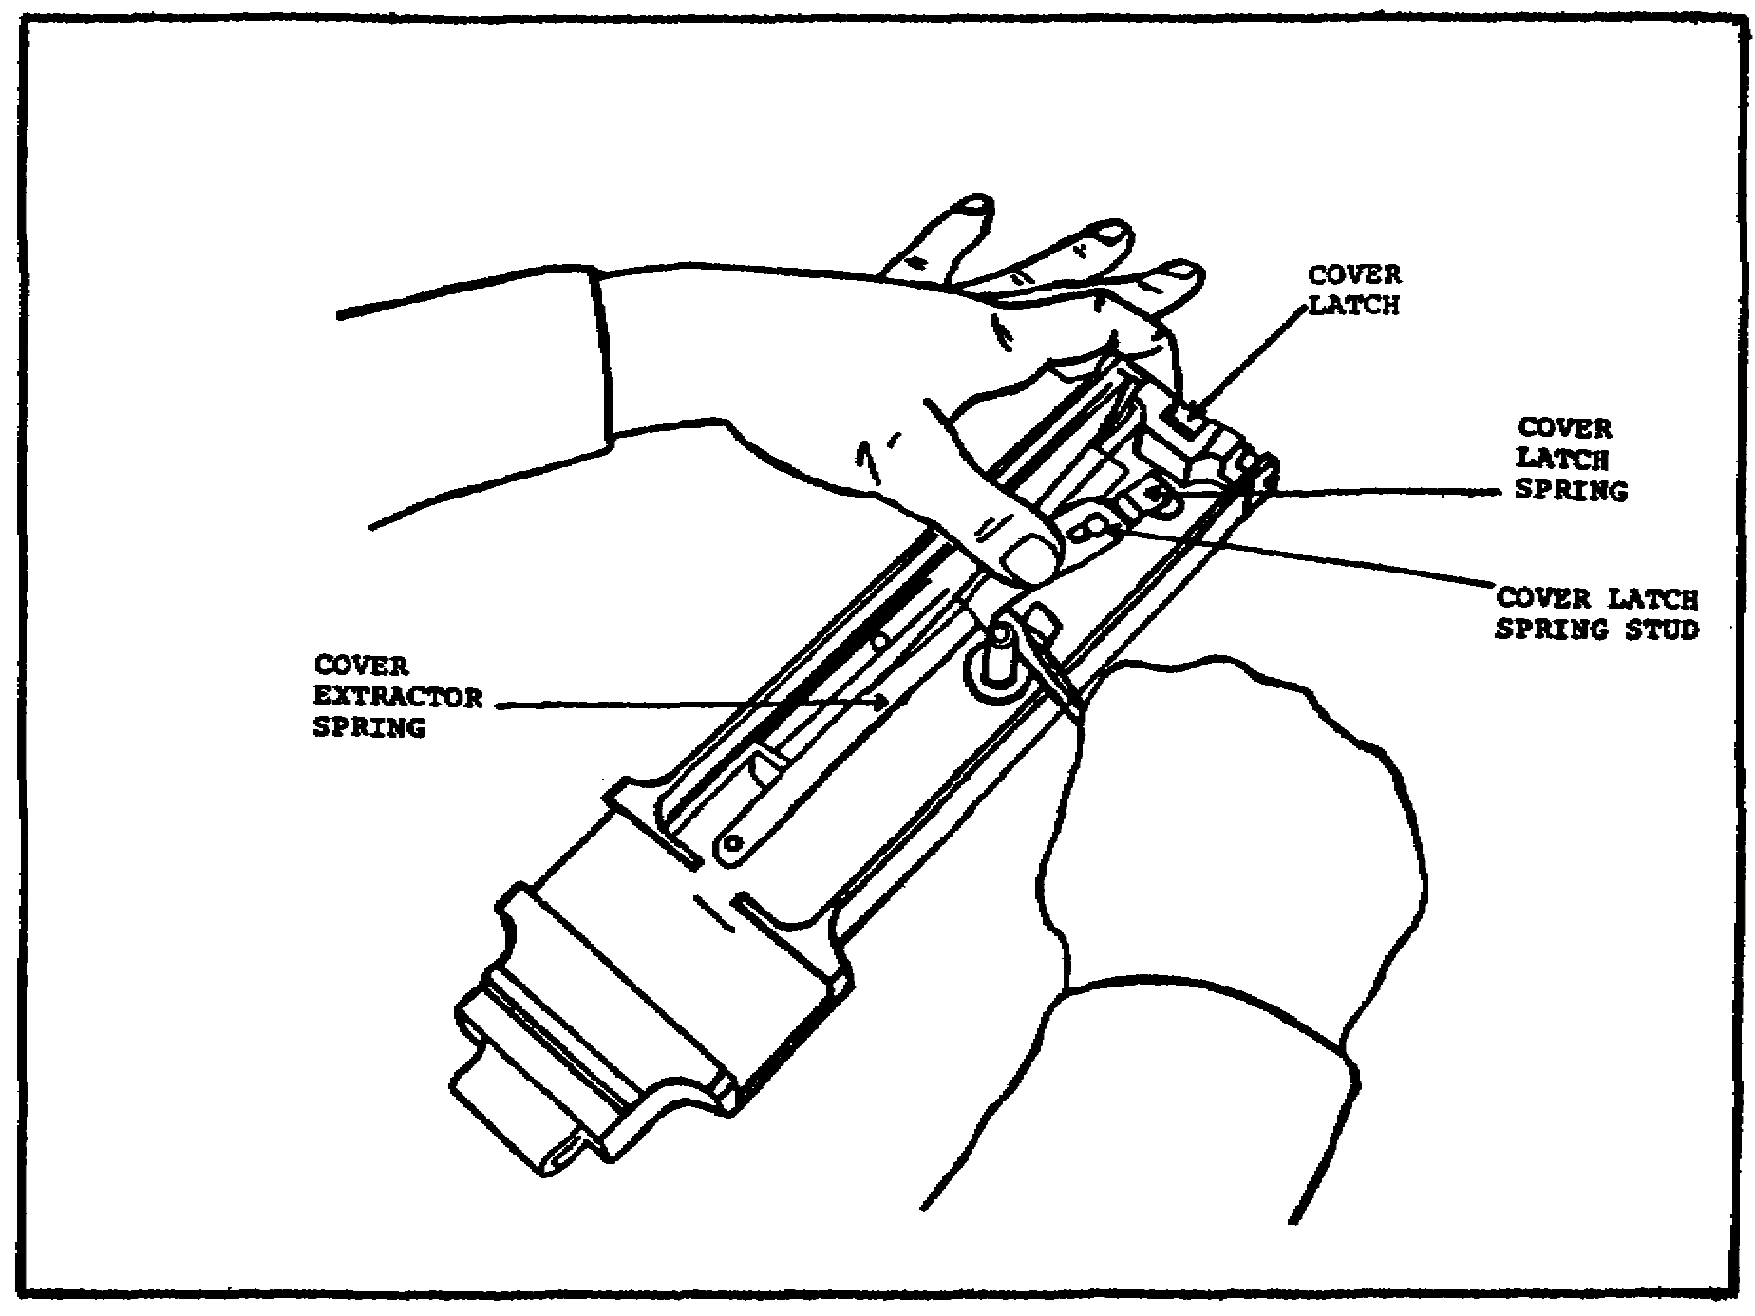

FIGURE 34. REMOVING THE COVER LATCH SPRING.

Press down on the cover extractor spring and pry the end of the spring out of its recess in the cover extractor cam (figure 35 on the following page). This spring, if not handled carefully, can cause injury. Disengage the opposite end of the spring from the cover extractor spring stud.

This completes the detailed disassembly procedures for the cover group. In the next paragraphs, the detailed disassembly procedures for the receiver group will be discussed.

32

M2 MACHINEGUN MAINTENANCE - OD1503 - LESSON 1/TASK 1

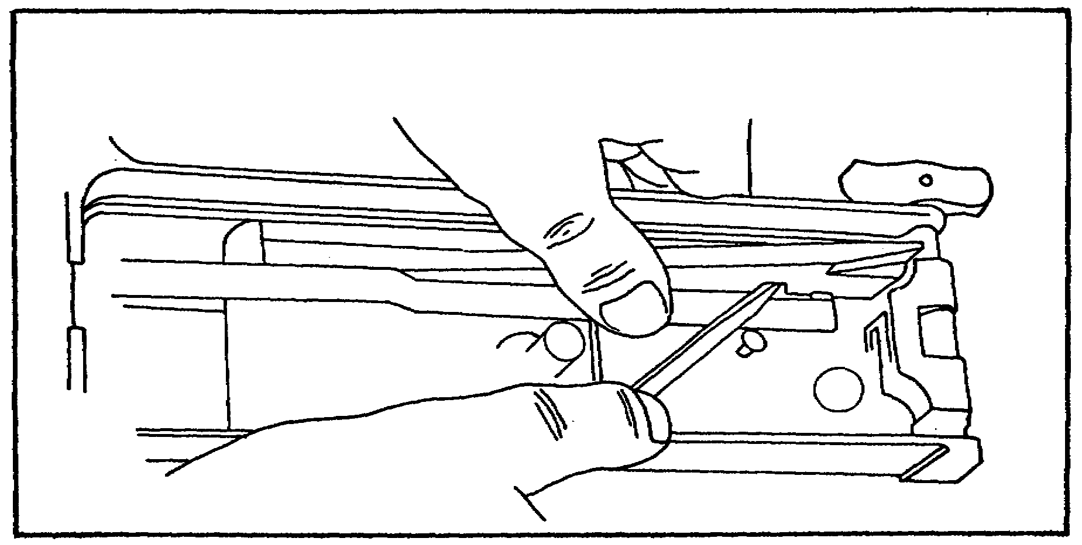

FIGURE 35. REMOVING THE COVER EXTRACTOR
SPRING.

(e) Receiver Group. To disassemble the receiver group, first, press down on the spring belt holding pawl and withdraw the belt holding pawl pin to the rear; use care not to lose the two springs.

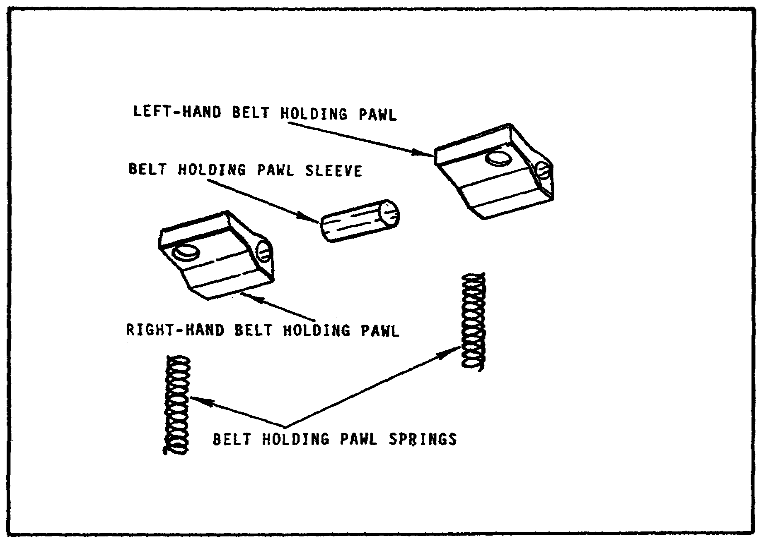
FIGURE 36. BELT HOLDING PAWL ASSEMBLY.

33

M2 MACHINEGUN MAINTENANCE - OD1503 - LESSON 1/TASK 1

The split belt holding pawl assembly includes a left-hand and right-hand belt holding pawl, connected by a belt holding pawl sleeve; two belt holding pawl springs are used (figure 36 on the previous page). Guns of earlier manufacture use a single belt holding pawl, adapted for either one or two springs (figure 37).

Now, withdraw the belt holding pawl pin from the right side of the receiver. Remove the cartridge
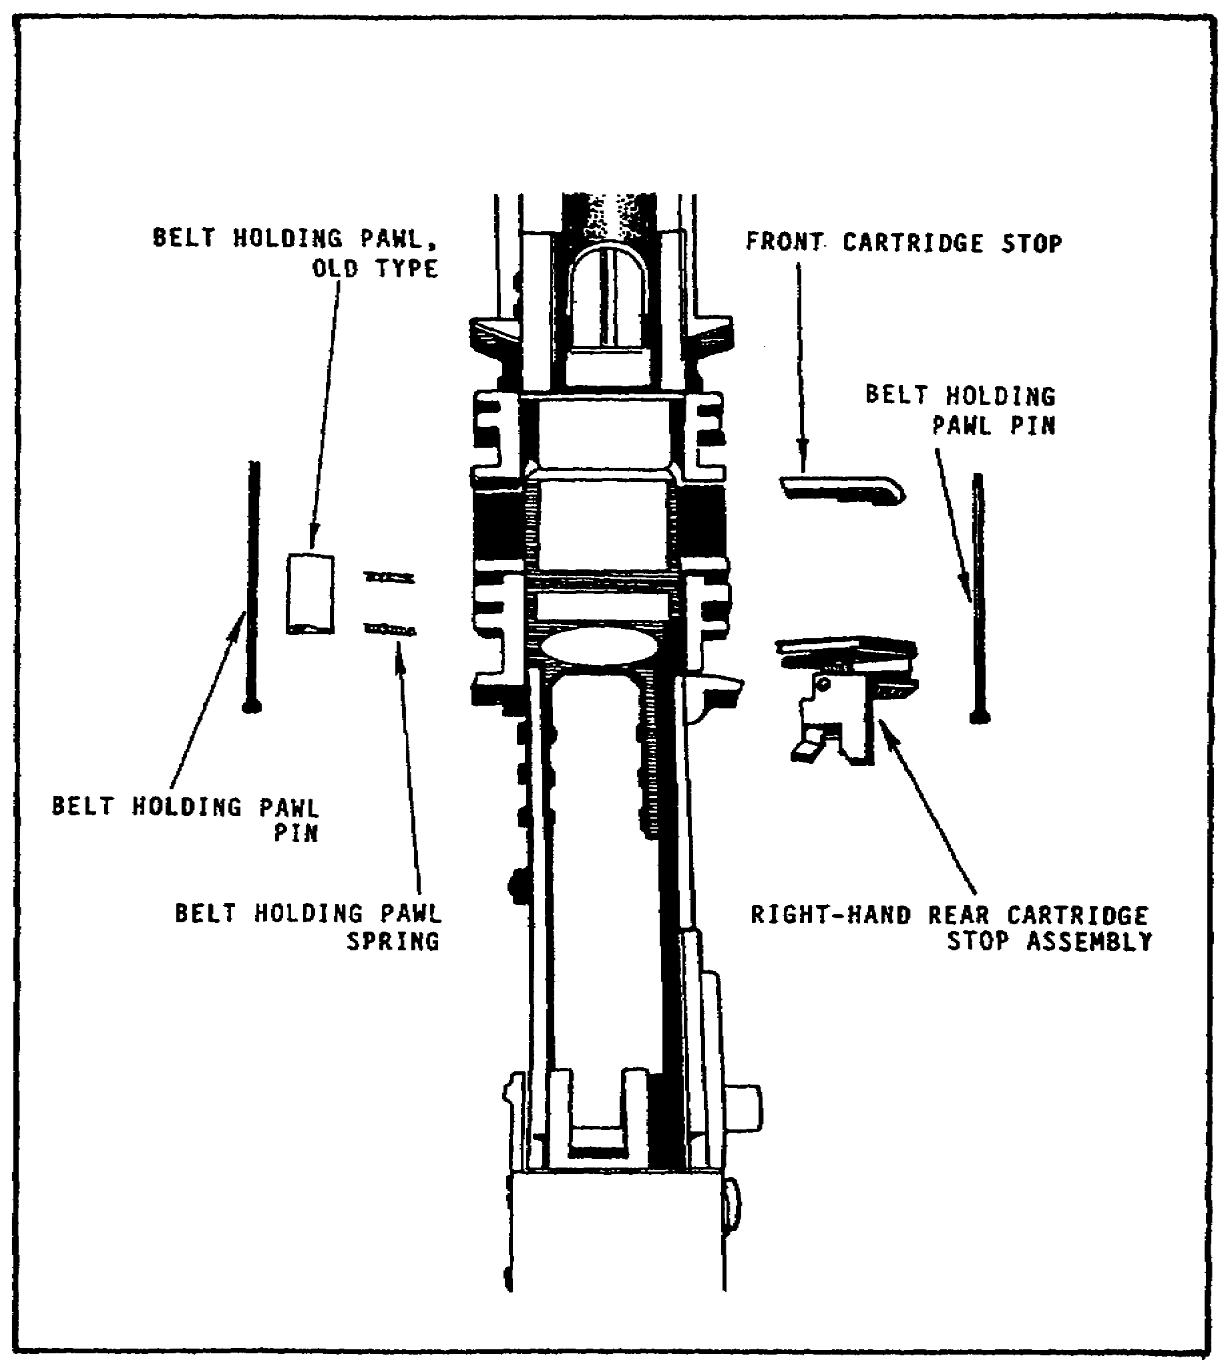

FIGURE 37. RECEIVER GROUP WITH OLD
TYPE BELT FEED PAWL.

34

M2 MACHINEGUN MAINTENANCE - OD1503 - LESSON 1/TASK 1

stop assembly (or rear cartridge stop and link stripper on guns of earlier manufacture), and front cartridge stop, from the right side of the receiver (figure 38).

Release the hinged lock from the left sideplate; turn the pin clockwise, and withdraw the pin to the left. Remove the trigger lever from inside the receiver. Guns of earlier manufacture may have a
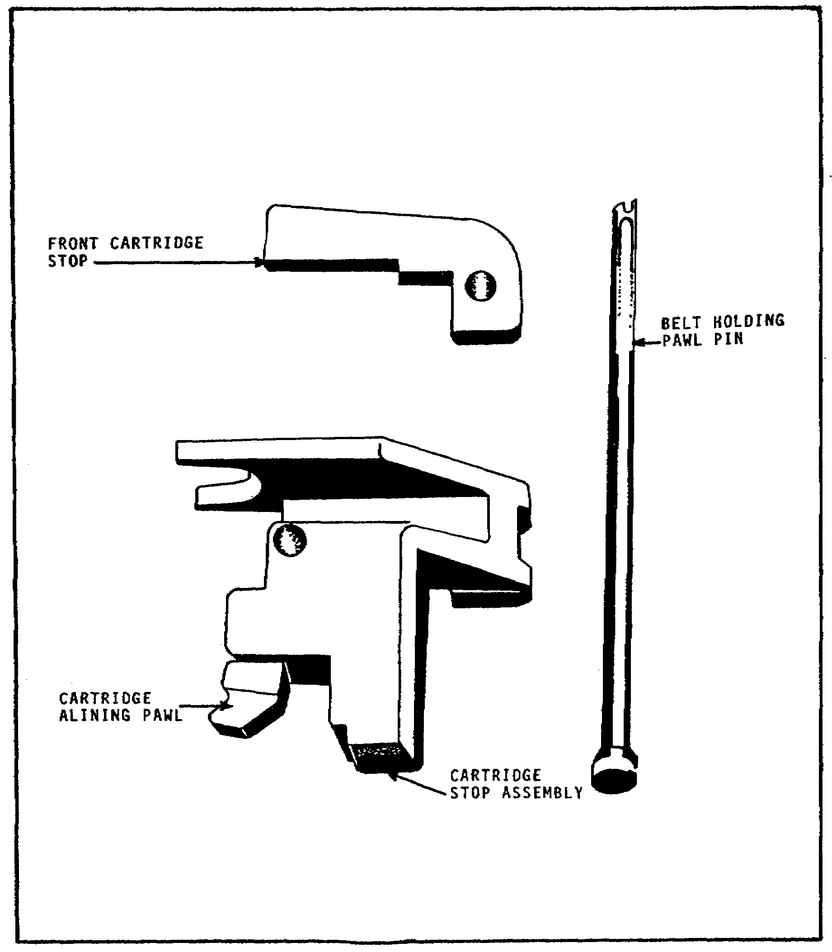

FIGURE 38. CARTRIDGE STOP ASSEMBLY, FRONT
CARTRIDGE STOP, AND BELT
HOLDING PAWL PIN.

35

M2 MACHINEGUN MAINTENANCE - OD1503 - LESSON 1/TASK 1

trigger lever pin assembly without the hinged lock. In this case, lift the lock of the pin out of the small hole in the left sideplate and rotate the lock end downward 90 degrees until it is just forward of a vertical position. Withdraw the pin to the left (figure 39). This completes the detailed disassembly procedures.
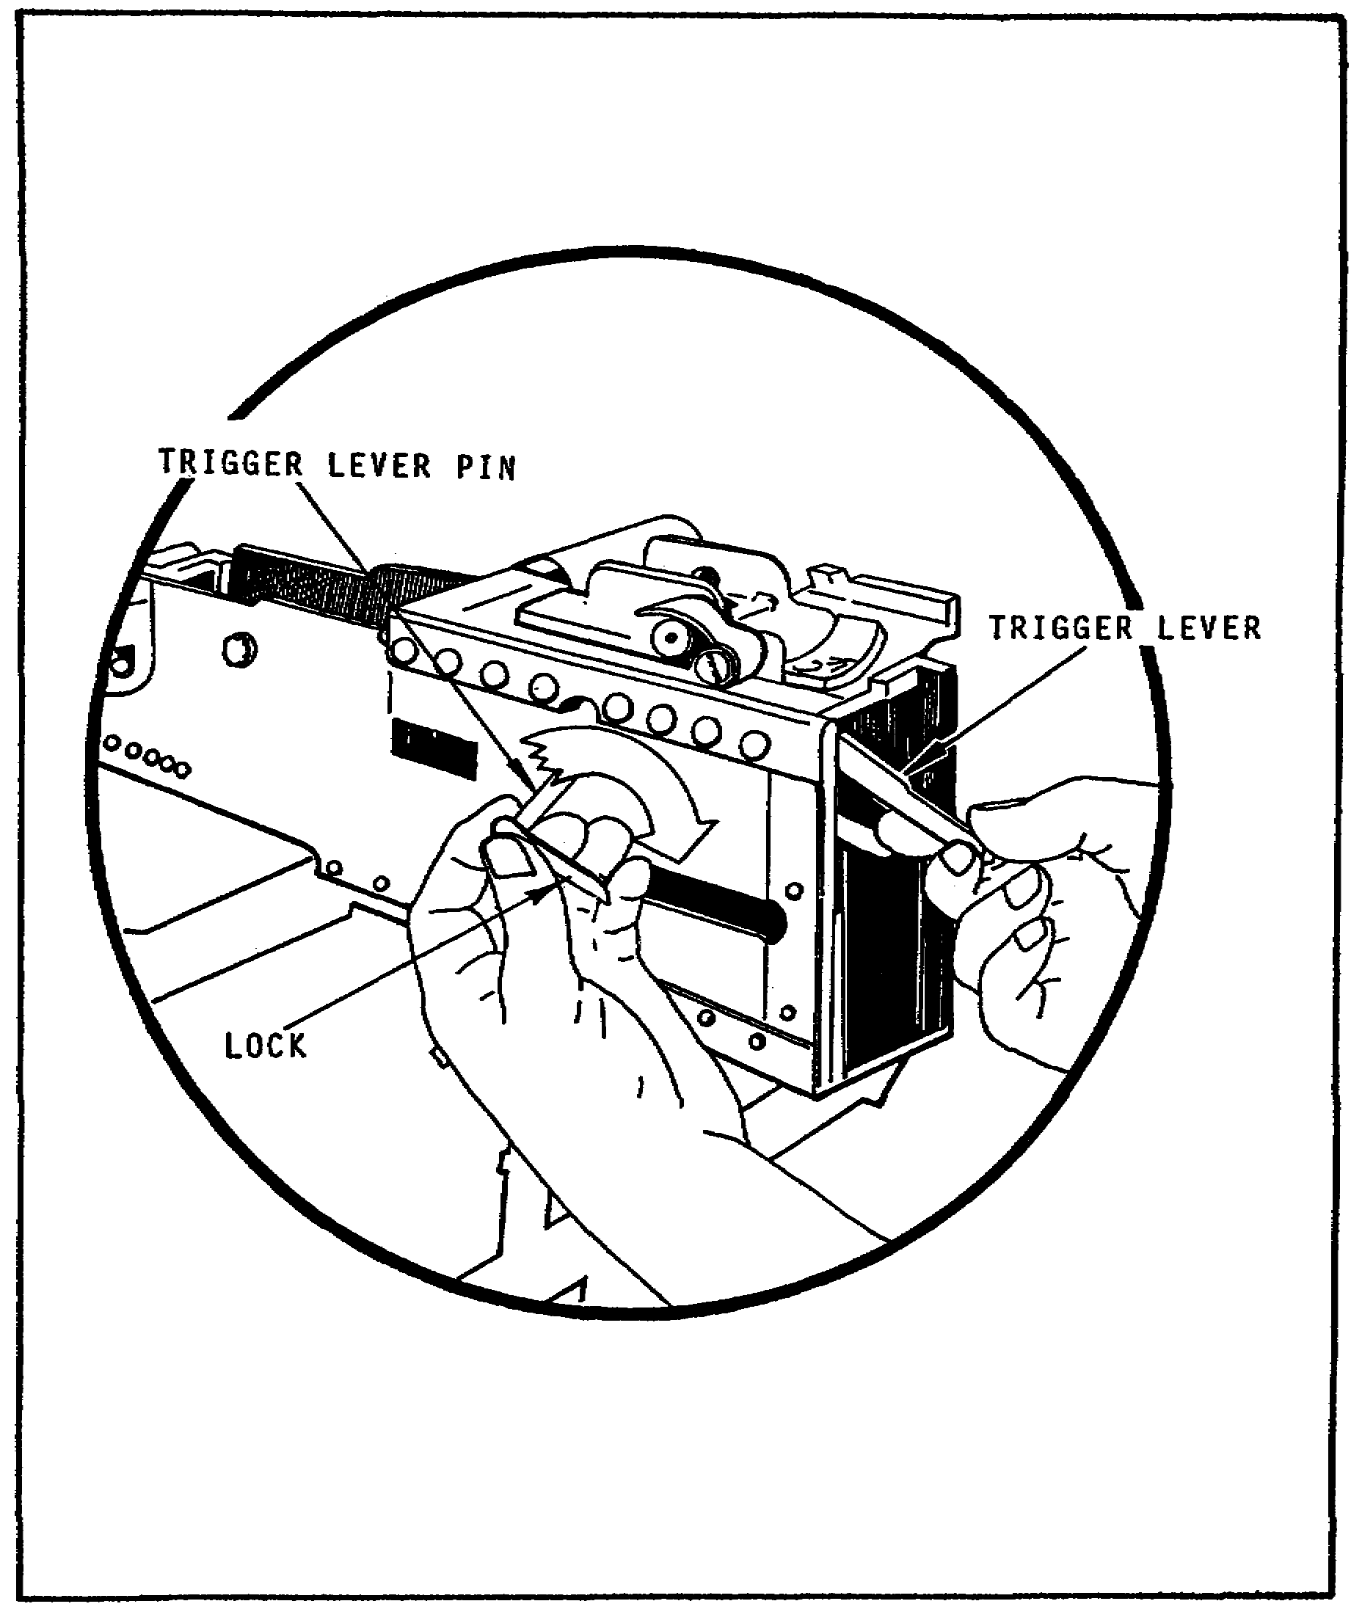

FIGURE 39. REMOVING THE TRIGGER LEVER PIN.

36
M2 MACHINEGUN MAINTENANCE - OD1503 - LESSON 1/TASK 1

5. Tripod Mount, M3

The M3 mount is the standard ground mount of the caliber .50 machinegun (figure 40 on the following page). It is a folding tripod with three telescopic, tubular legs, connected at the tripod head. Each leg ends in a metal shoe, which can be stamped into the ground for greater stability. The two trail legs are joined together by the traversing bar. The traversing bar serves as a support for the traversing and elevating mechanism, which in turn supports the rear of the gun. The tripod head furnishes a front support for the mounted gun which is further supported by the short front leg. When the tripod is emplaced on flat terrain, with all extensions closed, the adjustable front leg should form an angle of about 60 degrees with the ground. This places the gun on a low mount, about 12 inches above the ground. To raise the tripod farther off the ground, extend the telescopic front and trail legs (enough to keep the tripod level and maintain the stability of the mount).

a. General Data. The weight of the pintle and traversing and elevating mechanism are considered as part of the total weight of the tripod mount, M3 (44 lbs).

b. Front Leg and Leg Extensions.

(1) Front Leg. To adjust the front leg, turn the front leg clamp screw handle counterclockwise to loosen the front leg clamp screw nut. Adjust the leg to the desired angle, and tighten the front leg clamp.

(2) Leg Extensions. To extend any of the tripod legs, unscrew the leg clamping handle; press down on the indexing-lever, and extend the leg to the desired length. Align the stud on the indexing lever with one of the holes in the tripod leg extension. Release the pressure on the indexing lever, allowing the stud to fit the desired hole.

37

M2 MACHINEGUN MAINTENANCE - OD1503 - LESSON 1/TASK 1

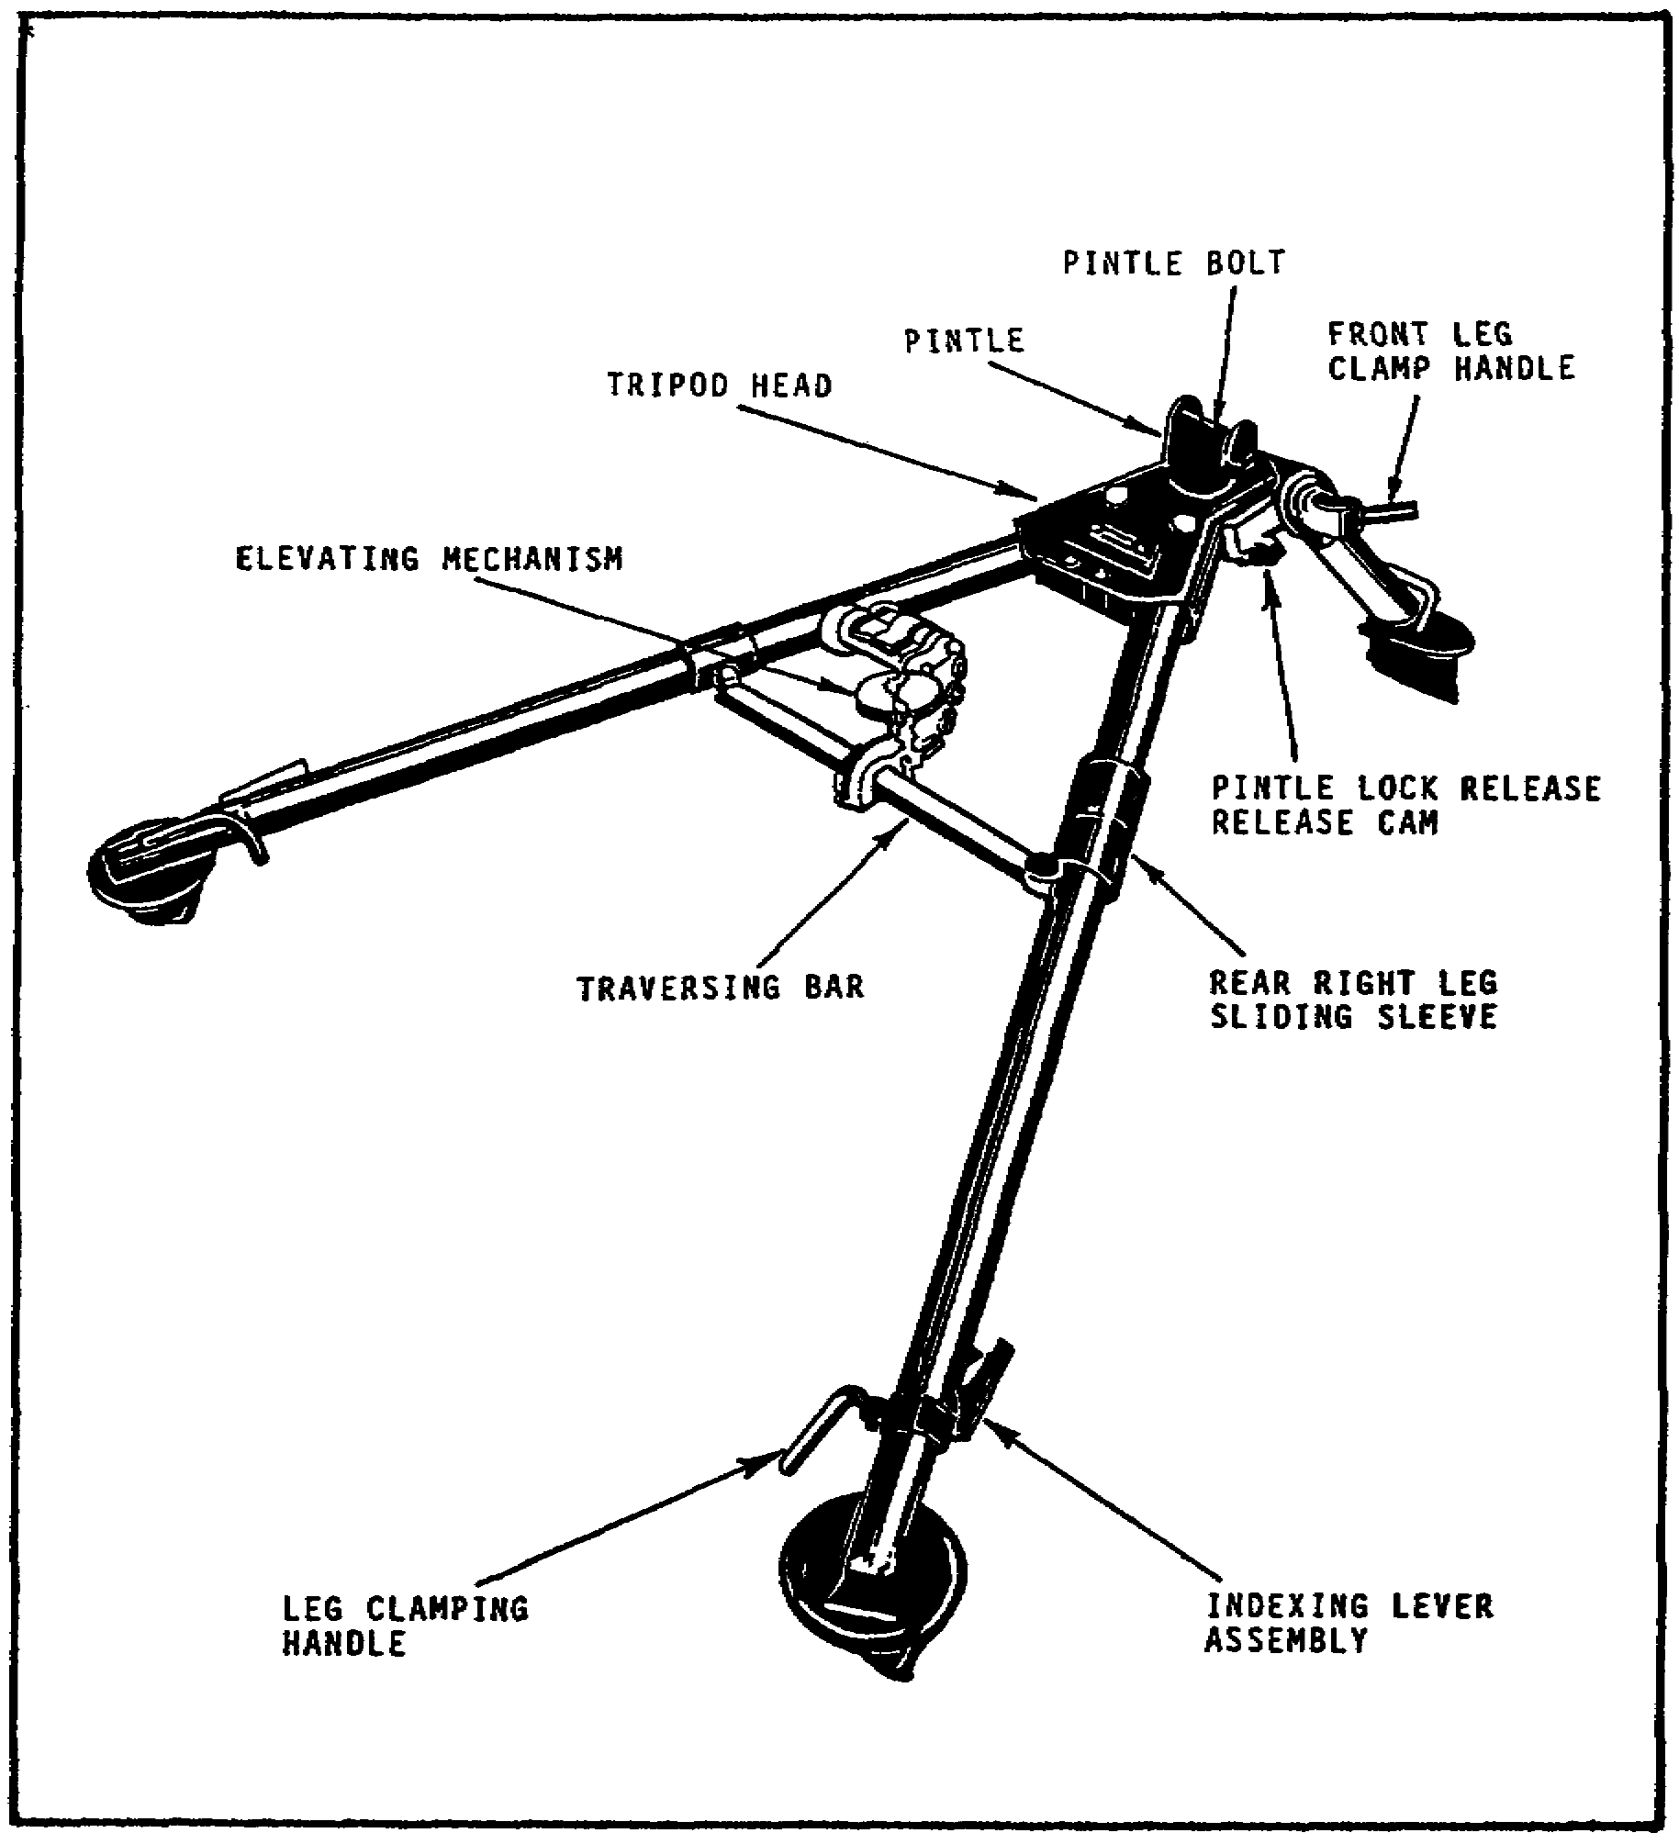

FIGURE 40. M3 TRIPOD MOUNT.

38

M2 MACHINEGUN MAINTENANCE - OD1503 - LESSON 1/TASK 1

c. Traversing and Elevating Mechanism.

(1) The Traversing Mechanism. Consists of a traversing bar, slide, and screw assembly. The traversing bar, graduated in five mil increments, fits between the trail legs of the tripod. The traversing slide and screw assembly are clamped in place on the traversing bar by the traversing slide lock lever. When the traversing slide is locked to the traversing bar, the traversing handwheel should be centered. The traversing slide is properly mounted when the lock lever is to the rear and the traversing handwheel is positioned to the left.

To make changes in direction, loosen the traversing slide lock lever and move the slide along the traversing bar. This permits traverse of 400 mils left or right of the zero index in the center of the traversing bar. Readings on the traversing bar are taken from the left side of the traversing slide. For changes of 50 mils or less in deflection, turn the traversing handwheel of the screw assembly. This allows a traverse of 50 mils left or right of center. One click in the traversing handwheel signifies one mil change in direction.

(2) The Elevating Mechanism. Consists of an upper and lower elevating screw, and is connected to the gun by inserting the quick release pin assembly through the holes in the upper elevating screw yoke and the rear mounting lugs of the receiver. A scale, graduated in mils, is fitted to the upper screw to indicate elevation. This scale is marked to show 250 mils in depression and 100 mils in elevation from the zero setting.

The elevating handwheel is graduated in one mil increments up to 50 mils, and is fastened to the elevating screw by a screw lock. This synchronizes the handwheel graduations with those on the upper elevating screw. A spring actuated index device produces a clicking sound when the handwheel is turned. Each click equals one mil change in elevation. The handwheel is turned clockwise to depress the barrel and counterclockwise to elevate. Figure 41, on the following page, shows details of the elevating mechanism.

39

M2 MACHINEGUN MAINTENANCE - OD1503 - LESSON 1/TASK 1

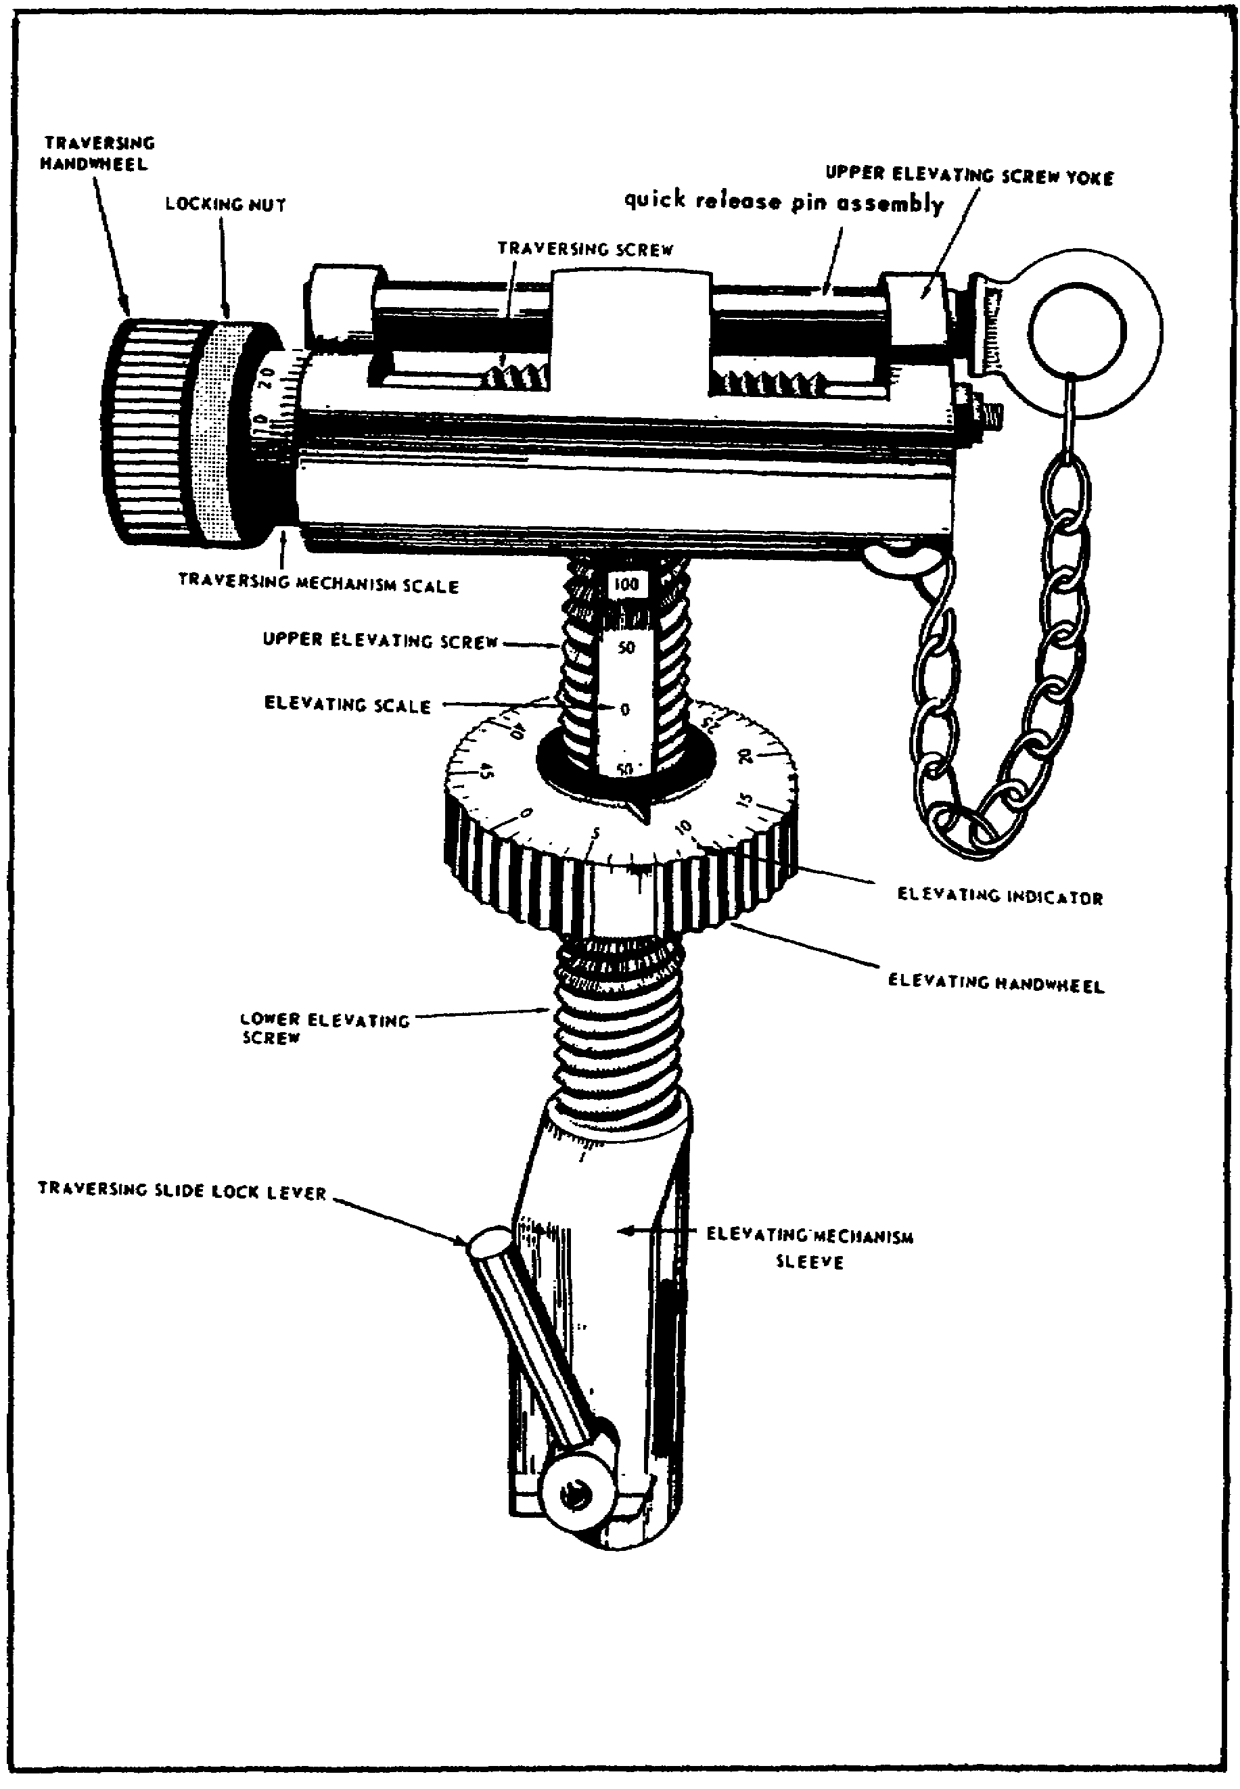

FIGURE 41. ELEVATING MECHANISM.

40
M2 MACHINEGUN MAINTENANCE - OD1503 - LESSON 1/TASK 1

d. Pintle. The gun is connected to the tripod mount, M3, by a pintle. This pintle is semipermanently attached to the machinegun by a pintle bolt through the front mounting hole in the receiver. The tapered stem of the pintle seats in the tripod head, and is held secure by a pintle lock and spring. To release the pintle, raise the pintle lock, releasing the cam.

6. Conclusion

This concludes this task dealing with the components and operation of the M2 caliber .50 machinegun. In the next task, we will cover the inspection and maintenance procedures employed by unit and intermediate direct support (IDS) levels of maintenance to keep this weapon operating.

41

M2 MACHINEGUN MAINTENANCE - OD1503 - LESSON 1/TASK 2

LESSON 1

THE COMPONENTS, OPERATION, INSPECTION, AND
MAINTENANCE PROCEDURES FOR THE M2 MACHINEGUN

TASK 2. Describe the inspection and maintenance procedures for the M2 machinegun.

CONDITIONS

Within a self-study environment and given the subcourse text, without assistance.

STANDARDS

Within three hours

REFERENCES

No supplementary references are needed for this task.

1. Introduction

In task 1, the importance of the operation, and the components of the Browning caliber .50 M2 machinegun HB were discussed. This information was presented, because an understanding of the operation and components is essential in gaining a knowledge of the inspection and maintenance procedures.

The inspection and maintenance procedures are the purpose of this task. After reading this task, the student should have a thorough understanding of the practices and procedures used to inspect and maintain the M2 machinegun and the M3 tripod mount.

2. Inspection and Maintenance Procedures

In the paragraphs that follow, the procedures to be used when inspecting and repairing the M2 machinegun and the M3 tripod mount will be discussed. The inspection and repair procedures for this particular task will be divided into two categories. First, the inspection and repair procedures performed by the user and the unit armorer, and second those inspection and repair

42

M2 MACHINEGUN MAINTENANCE - OD1503 - LESSON 1/TASK 2

procedures used by intermediate direct support (IDS) maintenance.

a. Unit Inspection and Repair Procedures. The weapon should be inspected by the user every day to ensure its serviceability. These inspection procedures are known as the preventive maintenance checks and services (PMCS). These inspection procedures should be performed before and during the disassembly of the weapon. Prior to beginning any work on this or any other weapon, first, ensure that the weapon is clear of ammunition. The procedures for clearing the weapon were covered in paragraph 3b(2) on page 8 of task 1. Throughout these paragraphs, unit level maintenance personnel are directed to effect corrective action either through repair and/or replacement of defective components. Before beginning any repair or replacement procedures, first consult the maintenance allocation chart (MAC) in Appendix B, TM 9-1005-213-25, to ensure that your level of maintenance is authorized to repair or replace the defective components. If your level of maintenance is not authorized to make the repairs, the item must be sent to IDS maintenance for repair.

(1) Preventive Maintenance Checks and Services. First, check the functioning of the weapon by using dummy ammunition. Once the functioning of the weapon has been tested, inspect the components and/or assemblies for any obvious defects such as nicks, burrs, rust corrosion, loose or missing rivets, screws, nuts and washers. Repair or replace any components found to be defective, provided that your level of maintenance is authorized to perform this function.

(a) Barrel Assembly/Group. Inspect the bore with a barrel reflector for rust, powder fouling, and obstructions. Check the barrel threads and locking notches for serviceability. Check the components of the barrel carrier assembly for serviceability. The retaining pin should be staked in the knob of the carrier assembly. The handle group should secure the carrier assembly firmly to the barrel assembly.

(b) Back Plate Assembly/Group. Ensure that the buffer tube sleeve rotates freely and the lock engages the bolt latch release. Operate the trigger to ensure that it functions properly.

43

M2 MACHINEGUN MAINTENANCE - OD1503 - LESSON 1/TASK 2

Ensure correct adjustment of the machine thread plug. Also ensure that the solenoid is secured with corrosion resisting wire and that the solenoid cable is not damaged or broken.

(c) Bolt Group and Rod Assembly. Inspect the firing pin tunnel in the bolt for powder fouling and foreign matter.

(d) Barrel Buffer Group. Inspect the buffer body lock for deformation and retention. The lock must be securely staked to the buffer body.

(e) Barrel Extension Group. Check the barrel locking spring to ensure that it puts tension on the lock to keep the barrel extension group securely mounted.

(f) Retracting Slide Assembly. Inspect the retracting slide assembly for loose studs, loose handle or loose lever. Check for a bent slide lever and whether the spring maintains the handle in an upright position. Ensure the installation of locking wire in two places secures the retracting slide assembly mounting screws.

(g) M10 Manual Charger. The inspection and repair procedures for the M10 manual charger will be presented in this text. However, it should be noted that the M10 manual charger is found only on the M48 version of the M2 machinegun. Inspect the charger cable assembly for broken or frayed strands. The charger should be secured to the receiver with screws which accommodate corrosion resisting wire.

(h) Cover Group. Manually operate the feed mechanism to ensure freedom of movement.

(i) Receiver Group. Check the trunnion block for cracks in the feedway. Check the receiver group for loose rivets in the trunnion block area. Inspect the adjustable trigger bar nut spring for broken prongs. Evacuate the receiver group to IDS maintenance if riveted components are loose or if weld failure is detected.

(j) M3 Tripod Mount. First, inspect the traversing slide lock lever for proper function. Check the traversing and elevating mechanism assembly for smoothness of operation and broken or missing components. Replace those components found

44

M2 MACHINEGUN MAINTENANCE - OD1503 - LESSON 1/TASK 2

to be unserviceable. Remember, consult the MAC to ensure that it is within your maintenance capabilities to replace the defective parts. If it is not within your maintenance capabilities, send the defective item to IDS maintenance.

Check the functioning of the legs and sleeve lock latch. Inspect all components for dents, cracks, or distortion. Check the clamping handle and round nut for retention on the legs and check for wear or distortion of the threads. Check the rear legs for full extension. The rear legs should be forced slightly apart by the traversing bar assembly when in the firing position. Check machine bolt 5139973 and the slotted nut for damaged threads or burrs. Finally, check the head for evidence of cracks or burrs. Again, repair by replacing defective components.

(2) Cleaning. In the paragraphs that follow, the cleaning procedures used by unit maintenance (user and unit armorer) before, during, and after firing and under unusual climatic conditions will be discussed.

(a) Care and Cleaning Before, During, and After Firing. Before firing, when the situation permits, take the following steps to ensure efficient functioning of the machinegun:

Step 1. Disassemble the gun into its major groups or assemblies.

Step 2. Clean the bore and the chamber, but do not oil them.

Step 3. Clean all the metal parts thoroughly and apply a light coat of oil to all metal parts which do not come in contact with the ammunition.

Step 4. To ensure complete removal of powder residue and primer fouling from the bore of the machinegun barrel, the bore should be cleaned at least once a day, for at least three consecutive days after firing. The bore sweats out this fouling or residue, and cleaning must be repeated until there is no further evidence of sweating.

(b) Care and Cleaning Under Unusual Climatic Conditions. Extreme cold, dry, hot, and tropical climates affect the gun and its functioning. Care should be taken under these climatic conditions to

45

M2 MACHINEGUN MAINTENANCE - OD1503 - LESSON 1/TASK 2

ensure that the gun is cleaned daily with the prescribed lubricants and protected from the elements by some sort of cover if possible. Further information on the care and cleaning of the M2 machinegun under unusual climatic conditions can be found in TM 9-1005-213-10.

(3) Inspection and Repair. In the paragraphs that follow, the inspection and repair procedures used by unit maintenance for the groups/assemblies of the M2 machinegun will be discussed.

(a) Machinegun. Visually inspect the components for wear, cracks, dents, and damage. Springs must be free of rust, corrosion, and deformation. Make certain all parts are properly installed and in working condition.

Repair the exterior of the machinegun by removing rough edges. Remove all traces of rust or scored areas from the finished surfaces with crocus cloth moistened lightly with oil.

(b) Barrel Assembly. Check for bulges, burrs, corrosion, and rust. Inspect the chamber and bore with the barrel reflector for pitting and rust. Replace the barrel assembly if it is found to be unserviceable.

(c) Back Plate Assembly/Group. Check the latch and latch lock for missing or broken lock pins and replace as necessary. Inspect the machine thread plug for damaged threads and the slot for burrs. Inspect the helical compression spring (machine thread plug) for corrosion, weakness, or distortion. Notify IDS maintenance if the spring is unserviceable. Inspect the buffer disks for frayed or broken conditions, and for the correct count to ensure that there are 22 buffer disks. Replace any disk(s) found to be unserviceable. Inspect the trigger for bent or broken conditions. If trigger 6008918 is unserviceable, notify IDS maintenance. Examine the solenoid trigger and replace if found to be unserviceable. Examine the electrical solenoid for looseness and damage. Check the riveted clip assembly and the clamp assembly for damage. Replace any of the above noted items found to be defective.

(d) Bolt Group and Rod Assembly. Inspect the bolt group and rod assembly components for damage. Replace only authorized parts as required. Inspect

46

M2 MACHINEGUN MAINTENANCE - OD1503 - LESSON 1/TASK 2

the driving spring rod assembly to ensure that it is not bent. Replace if necessary. Inspect the bolt switch for roughness or burrs. If found to be unserviceable, replace. Inspect the bolt assembly to see that there are no sharp corners on any surface. Replace any parts found to be unserviceable. Check for the proper usage and compatibility of parts when replacing unserviceable components.

(e) Barrel Buffer Group. Inspect the accelerator pin assembly for burrs or rust and for a broken or missing spring. Replace any components found to be unserviceable. Be sure to check for proper usage and compatibility of parts when replacing unserviceable components. Ensure that the buffer assembly does not contain oil. Oil is used only in aircraft-type weapons.

(f) Barrel Extension Group. Inspect the breech lock pin assembly for burrs or rusting. Inspect the barrel locking spring for firm retention in the groove and for wear, fracture, and burrs, especially on the nose. Replace any components found to be unserviceable.

(g) Retracting Slide Assembly. Inspect all parts for damage or a broken condition. If the damaged parts are not components unit maintenance are authorized to replace, notify IDS maintenance.

(h) M10 Manual Charger. Examine the cable for broken or frayed strands, and replace if found to be unserviceable. Replace all spring pins, screws, and washers removed during disassembly, provided they are damaged or worn. If any of the components are unserviceable, replace the entire charger assembly.

(i) Cover Group. Inspect the belt feed lever for fracture, deformation, and free movement on the pivot stud. If the belt feed lever is bent or broken, this would cause the weapon to fail to chamber a round, thereby rendering it useless to the user. Inspect the lugs on the ends for wear and for a missing headless shoulder pin. Inspect the belt feed slide assembly for burrs. The protruding pin, when assembled, should be flush. Inspect the belt feed pawl assembly for burrs, bent or missing pins. Replace any components found to be unserviceable. If the belt feed pawl arm is bent or broken, notify IDS maintenance. If the

47

M2 MACHINEGUN MAINTENANCE - OD1503 - LESSON 1/TASK 2

cover group does not lock securely, notify IDS maintenance.

(j) Receiver Group. Inspect the trigger level pin assembly for burrs or a broken lock. Inspect the trigger lever for deformation or burrs on the camming surfaces. Check the headspace and timing when the gun is assembled. If the headspace and timing cannot be adjusted, notify IDS maintenance. Check the cartridge stops and link stripper for correct position and condition. If unserviceable, notify IDS maintenance. Inspect the belt holding pawl assembly for burrs, wear and dirt. Check the belt-holding pawl pins to see that they fit snugly and are not broken. Replace any components found to be unserviceable. Check the components of the electrical solenoid assembly. If the cable assembly and corrosion resisting wire are unserviceable, replace them. Replace the solenoid if it is unserviceable.

(k) M3 Tripod Mount. Visually inspect the components for wear, cracks, dents, and damage. Springs must be free of rust, corrosion, and deformation. Make certain all parts are properly installed and in working condition. Remove burrs, rough edges, and all traces of rust from finished or functional surfaces with a crocus cloth moistened lightly with oil.

Inspect for smoothness of traversing and elevating screws. Check the helical torsion spring and lever for clamping action on the traversing bar assembly. Check the quick release pin and chain assembly for burrs and damage.

Inspect the legs for distortion, dents, and burrs. Check the telescoping function of the legs and leg sections. Check the adjustment of the traversing bar assembly when the legs and leg sections are extended. They must fit flush with the side of the tripod head. Check the functioning of the lever assembly, tension of the spring, and for a loose pin. Inspect the spades of the legs and leg sections for cracks at welds, and for being bent or damaged. Check the condition of the pins and pin holes in the tubing of the lower leg sections. Check the functioning of the leg clamping handle when the legs and leg sections are extended. Also, check for looseness in the handle and for burred or damaged threads. Check the lower leg sections for rust and dirt. Check the components of the

48

M2 MACHINEGUN MAINTENANCE - OD1503 - LESSON 1/TASK 2

traversing bar assembly for distortion, dents, looseness, wear, and burrs. Replace only authorized components if unserviceable.

When the tripod mount is placed in the firing position, the legs must be forced slightly apart and must contact the side of the head to ensure rigidity of the mount. If looseness is encountered, adjust the traversing bar assembly, as required.

Check the bolts and nuts for damaged threads and burrs. Check the pintle and bearing for looseness and burrs. Check the tripod head for cracks and burrs. Check the lock assembly for looseness and burrs. Check the locking action of the lock assembly. Inspect the serrated plates for gouges or other damage. Check the clamping action function of nut 5139964 on the serrated plates and for any loose play when locked.

(4) Headspace and Timing. Headspace is the distance between the face of the bolt and the base of the cartridge case when it is fully seated in the chamber. Headspace adjustment is correct when the following conditions are met: the recoiling groups are fully forward and there is no independent rearward movement between the bolt, barrel, and barrel extension. An improper headspace adjustment can cause the gun to function improperly. It may also result in damage to parts and/or injury to personnel.

Headspace is checked and set prior to firing. Other instances include: when the gun is disassembled, when the barrel or any major group or assembly within the receiver is replaced, and when there is doubt that the correct headspace is set.

The headspace and timing gage consists of a headspace gage and two timing gages. These gages provide an accurate means of checking the adjustment of headspace and timing.

(a) Headspace Adjustment with the Gage. With the gage, the distance between the face of the bolt and the chamber end of the barrel can accurately be determined by the following procedures:

Raise the cover and retract the recoiling parts following the procedures contained in paragraph 3b(2) on page 8 of task 1. Next, screw the barrel

49

M2 MACHINEGUN MAINTENANCE - OD1503 - LESSON 1/TASK 2

all the way into the barrel extension, then unscrew the barrel two notches.

Cock the gun by pulling the retracting slide handle all the way to the rear, then return it to its most forward position. Press the bolt latch release and allow the bolt to go forward. Be careful not to depress the trigger since this will cause the firing pin to be released. If the firing pin is forward, the gage cannot be inserted into the T-slot far enough to give an accurate determination. Never release the firing pin with the gage in the T-slot as this could damage to the firing pin and the gage.

Now pull the retracting slide handle back until the barrel extension is about one-sixteenth of an inch from the trunnion block. This will ensure that the locking surfaces of the breech lock and the bolt are in proper contact. This prevents the driving spring group and the weight of the parts from giving a false determination.

First, insert the GO end of the headspace gage in the T-slot, between the face of the bolt and the rear end of the barrel. If the GO end of the gage enters freely down to the center ring of the gage, then attempt to insert the NO GO end of the gage. If the GO end enters and the NO GO does not enter, correct headspace is set.

If the GO end of the gage does not enter freely, the headspace is too tight. When this condition exists, the barrel must be unscrewed one click (notch) at a time, checking with the gage after each click, until the GO end of the gage enters freely. To complete the adjustment, attempt to insert the NO-GO end of the gage; if it does not enter, the correct headspace is set. Remember to screw or unscrew the barrel into the barrel extension; the lug on the barrel locking spring must be aligned with the 3/8 inch hole in the right side plate.

If the NO GO end of the gage enters the T-slot, the headspace is too loose. The barrel must be screwed into the barrel extension one click at a time, checking with the gage after each click, until the GO end enters and the NO-GO end does not enter. After the headspace has been checked and adjusted, remove the gage.

50

M2 MACHINEGUN MAINTENANCE - OD1503 - LESSON 1/TASK 2

(b) Timing. Timing is the adjustment of the weapon so that firing takes place when the recoiling parts of the weapon are between .020 and .116 inches out of battery to prevent contact between the front end of the barrel extension and the trunnion block. Timing is correctly set when the following conditions are met: the recoiling parts are locked together, firing takes place just before the parts are in battery (fully forward), and when the gun fires on the FIRE gage, but does not fire on the NO FIRE gage. Timing must be checked and/or set each time headspace is set, or whenever timing is questionable.

(c) Checking and/or Setting Timing. Ensure that the gun has the correct headspace adjustment. Cock the gun; pull the retracting slide handle all the way to the rear, and return it to its most forward position. Press the bolt latch release and allow the bolt to go forward. Do not depress the trigger. Raise the extractor and pull the retracting slide handle back until the front end of the barrel extension is about one-fourth of an inch from the trunnion block.

Insert the NO FIRE timing gage between the barrel extension and the trunnion block, placing the beveled edge of the gage on the barrel notches. Let the barrel extension close slowly on the gage.

Depress the trigger firmly, attempting to release the firing pin. The firing pin should not release. If the firing pin does release, the gun is timed to fire too early. To correct for this, pull the retracting slide handle to the rear, allow the bolt to go forward. Insert the fire gage, remove the backplate and screw the timing adjustment nut to the left until it rests on the trigger lever. Press up firmly on the trigger lever and attempt to fire. Rotate the timing adjustment nut to the right, one notch at a time, each time pressing up firmly on the trigger lever, and attempt to fire the weapon. When the firing pin is released, turn the timing adjustment nut two additional notches to the right and replace the backplate.

CAUTION

Do not attempt to cock the gun with the backplate off.

51

M2 MACHINEGUN MAINTENANCE - OD1503 - LESSON 1/TASK 2

Recock the weapon and allow the bolt to go forward. Insert the NO FIRE gage between the trunnion block and the barrel extension. Attempt to fire the weapon by depressing the trigger. The weapon should not fire. If the weapon does fire, a mechanical defect exists and the proper troubleshooting and repair procedures should be used to locate and correct the cause of the malfunction.

Replace the NO FIRE gage with the FIRE gage and attempt to fire the weapon. The weapon should fire. When all of the above procedures have been completed, the weapon is correctly timed.

This completes the inspection and repair procedures used at unit level maintenance. Additional procedures and information can be found in FM 23-65 and TM 9-1005-213-25.

b. IDS Inspection and Repair Procedures. In the paragraphs that follow, the inspection and repair procedures used by IDS maintenance personnel will be discussed. Basically, IDS maintenance will perform the same inspection that unit level maintenance personnel perform. The only difference is that IDS will go into more detail. It should be noted that the actual inspection would be performed as the weapon is disassembled and any parts found to be defective would either be repaired or replaced at that time.

(1) Machinegun. Visually inspect the components for wear, cracks, dents, and damage. Springs must be free of rust, corrosion, and deformation. Make certain all parts are properly installed and in working condition.

Repair the exterior of the machinegun by removing rough edges. Remove all traces of rust or scored areas from the finished surfaces with crocus cloth moistened lightly with oil.

(2) Barrel Assembly. Check for bulges, burrs, corrosion, and rust. Inspect the chamber and bore with the barrel reflector for pitting and rust, replace the barrel assembly if it is found to be unserviceable. If the barrel installed on the weapon is unlined, use barrel erosion gage 7319900 and check the barrel erosion. If the barrel is lined, use barrel erosion gage M6A1 to check the barrel erosion. If the weapon is being sent

52

M2 MACHINEGUN MAINTENANCE - OD1503 - LESSON 1/TASK 2

overseas, barrel erosion cannot exceed the thirteenth graduation on the gage. If the weapon is to be used by troops in the United States, barrel erosion cannot exceed the twentieth graduation as indicated on the barrel erosion gage. Reject the barrel assembly if the barrel is worn enough to affect the sharpness of lands. Make sure serrations are well defined so as to retain the barrel assembly setting by the locking spring. The barrel should not be able to be rotated after it is attached to the receiver.

(3) Backplate Assembly/Group. Check the latch and latch lock for missing or broken lock pins and replace as necessary. Inspect the machine thread plug for damaged threads and the slot for burrs. The machine thread plug should be tight. Headless shoulder pin 5152839 will be in the locking notch in the buffer tube. The buffer plate should protrude approximately 3/16 of an inch from the front of the backplate. Inspect the helical compression spring (machine thread plug) for corrosion, weakness, or distortion. Replace the spring if it is unserviceable.

Inspect the buffer disks for frayed or broken condition, and for correct quantity. There should be 22 buffer disks. Replace any disk(s) found to be unserviceable. Inspect the trigger for bent or broken condition. If the weapon is equipped with a solenoid and electrical trigger, inspect them for damage or unserviceable condition and proper retention. If an unserviceable condition exists, repair or replace the necessary components. Examine the electrical solenoid for looseness and damage. Check the riveted clip assembly and the clamp assembly for damage. Replace any of the above noted items found to be defective. The backplate assembly should fit firmly on the receiver group, but freely enough to be removed by hand.

(4) Bolt Group and Rod Assembly. Inspect the bolt group and rod assembly components for damage. Replace only authorized parts as required. Inspect the driving spring rod assembly to ensure that it is not bent and replace if necessary. Inspect the bolt switch for roughness or burrs. If found to be unserviceable, replace. Inspect the bolt assembly to see that there are no sharp corners on any surface. Replace any parts found to be unserviceable. Check for the proper usage and

53

M2 MACHINEGUN MAINTENANCE - OD1503 - LESSON 1/TASK 2

compatibility of parts when replacing unserviceable components. Check the clearance of the bolt group with the sideplate. The recoil plate should be flush with the face of the bolt assembly. The trigger lever should not drag on the bolt group when the trigger is depressed. The angle on the mating surface that engages the firing pin extension must be sharp, without a feather edge. The stud must be staked in three places.

Measure the firing pin protrusion using gage 7799739. The minimum allowable protrusion of the firing pin is 0.073 inch, while the maximum allowable firing pin protrusion is 0.080 inch. Use NO-GO plug gage 7458406 and measure the firing pin hole. The firing pin hole must not exceed 0.084 inch in diameter. If the NO-GO gage enters the firing pin hole all the way, the bolt group should be rejected. Elongation of the firing pin hole is also cause for rejection. Inspect the firing pin and extension for wear, damage, rust, or corrosion. The sear engaging notch on the firing pin extension should have a black or dull gray finish, and the angle must be sharp without a feathered edge.

(5) Barrel Buffer Group. Inspect the accelerator pin assembly for burrs or rust and for a broken or missing spring. Replace any components found to be unserviceable. Be sure to check for proper usage and compatibility of parts when replacing unserviceable components.

NOTE

Ensure that the buffer assembly does not contain oil. Oil is used only in aircraft-type weapons.

The overall length of the buffer assembly (rear face of the tube to the forward inside face of the engaging notch) must be between 6.086 and 6.117 inches. Use oil buffer rod gage 7160900 to make this measurement.

The breech lock depressors may have vertical movement which does not exceed 3/32 of an inch and lateral movement which does not exceed 1/16 of an inch, measured at the tips. Longitudinal movement must not exceed .005 inch. The buffer body lock must not be overstaked. Staking or swaging to

54

M2 MACHINEGUN MAINTENANCE - OD1503 - LESSON 1/TASK 2

secure or limit the movement of the breech lock depressors in their recesses in the buffer body is not permitted. Marks derived from previous unauthorized staking or swaging of the buffer bodies will be acceptable if the function is not affected. The guide must be sufficiently staked and free of damage. Do not put oil in the buffer assembly; oil is used in aircraft-type guns only.

(6) Barrel Extension Group. Inspect the breech lock pin assembly for burrs or rusting. Inspect the barrel locking spring for firm retention in the groove and for wear, fracture, and burrs, especially on the nose. Replace any components found to be unserviceable.

(7) Retracting Slide Assembly. Inspect all parts for damage or a broken condition.

(8) M10 Manual Charger. Examine the cable for broken or frayed strands, and replace if found to be unserviceable. Replace all spring pins, screws, and washers removed during disassembly, provided they are damaged or worn. If any of the components are unserviceable, replace the entire charger assembly.

(9) Cover Group. Inspect the belt feed lever for fracture, deformation, and free movement on the pivot stud. Inspect the lugs on the ends for wear and for a missing headless shoulder pin. Inspect the belt feed slide assembly for burrs. The protruding pin, when assembled, should be flush. Inspect the belt feed pawl assembly for burrs, bent surfaces, and missing pins. Replace any components found to be unserviceable. If the belt feed pawl arm is bent or broken, replace it. If the cover group does not lock securely, replace the cover group latch assembly. Measure the cover latch and notch clearance. If the weapon is destined for overseas service, the measurement between the cover latch and notch should be a maximum of 0.010 inch. If the weapon is to be used in the United States, the measurement should be 0.015 inch. If either of these two measurements is not indicated when the measurement is taken, replace the cover latch.

(10) Receiver Group. Inspect the trigger level pin assembly for burrs or a broken lock. Inspect the trigger lever for deformation or burrs on the camming surfaces. Check the headspace and
timing when the gun is assembled. If the headspace and

55

M2 MACHINEGUN MAINTENANCE - OD1503 - LESSON 1/TASK 2

timing cannot be adjusted, troubleshoot the weapon to identify and locate the malfunction, then perform the corrective action. Check the cartridge stops and link stripper for correct position and condition. If they are unserviceable, replace them.

Inspect the belt-holding pawl assembly for burrs, wear and dirt. Check the belt-holding pawl pins to see that they fit snugly and are not broken. Replace any components found to be unserviceable. Check the components of the electrical solenoid assembly. If the cable assembly and corrosion resisting wire are unserviceable, replace them. Replace the solenoid if it is unserviceable.

Inspect the trunnion blocks for cracks, wear, rust and corrosion. If the trunnion blocks are rusted or corroded, remove the corrosion, treat the metal with a corrosion preventive compound and refinish the trunnion blocks. If the trunnion blocks are cracked or worn, replace them. Check the pawl and helical compression spring. The spring must not bind in the trunnion block and must hold the cover open in positions of quarter, half, and full open.

Now inspect the top and bottom plates for loose rivets, bends, and other damage. Also check the bottom plate for damage at the mounting holes and the bolt latch. The following inspection criteria will apply in the inspection for loose rivets: if the .005 inch leaf of the feeler gage penetrates to the depth of the rivets at any point in the riveted area, the weapon will be turned in for overhaul and a new weapon drawn from stock.

Use a feeler gage and check the trigger lever clearance. Refer to figure 42 on the following page; retract the bolt group 1 and 1/2 inches. Insert the feeler gage between the top of the bolt and the bottom of the trigger lever. The clearance between the trigger lever and the bolt should be a minimum of 0.005 inch. If the trigger lever clearance is not within tolerance, rotate the adjusting knob either clockwise or counterclockwise and bring the trigger lever within the proper clearance.

56

M2 MACHINEGUN MAINTENANCE - OD1503 - LESSON 1/TASK 2

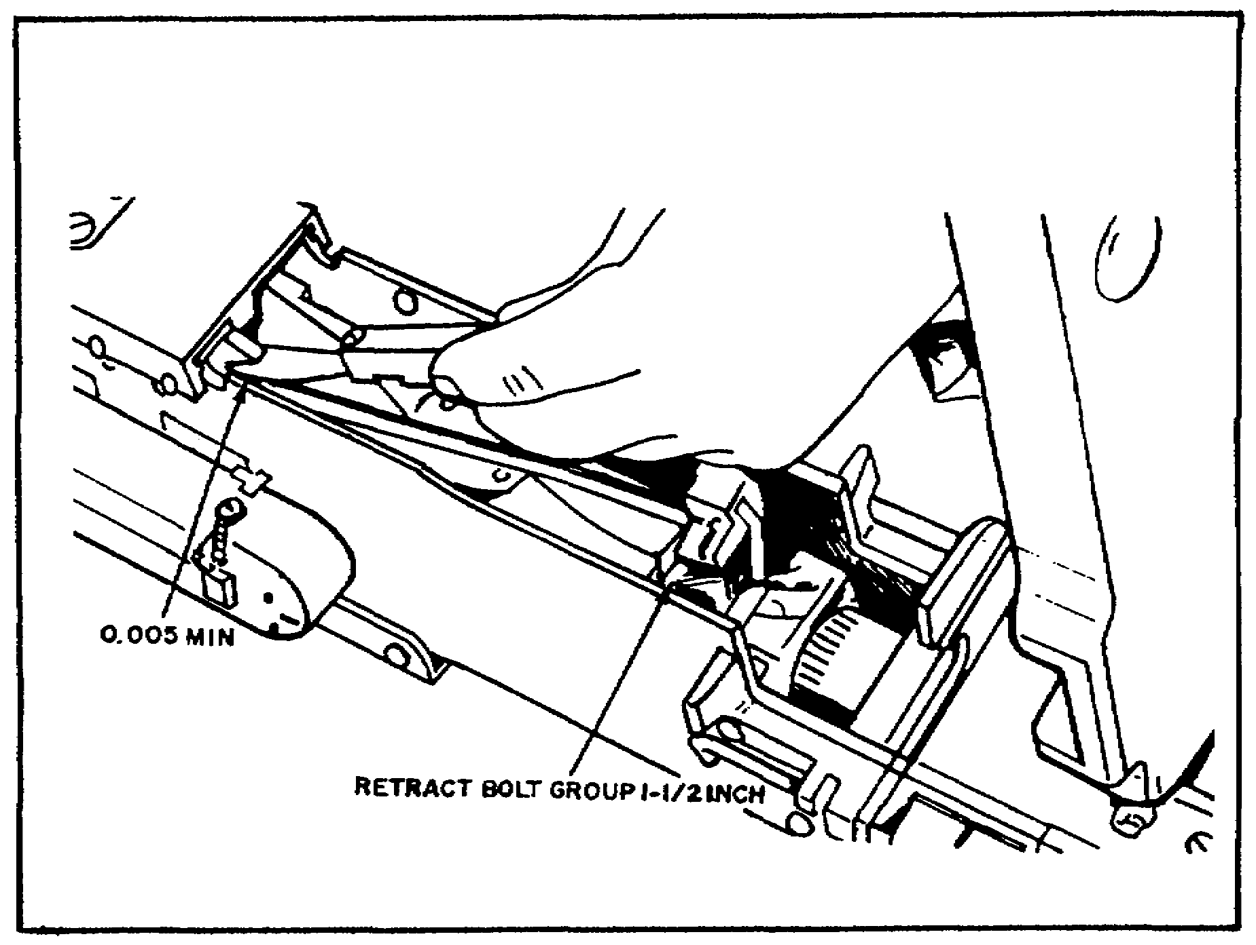
FIGURE 42. MEASURING TRIGGER LEVER
CLEARANCE.

Now check the adjustment of the breech lock cam. This is done by inserting a feeler gage between the cam and the bottom of the receiver group as shown in figure 43, on the following page. The adjustment should be between 0.001 inch and a maximum of 0.008 inch. If the adjustment is not within these limits, remove the cotter pin from the castle nut on the cam adjusting screw. Then rotate the screw either right or left to bring the cam adjustment to the proper tolerances.

Finally, inspect the rear sight assembly. Ensure that only acceptable types of rear sights are used. Observe the clicking action of the plungers and springs; flat spring 7265577 must hold the leaf at a 90 degree angle without excessive play in the leaf assembly. Figure 44, on the following page, shows only those rear sight assemblies that are acceptable.

57

M2 MACHINEGUN MAINTENANCE - OD1503 - LESSON 1/TASK 2

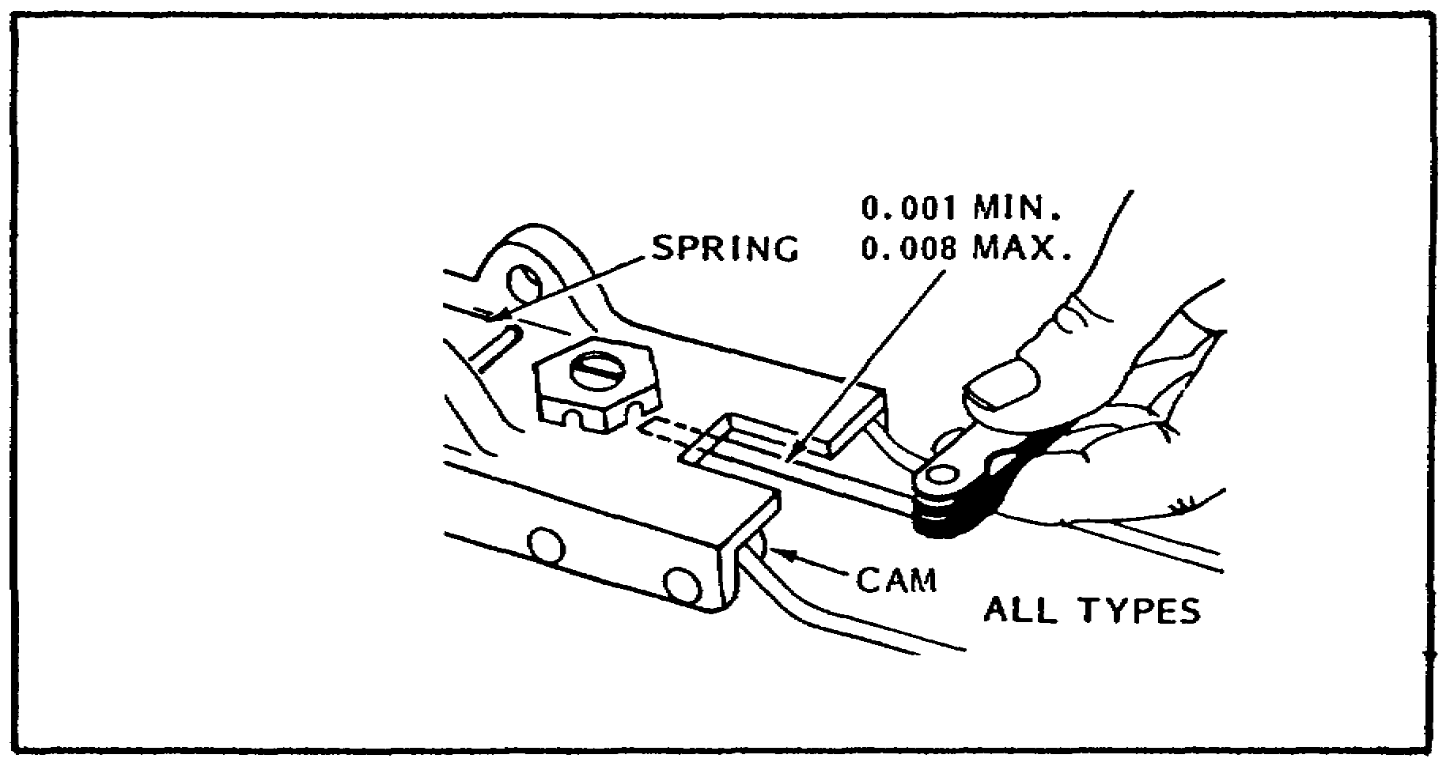
FIGURE 43. MEASURING CAM CLEARANCE.

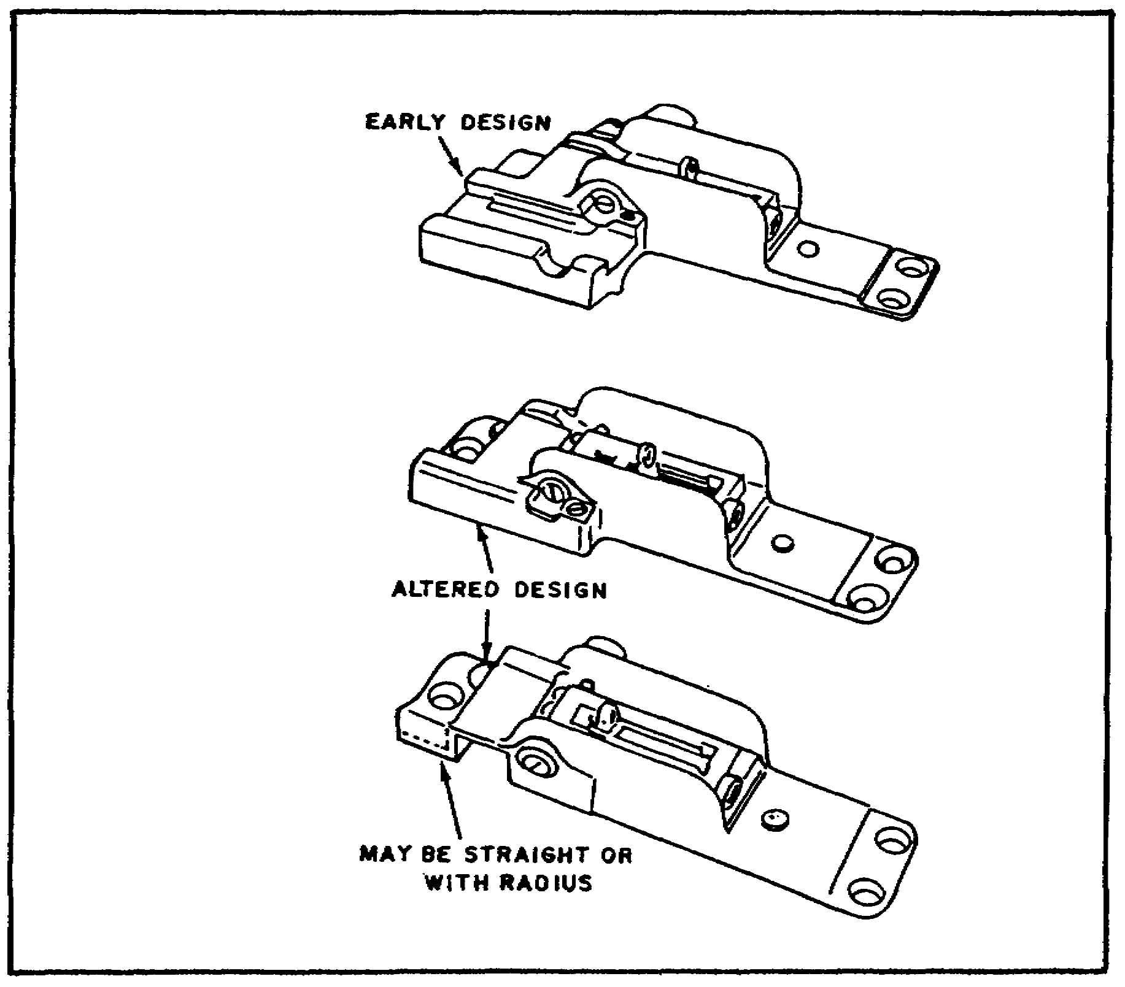

FIGURE 44. ACCEPTABLE REAR SIGHTS.

58

M2 MACHINEGUN MAINTENANCE - OD1503 - LESSON 1/TASK 2

(11) M3 Tripod Mount. First, inspect all pins, springs, and handwheels for proper functioning. Now measure the distance between the sleeves and the collar. This distance should not be less than 1/2 inch or more than 3/4 inch before locking traversing bar assembly to the right rear leg. Now measure the distance between the pintle shoulder and the tripod head. The distance should be a minimum of 0.003 inch.

When inspecting the traversing and elevating mechanism assembly, ensure that the pointer and designation plate on the upper elevating screw coincide with the 0 reading. The dial pointer will be staked to the click ring in three places.

Now inspect the legs and tripod head group. First, the serrations must be clear when the legs are being adjusted and in proper alignment to ensure an even spread of the legs when they are clamped. Ensure that the sleeve bearing is sufficiently staked at each end of the screw slot.

3. Reassembly Procedures

In the paragraphs that follow, the reassembly procedures for the M2 will be covered. Refer back to figures 1 through 39 on pages 10 through 36 in task 1 which dealt with dissassembly of the weapon.

a. Detailed Reassembly. In the paragraphs that follow, the detailed reassembly procedures, starting with the receiver group, will be discussed.

(1) Receiver Group. First, place the trigger lever in the receiver, with the long end forward and the bowed surface upward, between the top plate bracket and the bolt latch bracket. The trigger lever should project about 1/8 inch beyond the timer adjustment nut. Align the hole in the trigger lever with the holes in the receiver. Position the trigger lever pin assembly so that the key on the pin will pass through the keyway in the left sideplate. Push the trigger lever pin assembly all the way in and turn the pin 90 degrees to the left, or counterclockwise. Turn the lock flat against the side of the receiver. Turn the lock which does not have a hinge counterclockwise until the lock fits in the small hole in the sideplate.

59

M2 MACHINEGUN MAINTENANCE - OD1503 - LESSON 1/TASK 2

Now install the cartridge stop assembly (or rear cartridge stop and link stripper) and front cartridge stop, on the right side of the receiver. Install the belt holding pawl pin. Place the belt holding pawl in position on the left side of the receiver, first seating the springs. Depress the pawl and insert the belt holding pawl pin. This completes the reassembly of the receiver.

(2) Cover Assembly. Place the cover in the same position as for detailed disassembly. Hook the slotted end of the spring under the cover extractor stud with the projection pointing in the direction of its recess. Exercising caution, press down, and seat the projection of the spring in its recess in the cover extractor cam.

Now place the cover latch spring inside the cover with the enlarged hole meshing with the cover latch spring stud, the hooked end down (resting on the cover extractor spring). Press down on the cover latch spring and slide it toward the latch. Pry up on the latch end of the spring, so that it rides up over the projecting wing of the cover latch. Snap the hooked end of the spring into its groove in the cover.

Replace the belt feed pawl arm on the belt feed pawl. There are two pins on each side of the belt feed pawl. The larger is the belt feed pawl arm pin; the smaller is the belt feed pawl arm locating pin. For a left-hand feed, the belt feed pawl arm must be placed over the pins so that the belt feed pawl arm is toward the latch end of the cover, when the assembled side is returned to the cover. Place the small end of the belt feed pawl spring over the belt feed pawl spring stud (inside the belt feed slide). Place the assembled pawl and arm over the spring so that the large end of the spring is seated in the recess in the pawl, with the projecting oval (loop) of the spring away from the belt feed pawl arm. Align the pinholes in the pawl, arm, and slide; replace the belt feed pawl pin. Make sure that the pin is flush with the sides of the slide. Replace the belt feed slide in its guideways, with the belt feed pawl to the left, arm toward the latch.

Now replace the shoulder headless pin and spring in their seats in the side of the belt feed lever. For left-hand feed, the spring and pin are seated in the hole nearest the belt feed lever lug. Now,

60

M2 MACHINEGUN MAINTENANCE - OD1503 - LESSON 1/TASK 2

place the belt feed lever over the pivot stud, lug up and to the left. With a thumb at either end of the lever, press down and turn the lever until the shoulder headless pin is against the inside of the cover. Pivot the lever until it is aligned with the slots of the cover and slide. Press the lever down as far as it will go. Move the lug end all the way to the right. Maintaining a downward pressure, snap the lug end all the way to the left so that the shoulder headless pin is properly positioned in the cover. Replace the lock pin (cotter pin) in the pivot stud, making sure that the toe end of the lever moves laterally in its slot without binding.

To replace the cover group on the receiver, place the latch end of the cover in position, with the latch engaging the top plate. With the heel of your hand, tap the hinged end downward into position. Align the pin holes and replace the cover pin. Insert the cotter pin in the cover pin and spread the ends. This completes the reassembly of the cover group.

(3) Barrel Extension Group. Replace the breech lock from the bottom of the barrel extension. Make sure that the wide, single-beveled edge (or double-beveled edge) is up and to the front. In any case, the breech lock will be correctly positioned in its slot when the beveled edge is up and to the front, and the hole for the breech lock pin is toward the bottom of the barrel extension. Replace the breech lockpin so that the ends of the pin are flush with the sides of the barrel extension. This completes the reassembly of the barrel extension group.

(4) Barrel Buffer Body Group. Replace the accelerator with the tips up and the claws to the rear. Replace the accelerator pin so that the ends are flush with the sides of the barrel buffer body group. Turn the barrel buffer body group upside down. Hold the assembly against the barrel buffer body group, lug down. With the thumb of one hand, press the forward winged part into the circular opening of the slot. With the other hand, raise the rear of the assembly enough to lift the lug over the buffer body. Push the assembly forward until the rear winged part (barrel buffer tube lock latch) snaps into the circular opening in the slot. This completes the reassembly procedures for the barrel buffer body group.

61

M2 MACHINEGUN MAINTENANCE - OD1503 - LESSON 1/TASK 2

(5) Bolt Group. Engage the rear end of the firing pin in its seating groove, located in the front end of the firing pin extension assembly. Insert the firing pin and extension assembly in the bolt, striker first, sear notch down. Push the extension assembly into the bolt, and tilt the front end down until the striker protrudes through its aperture in the face of the bolt.

With the sear spring wedged on the cocking lever, replace the spring, and insert the sear in its slot-stud up, with the notch to the front. Make sure the sear spring is seated in its recess in the bolt, and the bottom of the sear.

Press down on the sear and replace the sear slide in its guideways. The slide may be inserted from either side, unless the gun is to be fired by the sideplate trigger. In that case, the square end must be to the left. Replace the sear stop and pin (accelerator stop and lock). Press down on the head of the pin (base of the accelerator stop) to force it into place; swing the sear stop into its groove in the bolt.

Replace the cocking lever, rounded nose down and to the rear with the top of the cocking lever to the rear. Replace the cocking lever pin from the left-side of the bolt. To test for correct assembly, cock the firing pin by rotating the top of the cocking lever toward the front of the bolt; then rotate it to the rear and depress the sear. This completes the reassembly procedures for the bolt group.

This completes the detailed reassembly procedures for the M2 machinegun.

b. General Reassembly. In the next paragraphs, the general reassembly procedures for the weapon will be covered.

(1) Barrel Buffer Assembly and Barrel Buffer Body Group. Replace the barrel buffer assembly, in the barrel buffer body group, with the key on the spring guide to the right. This key must fit in its slot in the right-side of the barrel buffer body. Turn the barrel buffer tube until the screwdriver slot (in the rear of the tube) is vertical, the arrow pointing to the right. The stud on the tube lock will now engage the serrations in the barrel buffer tube to keep the

62

M2 MACHINEGUN MAINTENANCE - OD1503 - LESSON 1/TASK 2

tube from turning. Now push the barrel buffer assembly fully forward.

(2) Barrel Buffer Group and Barrel Extension Group. To join the two groups together, hold the barrel buffer group in the right hand, with the index finger supporting the accelerator. Join the notch on the shank of the barrel extension group with the cross-groove in the piston rod of the barrel buffer assembly. At the same time, align the breech lock depressors with their guideways in the sides of the barrel extension (claws against the shank) and push the groups together. As the accelerator rotates to the rear, press down on its tips to ensure positive locking of the groups. Place the groups in the receiver, and push them forward until the barrel buffer body spring lock snaps into position. When the parts are properly locked in place, the barrel buffer tube should protrude about 1 and 1/8 inches from the rear of the barrel buffer body group.

(3) Bolt. Place the bolt in the receiver, with the top of the cocking lever forward and the extractor down. Push the bolt forward into the receiver. As the front end of the bolt approaches the tips of the accelerator, lock in the sideplate of the receiver, press down on the rear end of the bolt to ensure the front end of the bolt clears the accelerator tips. Raise the rear of the bolt and continue to push the bolt forward until the bolt latch engages the notches in the top of the receiver.

NOTE

The barrel extension, barrel buffer, and bolt groups may be assembled and returned to the receiver together.

(4) Bolt Stud. Align the bolt stud hole in the bolt with the clearance hole and replace the bolt stud, ensuring that the shoulder of the stud is inside the sideplate.

(5) Driving Spring Group. Press up on the bolt latch and push the bolt all the way forward by pushing on the bolt stud only. Place the end of the driving spring rod in its hole in the rear of the bolt, and push forward on the driving spring group and barrel buffer tube. Press in and to the

63

M2 MACHINEGUN MAINTENANCE - OD1503 - LESSON 1/TASK 2

right on the head of the driving spring rod, and place the retaining pin in its seat in the right sideplate.

NOTE

At this time, the barrel buffer tube should be completely inside the receiver. If not, the barrel buffer body spring is not properly seated.

(6) Backplate Group. Hold the backplate with the latch down and the trigger up; place the backplate guides in their guideways. Hold out on the latch lock and tap the backplate into position until the latch snaps into place. Release the latch lock, and pull up on the backplate group to ensure it is firmly seated.

(7) Barrel. Pull the retracting slide handle to the rear until the lug on the barrel locking spring is visible through the 3/8 inch hole in the right sideplate. Place the smallest loop of a caliber .50 link, or suitable spacer, between the trunnion block and into the barrel extension; then unscrew the barrel two notches. Remove the link and close the cover. This completes the general reassembly procedures for the Browning caliber .50, M2 HB machinegun.

After the weapon has been reassembled, be sure to coat frictional or sliding surfaces with either aircraft and weapons lubricant or general purpose lubricating oil (PLS).

4. Final Inspection, Function, and Firing Test

In the paragraphs that follow, the procedures used in performing the final inspection, function test, and the firing test will be covered. These procedures are necessary as they provide maintenance personnel with a means of double-checking their work to ensure that no defects were overlooked, that the weapon was reassembled correctly, and that it will operate in the proper manner.

a. Final Inspection Procedures. First, visually inspect the machinegun to ensure that it is a complete and serviceable weapon. Inspect the exposed metal surfaces for dull rust-resistant

64

M2 MACHINEGUN MAINTENANCE - OD1503 - LESSON 1/TASK 2

finish, free from burrs and deep scratches. Ensure that the serial number is legible. Inspect all of the assemblies of the weapon to ensure that they are not loose.

(1) Machinegun. Ensure that the weapon is complete and serviceable. Inspect all exposed metal surfaces to ensure that they contain a dull rust-resistant finish which is free of burrs and deep scratches. Make sure that the serial number is legible and that all assemblies are not loose.

(2) Barrel Assembly. Inspect the barrel assembly to ensure that it is straight, clean, free of rust, powder fouling, bulges, and rings. Ensure that the serrations will be well defined so as to retain the barrel assembly setting by the locking spring. Ensure that the barrel carrier is secured to the barrel assembly.

(3) Backplate Group. Make sure that the backplate group locks securely to the receiver group. Check the trigger, bolt latch release, latch and buffer tube sleeve for positive functioning.

(4) Bolt Group with Rod Assembly. Ensure that the components are secure and properly positioned. The sear slide in the bolt should be assembled to the bolt from the left side (square end to the left). Make sure that the trigger lever does not drag on the bolt group when the trigger is depressed. Check the cartridge extractor for binding against the side plate. Make sure the ejector returns to the neutral position when it is pulled to the rear side and released. The firing pin and firing pin extension should move freely and align properly. Ensure that the sear and sear slide assembly function smoothly in the guideways without binding. Ensure that the driving spring rod assembly does not bind in the bolt group, also make sure that the driving spring rod locks securely to the side plate.

(5) Barrel Buffer Group. The free ends of the breechblock depressors will have a slight vertical play, but no longitudinal or lateral movement. Ensure that the buffer body lock is not overstaked and that the guide is tight. Make sure that the buffer assembly contains no oil. Ensure that there is no binding between the accelerator claws and the depressors.

65

M2 MACHINEGUN MAINTENANCE - OD1503 - LESSON 1/TASK 2

(6) Barrel Extension Group. Ensure that the shank fits tightly and that the breechblock functions freely with a minimum of looseness in the slot.

(7) Retracting Slide Handle. Make sure that the retracting slide handle is secured to the receiver group. Check the headless shoulder pin and the shouldered and stepped stud for looseness. Ensure that the retracting slide stud is firmly secured to the bracket. Check the helical torsion spring for correct positioning. Make sure that the retracting slide handle functions freely in the bracket and that it functions freely in its orbit.

(8) M10 Charger. Visually inspect the M10 charger to ensure that it is secured to the correct side of the receiver group and that it is lockwired properly. Also ensure that it moves the bolt group to the rear and charges the machinegun.

(a) Slide Group. Ensure that it moves through the full range of travel without binding. Make sure that the slide lock pawl lever engages and disengages the selector when the selector is manually operated. When the lever is disengaged from the selector, the slide shall lock in the rearward position. When the selector is engaged, the slide shall return to the forward position as the handle assembly is moved forward. Determine that the other components function as intended.

(9) Rear Sight Assembly. The rear sight assembly should be secured to the top plate of the receiver group so that there will be no relative movement. Ensure that the leaf assembly moves manually between horizontal and vertical positions and that the sight assembly is held in either position under spring action until manually changed. Make sure that the elevating and windage adjustment knobs turn manually through their full range of travel, and produces positive retention perceptible by touch of each detent notch when the sight is adjusted.

(10) Cover Group. Ensure that the bolt feed pawl spring with the oblong coil on the large end is positioned correctly. Also ensure that the cover operates freely in its travel.

(11) Receiver Group. Make sure that all the rivets are tight. Ensure that the barrel support

66

M2 MACHINEGUN MAINTENANCE - OD1503 - LESSON 1/TASK 2

with applicable shim will be assembled to the trunnion block and locked into position. Ensure that the front sight cover and blade are firmly secured to the trunnion block.

Determine that the bolt group does not bind and that the breech lock cam floats slightly. Ensure that the side plate switch nut is secure and that the switch does not bind.

(12) Tripod Mount M3. Visually inspect the dial pointer for looseness. Check the upper elevating screw stop and traversing slide lock for proper functioning. Test the upper and lower elevating screws for binding. Now check the telescoping function of the upper and lower leg sections and the indexing lever assembly. Check the clamping action of the front leg clamp screw nut. Check that the serrations are in the proper alignment to ensure even spread of the legs when clamped. Check the function of the sliding sleeve and sleeve lock latch on the right rear leg, and the pintle and lock assembly. Finally, check the tension of the helical compression springs in the lock assembly.

b. Function and Firing Test. In the following paragraphs, the function and firing test procedures employed by unit and IDS maintenance personnel to test the correct assembly and proper functioning of the machinegun will be discussed.

The machinegun will be function tested by hand using 10 rounds of dummy ammunition. Upon completion of the hand functioning, the weapon will be test fired on a firing range or a provisioned firing range using 10 rounds of ball ammunition.

Upon completion of firing, the machinegun will be properly cleaned and lubricated. The procedures for cleaning and lubricating the weapon were discussed in paragraph 2a(2) on page 45 of this task.

Guns that fail to meet the functioning and firing tests are to be corrected by replacement of defective components. Upon completion of any additional repair work, the above procedures must once again be performed to test the weapon for correct assembly and proper functioning of components.

67

M2 MACHINEGUN MAINTENANCE - OD1503 - LESSON 1/TASK 2

5. Conclusion

In this subcourse, the student was introduced to the components and operation of the M2, caliber .50 HB machinegun. Then the student was taken through the disassembly, inspection, repair, reassembly, and the final inspection and function tests used on this weapon.

From the information presented in this subcourse, the student should be able to describe the components and operation of the M2 as well as explain the inspection and repair procedures used by unit and IDS maintenance personnel. It should be pointed out that this text is intended only as a learning guide and should not be used as a guideline for actually inspecting or repairing an M2 machinegun.

68

M2 MACHINEGUN MAINTENANCE - OD1503 - LESSON 1/PE 1

PRACTICAL EXERCISE 1

1. Instructions

Read the scenario and respond to the requirements that follow the scenario.

2. Scenario

You are the Armament Repair Section NCO of a Heavy Maintenance Company located in the Federal Republic of Germany. One afternoon around 1430 hours, your OIC who is the Armament Repair Technician notifies you that in approximately 60 days the maneuver elements of the division will be engaged in a month-long field training exercise (FTX).

You have been directed to form a Maintenance Support Team (MST) and move down to the companies in one of the maneuver battalions. The purpose of this MST will be to inspect and/or repair all M2, caliber .50 machineguns in each of the companies.

Since you have several days before leaving for the companies in the battalion, you decide to prepare a quiz to test the knowledge of your team concerning the M2 machinegun. Your OIC likes this idea and suggests that you take the quiz along and conduct some informal training with the unit supply specialist/unit armorers from each of the companies.

3. First Requirement

Below are the questions that you prepared to administer to the men of your MST and to the unit supply specialists/unit armorers. All that is left for you to do is to prepare an answer sheet for the quiz. Use your knowledge of the M2 machinegun and this subcourse to answer the questions below.

a. When does locking begin in the M2 caliber .50 machinegun?

b. Describe the procedures used when clearing the M2 machinegun.

c. Describe the procedures for disassembling the barrel extension group.

69

M2 MACHINEGUN MAINTENANCE - OD1503 - LESSON 1/PE 1

d. Briefly describe the M3 tripod mount.

e. Describe the Preventive Maintenance Checks and Services. Inspection procedures used for the barrel assembly/group.

f. Describe the procedures used for the care and cleaning of the weapon before, during, and after firing.

g. How many buffer disks are there in the backplate assembly/group?

h. The overall length of the buffer assembly (rear face of the tube to the forward inside face of the engaging notch) must be what?

i. After the weapon has been reassembled and the final inspection procedures have been performed, the weapon should be hand functioned and test fired. How many rounds of dummy ammunition should be used when hand functioning the weapon?

70

M2 MACHINEGUN MAINTENANCE - OD1503 - LESSON 1/PE 1

LESSON 1. PRACTICAL EXERCISE - ANSWERS

First Requirement

a. Locking begins 1 and 1/8 inches before the recoiling parts are fully forward.

b. To clear the weapon first, unload the gun. This is done by unlocking the bolt latch release and raising the cover. Now the ammunition belt is lifted from the feedway. Now the bolt is pulled to the rear and the chamber and T-slot are examined to ensure that they contain no ammunition. After these steps have been performed, a wooden block extending approximately one inch above and below the receiver is inserted into the receiver between the bolt and the rear of the barrel. A cleaning rod is then inserted into the muzzle end of the barrel, pushed through the bore until it can be seen in the receiver, it is then immediately removed.

c. First, drift the lockpin out and remove the breech lock from the bottom of the barrel extension group.

d. The M3 mount is the standard ground mount for the M2 machinegun. It is a folding tripod with three telescopic, tubular legs, connected at the tripod head. The entire mount assembly weighs approximately 44 pounds.

e. Inspect the bore with barrel reflector for rust, powder fouling, and obstructions. Check the barrel threads and locking notches for serviceability. Check the components of the barrel carrier assembly for serviceability. The retaining pin should be staked in the knob of the carrier assembly. The handle group should secure the carrier assembly firmly to the barrel assembly.

f. First, disassemble the weapon into its major groups or assemblies. Clean the bore and the chamber, but do not oil them. Clean all the metal parts thoroughly and apply a light coat of oil to all the metal parts which do not come in contact with the ammunition. To ensure complete removal of powder residue and primer fouling from the bore of the machinegun barrel,

71

M2 MACHINEGUN MAINTENANCE - OD1503 - LESSON 1/PE 1

the bore should be cleaned at least once a day, for at least three consecutive days after firing. The bore sweats out this fouling and residue, and cleaning must be repeated until there is no further evidence of sweating.

g. There are 22 buffer disks in the backplate/assembly group.

h. The overall length of the buffer assembly (rear face of the tube to the forward inside face of the engaging notch) must be between 6.086 and 6.117 inches.

i. The weapon should be hand functioned using 10 rounds of dummy ammunition.

72

M2 MACHINEGUN MAINTENANCE - OD1503 - REFERENCES

REFERENCES

73

M2 MACHINEGUN MAINTENANCE - OD1503 - REFERENCES

REFERENCES

The following documents were used as resource materials in developing this subcourse:

FM 23-65
TB 9-1000-247-34
TM 9-1005-213-25

74

